# Weekly Reflections (Akashkumar Vanzara – 2524845)

# Week 1 Reflection: Embarking on JavaScript and Visual Studio Code

In the first lab for Web and Mobile Apps, we set up MERN and all the apps, such as NodeJS, MongoDB, Visual Studio Code, and POSTMAN. After the lesson, our teacher also went over the material and talked about Web applications, Web development, N-tier applications, and stacks.

First, we did the lab practice for week 1, which was to make a program that can add, remove, multiply, and divide two or more numbers. This is how I did it:

To begin, we will make two variables that will be used for the tasks.

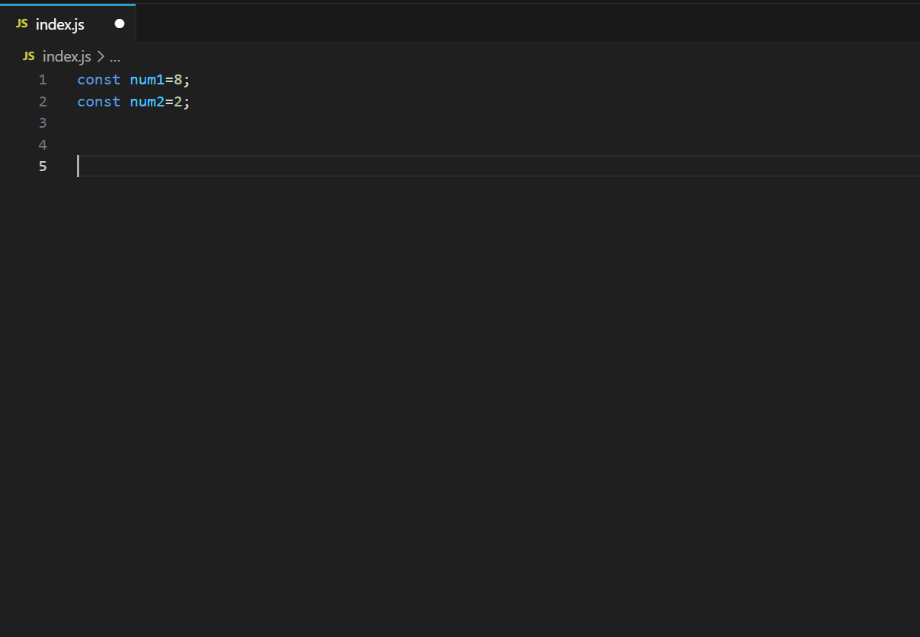

* I'm now going to give them the methods for each process.

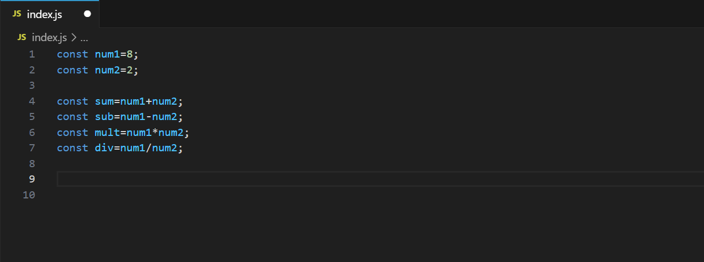

* I will now display the responses of all of them in the terminal when the program is executed.

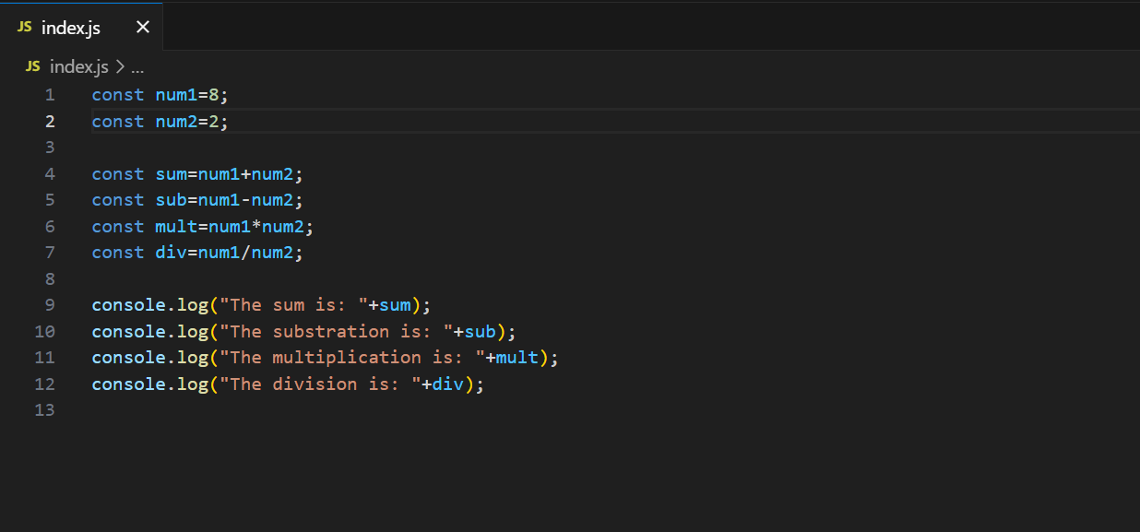

* The program has been read, and we must execute it by entering the command node index.js in the terminal window.

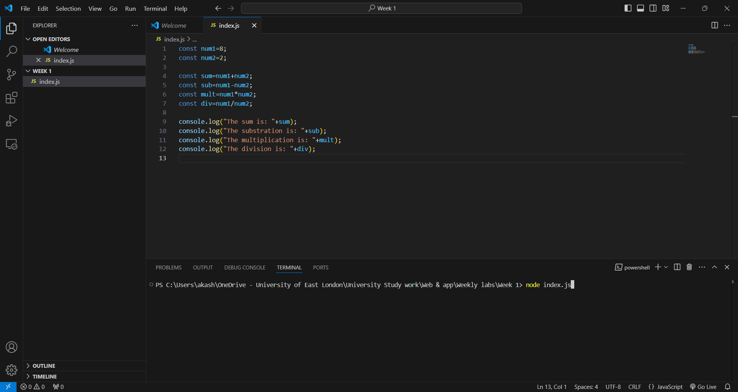

* The program has been read, and we must run it by typing node index.js into the terminal window.

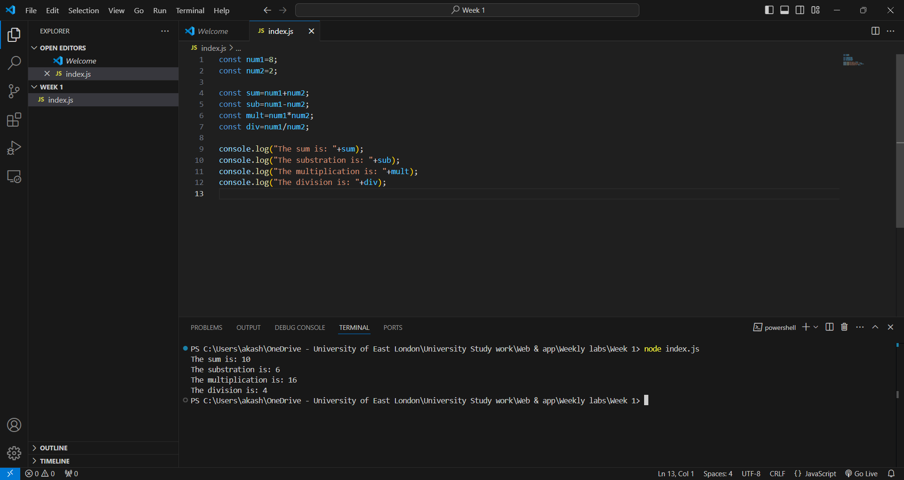

**1. Learning Objectives**

This week, I started learning JavaScript and Visual Studio Code for professional coding. The main goal was to learn VS Code and install Node.js, which is needed to run JavaScript outside a browser. This week, I wrote my first JavaScript application, which was a basic yet important milestone in my web development education. I was eager to explore this new world and see my code on the terminal.

**2. Key Learning Points**

Installing Visual Studio Code was first. I learned that web developers love VS Code for its flexibility. I needed time to learn the UI and where each function was, but roaming the workplace helped me relax. Following the step-by-step tutorial, I confirmed Node.js installation using node -v in the terminal. Checking the version was quite satisfying—it confirmed everything was put up correctly.

Then I made my first JavaScript file. After selecting "New Text File," choose JavaScript as the language. My primary file is index.js, as per JavaScript tradition. Saving and finding files correctly was vital since managing my files would help me monitor my tasks as they get more complicated. Then I typed my first JavaScript lines.

**3. Challenges Faced**

Challenges arose this week. Terminal directory navigation was the first challenge. I learned a simple mistake, like being in the wrong folder, may stop the application. The path where my index.js file was stored was initially unknown. Pwd (print working directory) helped me check my position, and cd (change directory) helped me browse to other directories. A simple thing, but knowing these instructions is vital for functioning efficiently in this context.

Syntax mistakes were another issue. I forgot a semicolon while developing the code, which caused a runtime issue. I learnt that JavaScript syntax must be accurate since even tiny errors can impede operation. Correcting these problems took patience and showed me that coding is about logic and detail. This taught me the importance of reviewing each line of code before running it.

**4. Reflection**

I felt accomplished after this week. I've begun learning JavaScript, something I'd just heard about. Setting up VS Code, learning Node.js, and building a tiny program may seem like little activities, but for me, they start a new set of abilities. This week taught me that coding is about problem-solving, detail, and experimentation and learning from failures, not just remembering instructions.

My goal is to practice terminal commands and JavaScript syntax to expand on my knowledge. Working through problems and comprehending each line of code helped me learn JavaScript. I'm enthusiastic about the difficulties and discoveries.

https://github.com/u2524845/CN5006-week1.git

# Week 2 Reflection: Managing Data with MongoDB Compass

This week, we are studying MongoDB. A CSV file titled people.csv has been provided. Our objective was to get the file from Moodle to conduct this week's laboratory session. I downloaded the file and placed it in my Week 2 folder for this lesson. I created a folder for the database and subsequently placed the CSV file into it.

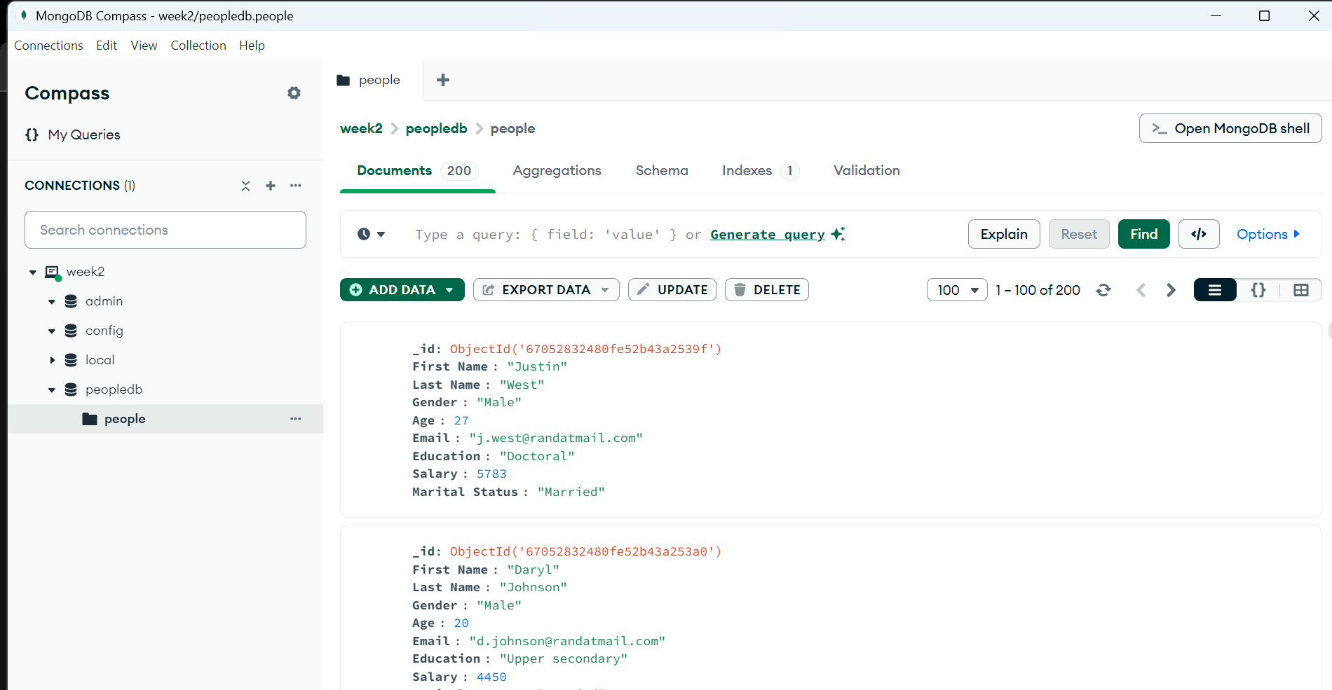

* I can now update the file by hitting the pencil button and making any changes I want. Then I can click update to finish the process.

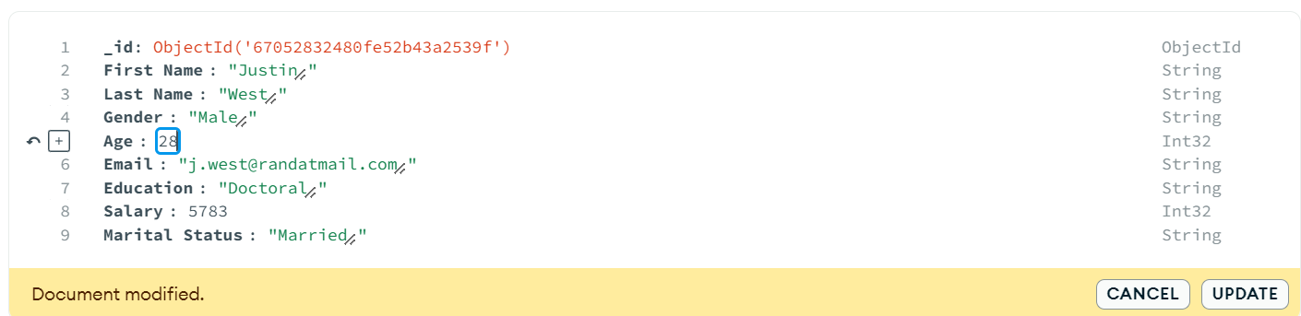

* To remove an item, I may simply click on the delete symbol to eliminate the chosen entries.

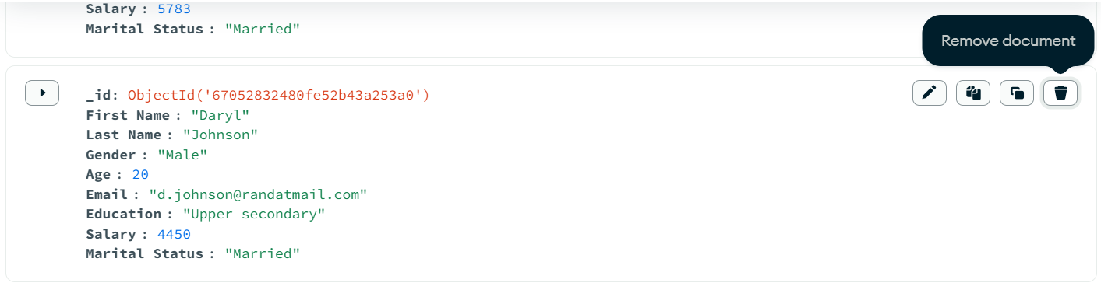

* To do the aggregate, we will navigate to the aggregation tab, establish a stage, and execute several operations to identify and align distinct fields.

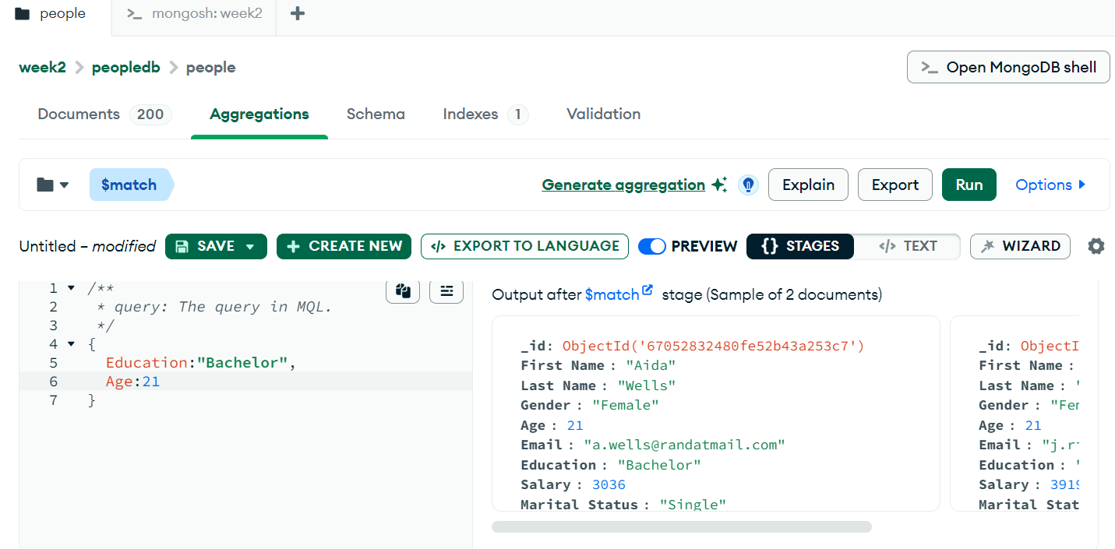

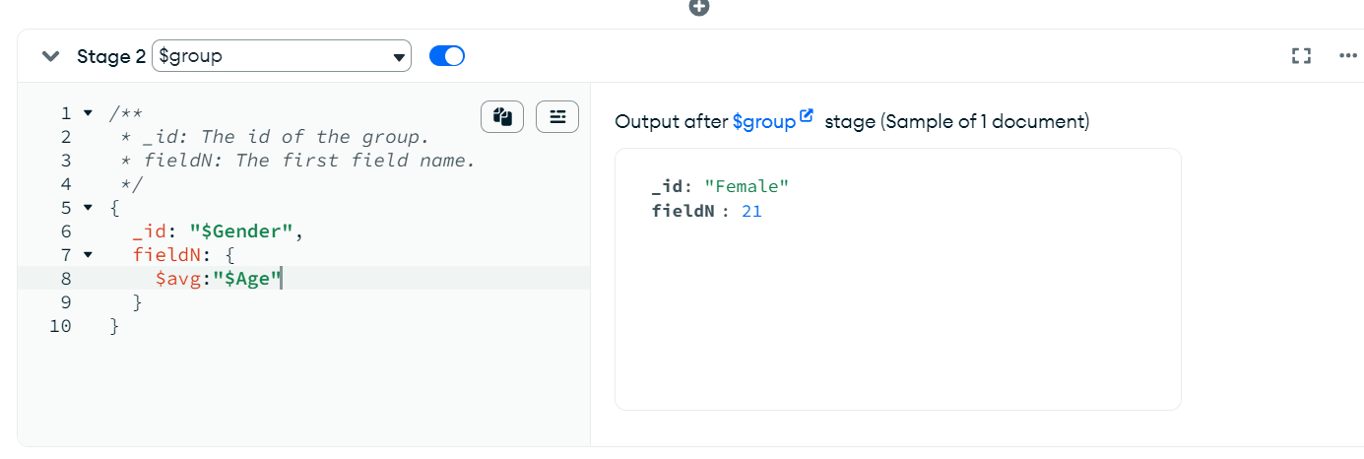

* To repeat the same procedure in quest of master’s degree in education. Sort the individuals group by marital status to find the average, minimum, maximum age and average min, max salary:

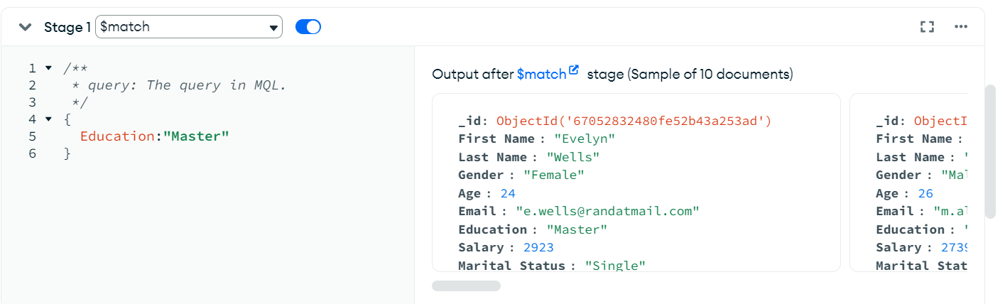

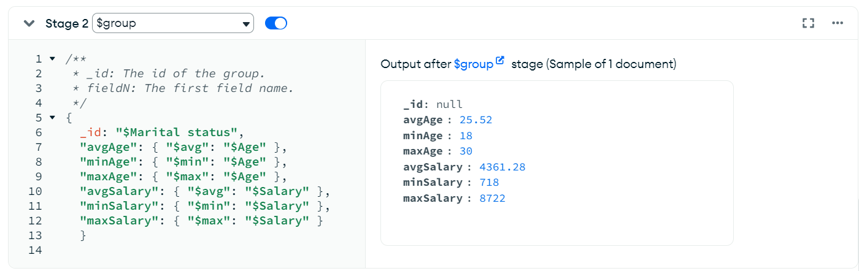

* To determine the minimum and maximum average salaries of women in each age group:

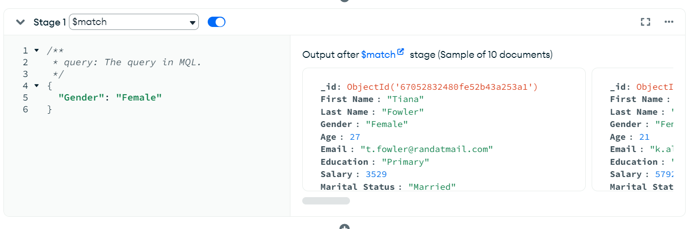

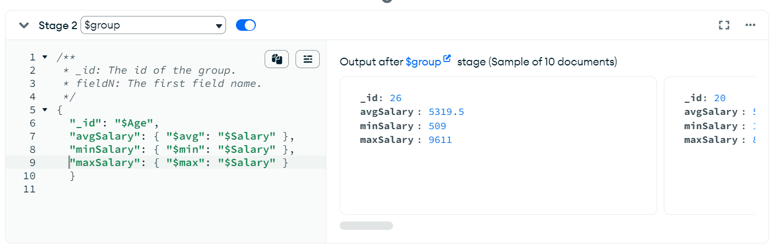

* To determine the minimum and maximum average salaries of males in each age group:

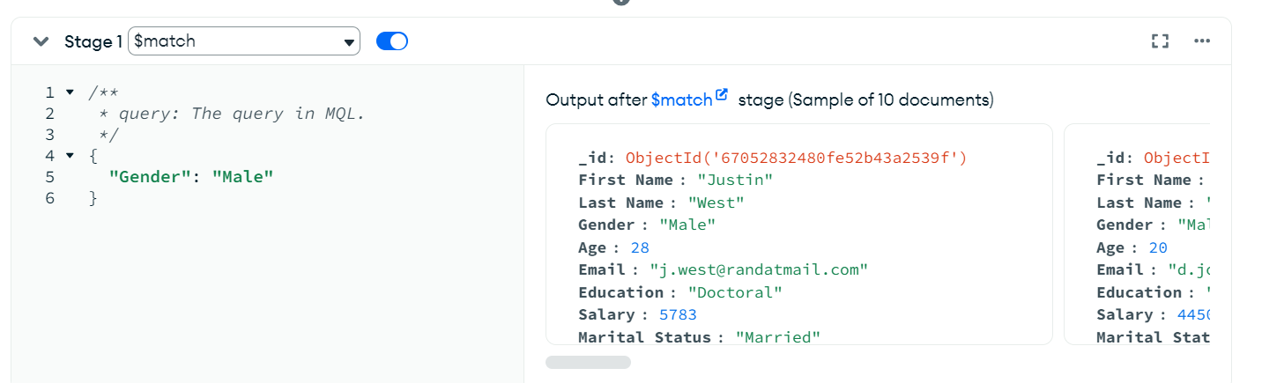

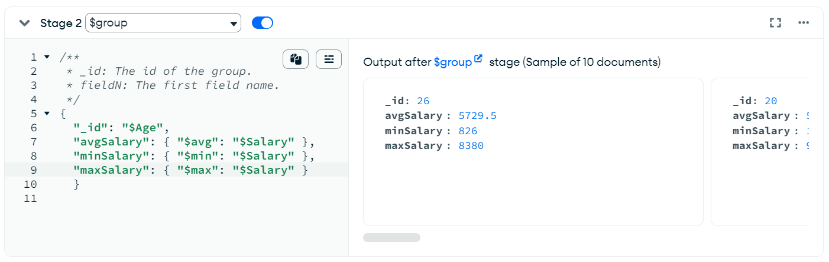

* To calculate the number of married and unmarried females and males:

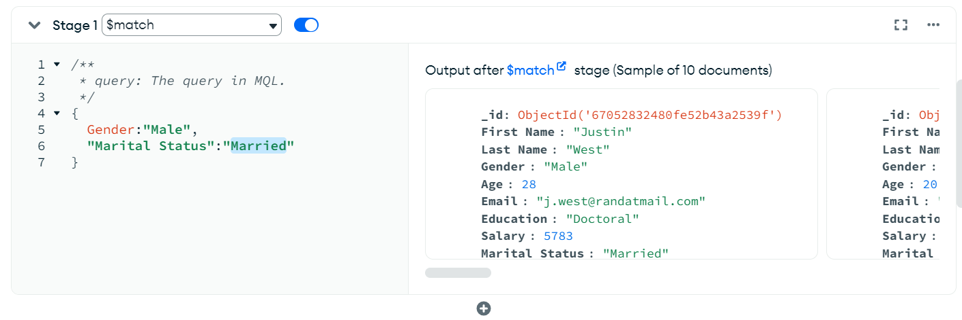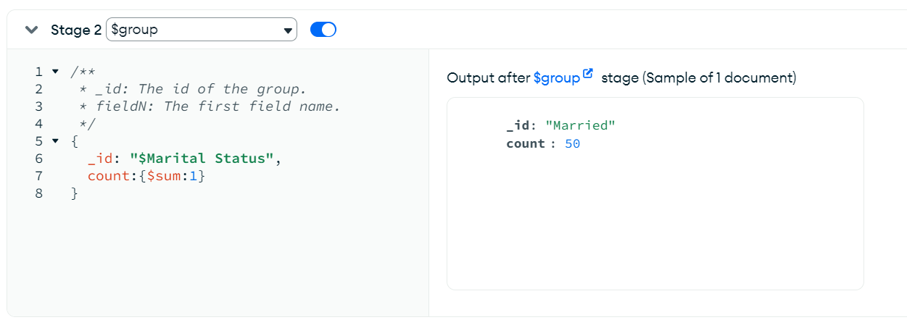

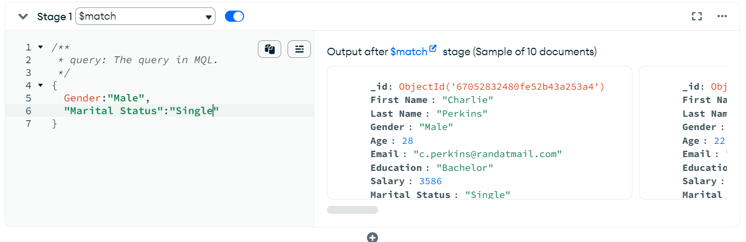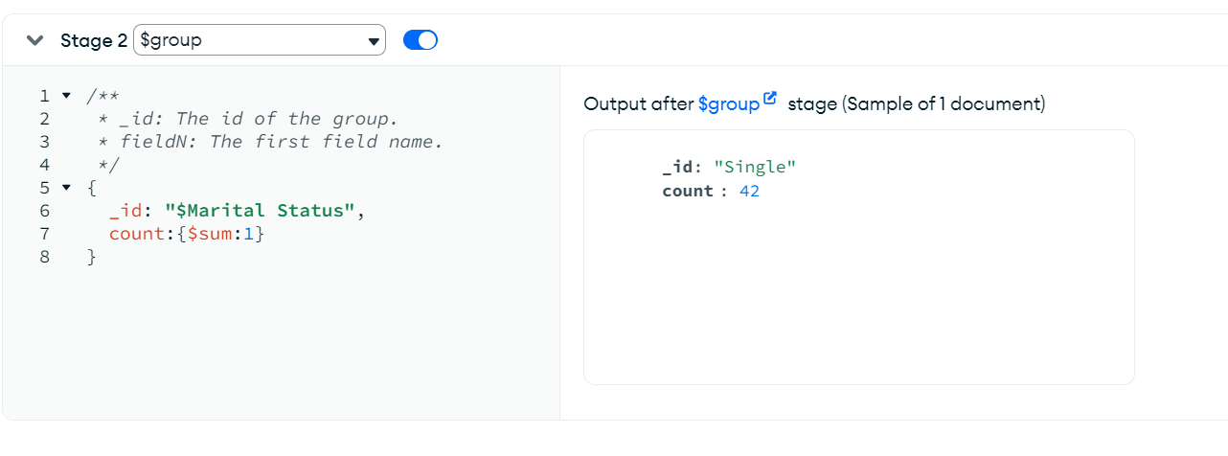

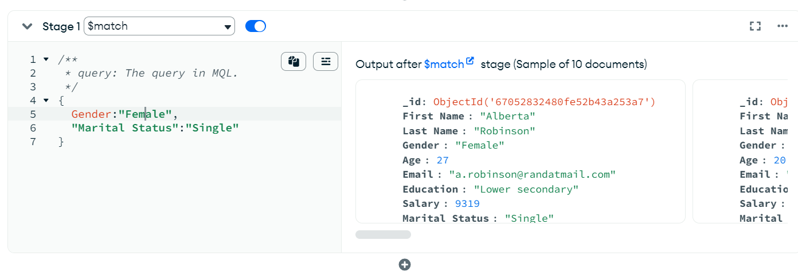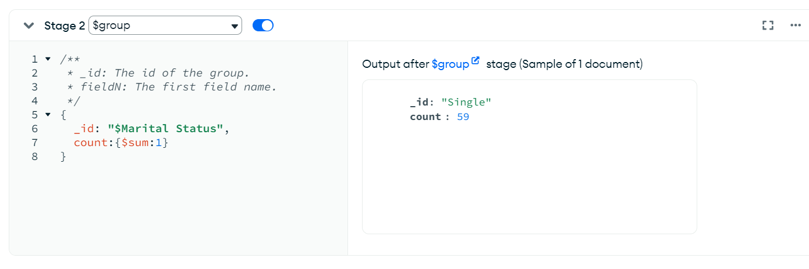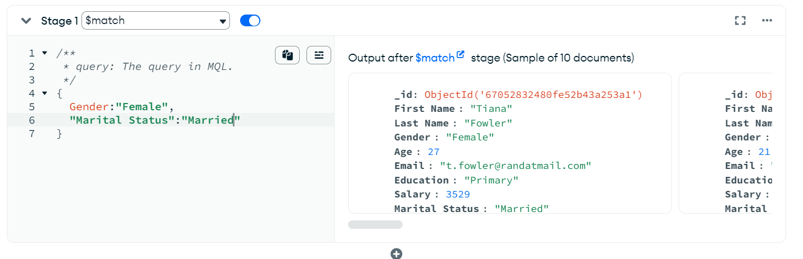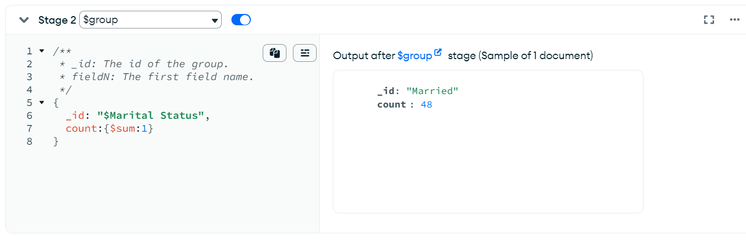

**1. Learning Objectives**

The main goal for this week was to learn about MongoDB, a document-oriented database, and how to use MongoDB Compass to do simple things with it. You learned how to do CRUD (Create, Read, Update, and Delete) tasks and how to collect data. I didn't know much about databases before I started learning MongoDB. It was both fun and hard for me. My goal was to learn about the structure of MongoDB and how it is different from regular relational databases.

**2. Key Learning Points**

I could think more easily about data with MongoDB than with relational systems because of how it organized data. From what I learned, MongoDB saves data as documents that look like JSON and have changeable fields. This freedom is helpful for data that doesn't fit into a schema.

I first linked MongoDB Compass to a local computer to set it up. After entering the address and port, I was able to join. It was easy to set up the link, but it taught me about the parts I need to use and talk to files on my PC.

* Made data in peopledb and people groups and imported it for lab work. "Import CSV" is how I added People.csv to the group. For this process to work, field data types had to be changed. I changed Age and Salary from words to numbers so that MongoDB could handle searches with numbers. These little things taught me how important it is to have right database setup.
* It was easy to do CRUD operations with MongoDB Compass's visual and live interface. To add a document, I clicked "Add Data" and filled in the blanks in list view. It was simple to click the edit button, make changes, and save the paper. This ease of changing showed me how MongoDB focuses on making databases easy for beginners to use. Lastly, it was easy to get rid of a paper, but I was told that lost data can't be recovered.
* The aggregation process in MongoDB was a key part of this week's test. I used $match to find bachelor’s degree papers and $group to find the means, minimums, and maximums for age and income based on gender. At first, the wording seemed hard, especially since the command structure looked like JSON, but the results were good. I learned that MongoDB aggregation lets you do deep data analysis inside the database, so you don't have to do any work outside of the database.

**3. Challenges Faced**

It was fun to work with MongoDB, but there were some problems that came up. I had a hard time at first understanding MongoDB's language. It took me a while to fully understand terms like "collection" (which means "table") and "documents" (which means "row"). This was especially true when I switched between thinking in relational and NoSQL ways. Another difficult part was changing the data types during the CSV import. At first, I skipped this step and my queries didn't work the way I thought they would. When I realized what I had done wrong, I changed the data types and was able to run the queries properly again. These events made me realize how important it is to set up data carefully from the start.

It was also hard to do aggregation because it needed accurate grammar. For values like $avg, $min, and $max, writing searches that looked like JSON took some practice. When I first started, I made a lot of small grammar mistakes. But as I learned the structure, I realized how powerful these functions could be. I learned how to debug and figure out what was wrong with my code by making mistakes and fixing them.

**4. Reflection**

After thinking about this week's lab, I feel like I have a much better idea of databases. Compass's visual design and MongoDB's freedom made it easy for anyone to use, even a beginner. This week has made me more interested in data handling and how databases are used in web apps. I felt like I had power over the data I was working with when I did CRUD tasks, and aggregation taught me how to use databases to find insights. I can also see how MongoDB's NoSQL structure could be useful when data doesn't fit nicely into rows and columns. This is something that standard databases might not be able to do as well.

I want to keep working with MongoDB and look into more complex queries in the future. I want to get better at using code and learn more about how to successfully change data. This week has given me a strong base, and I'm excited to see how these skills grow in the setting of web development.

# Week 3 Reflection: Exploring JavaScript Functions and Node.js Modules

We learned about functions in JavaScript this week in lab. We will be writing all of the programs in VS Code. To make sure I had node JS loaded, I typed node -v into the console window.

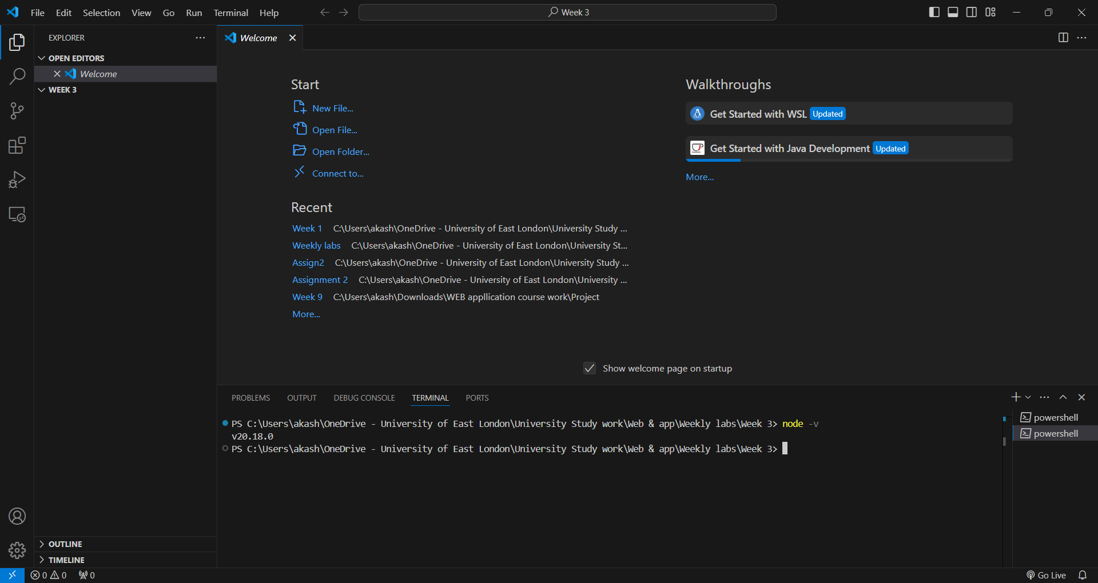

* To write the lab activity for this week, we will now create a file:

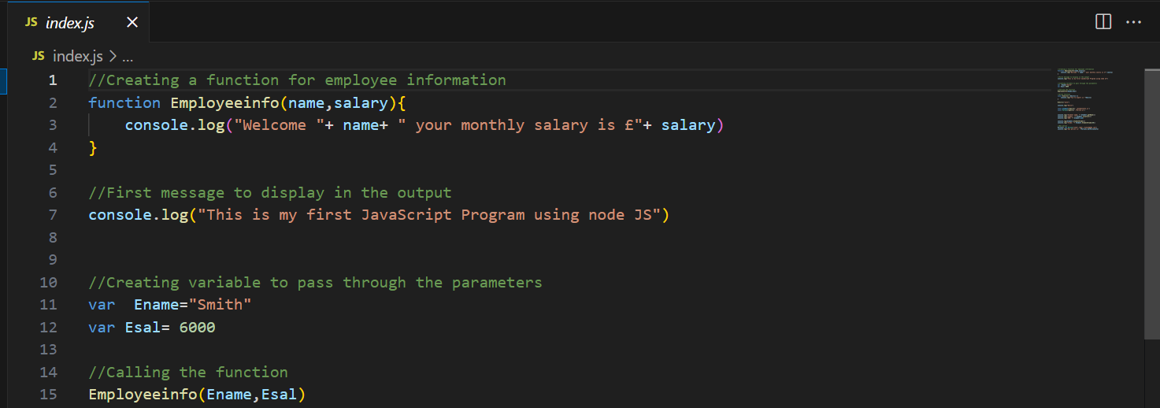

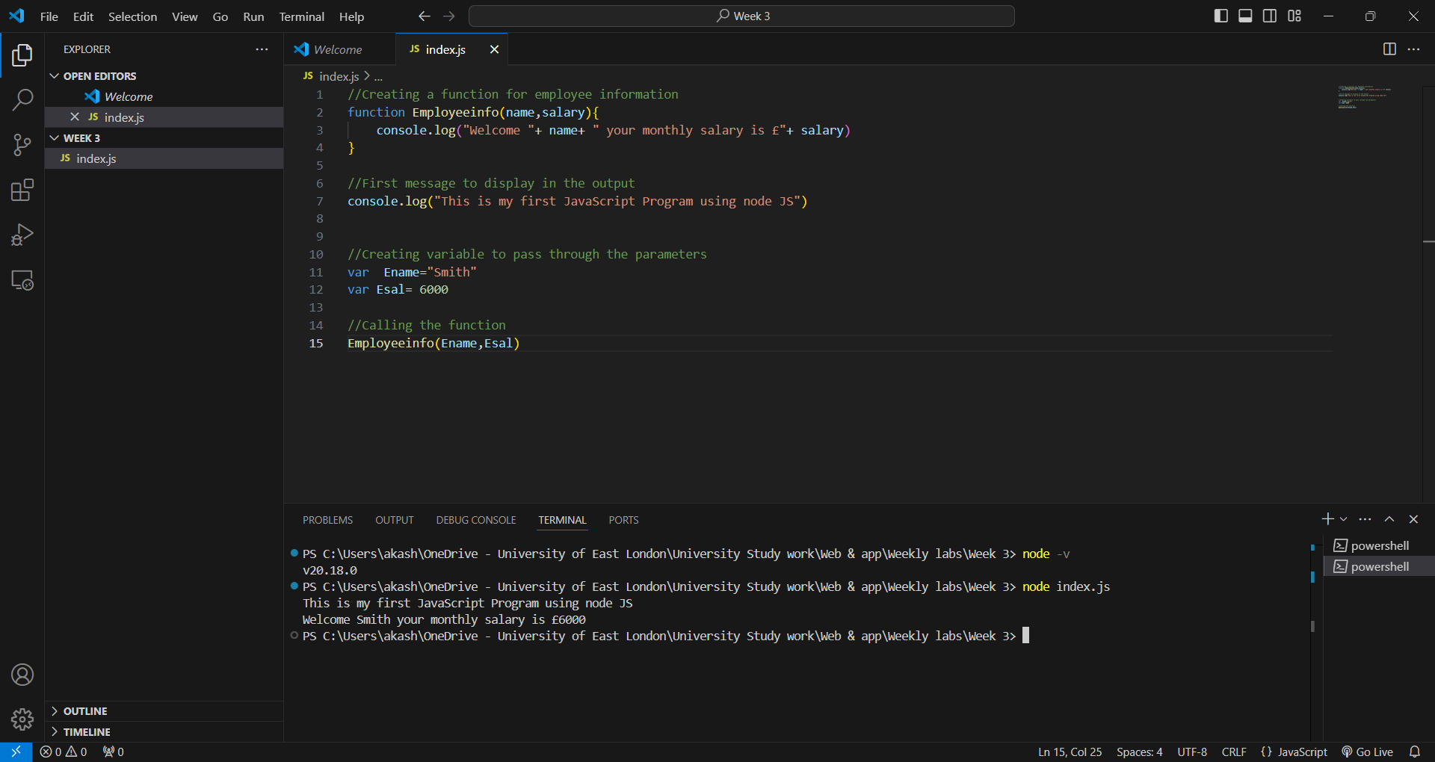

Exercise 2:

In this we have created an arrow function

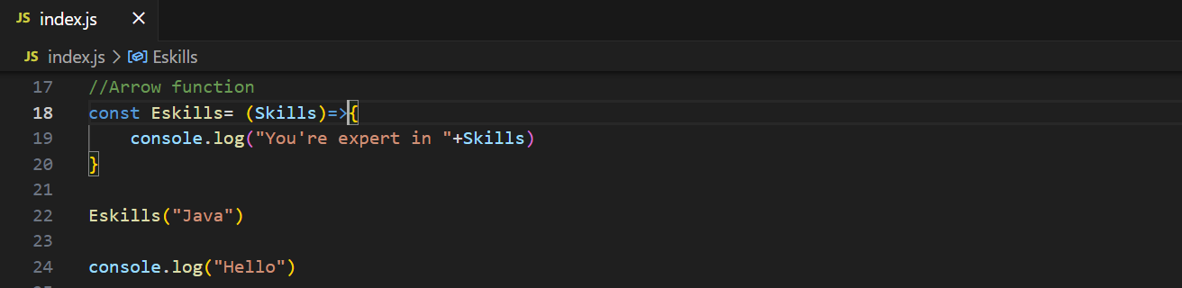

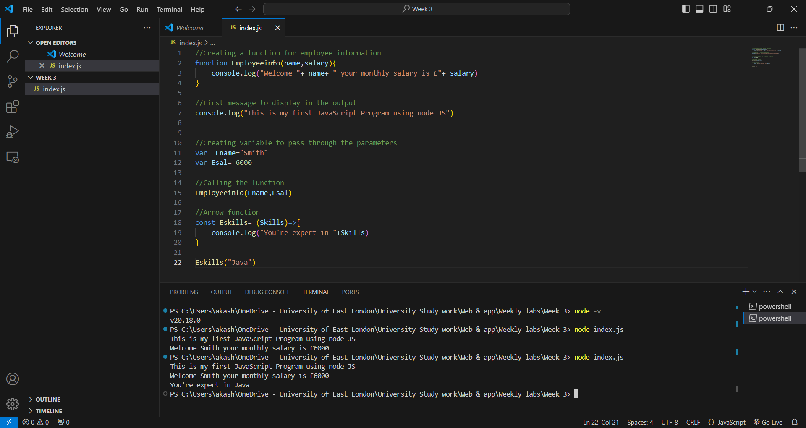Exercise 3:

Now we will work on java script modules, and for that we will need to create 3 files that is index.js, person.js and student.js. All this file will be created separately in my week 3 folder. This is my StudentInfo.js file:

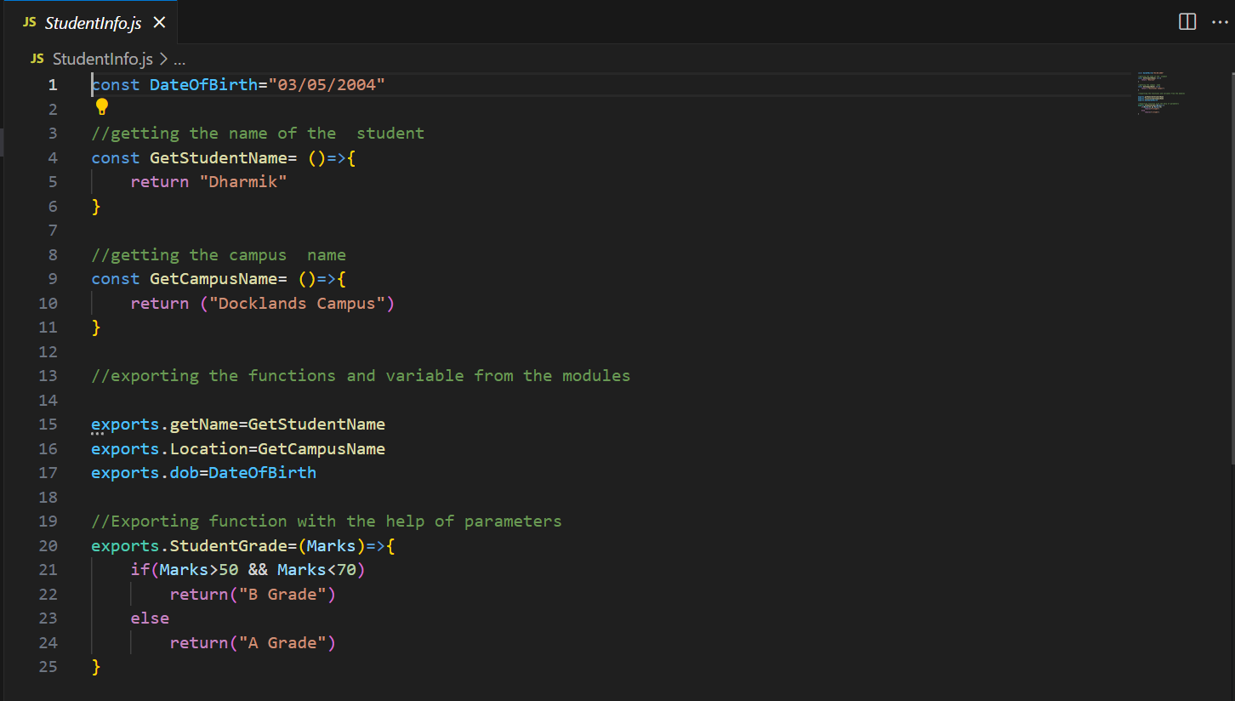

And this is my Person.js file:

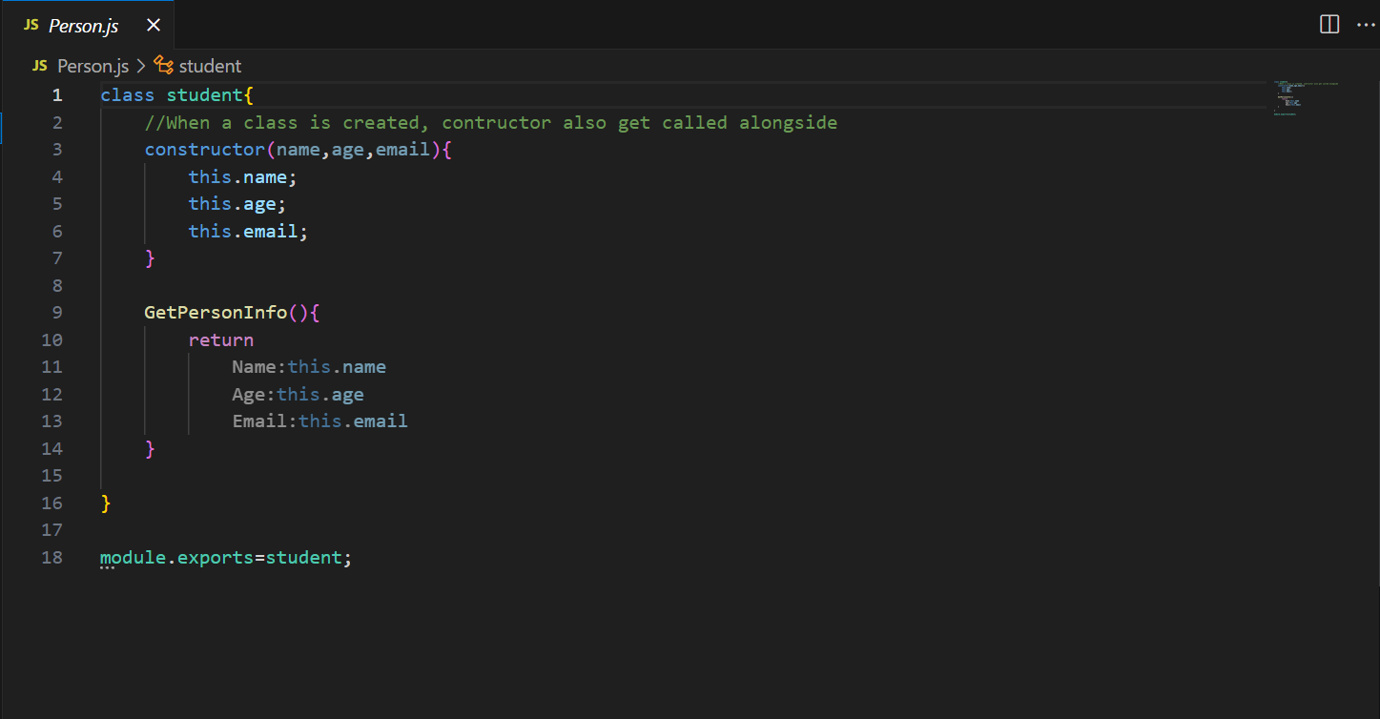

Now we will add few more lines of code to the index.js file to connect it with the other 2 files: 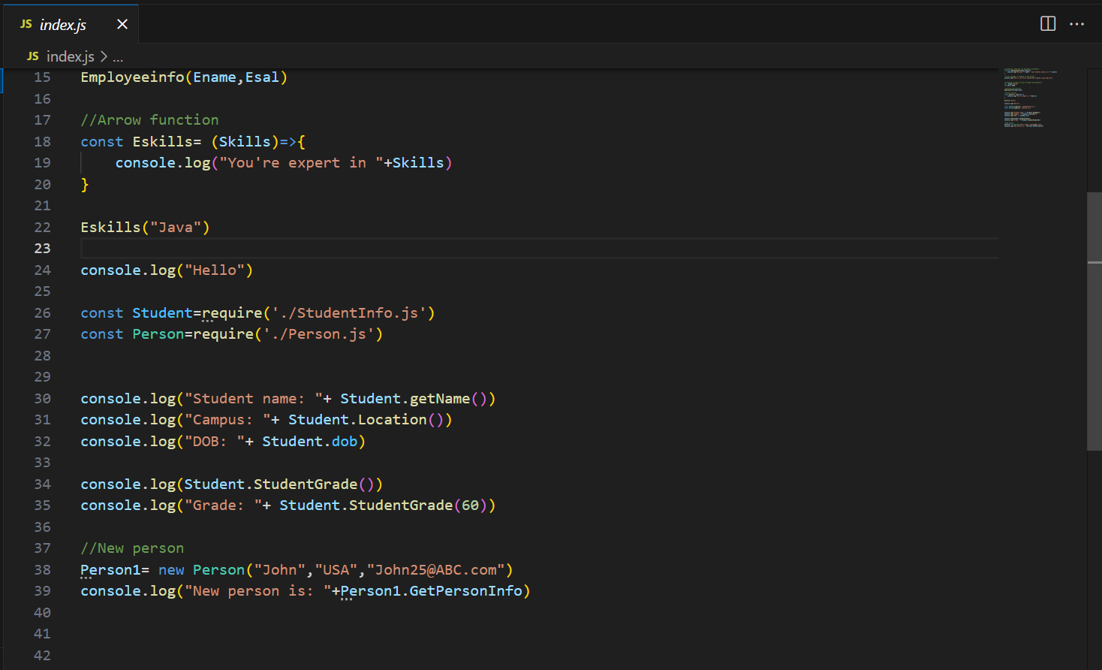

And this is my final output:

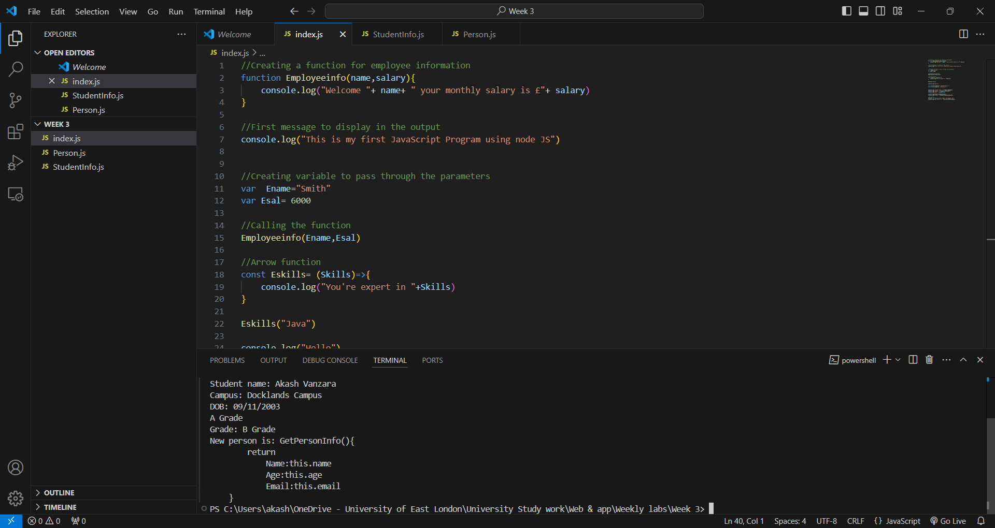

Exercise 4:

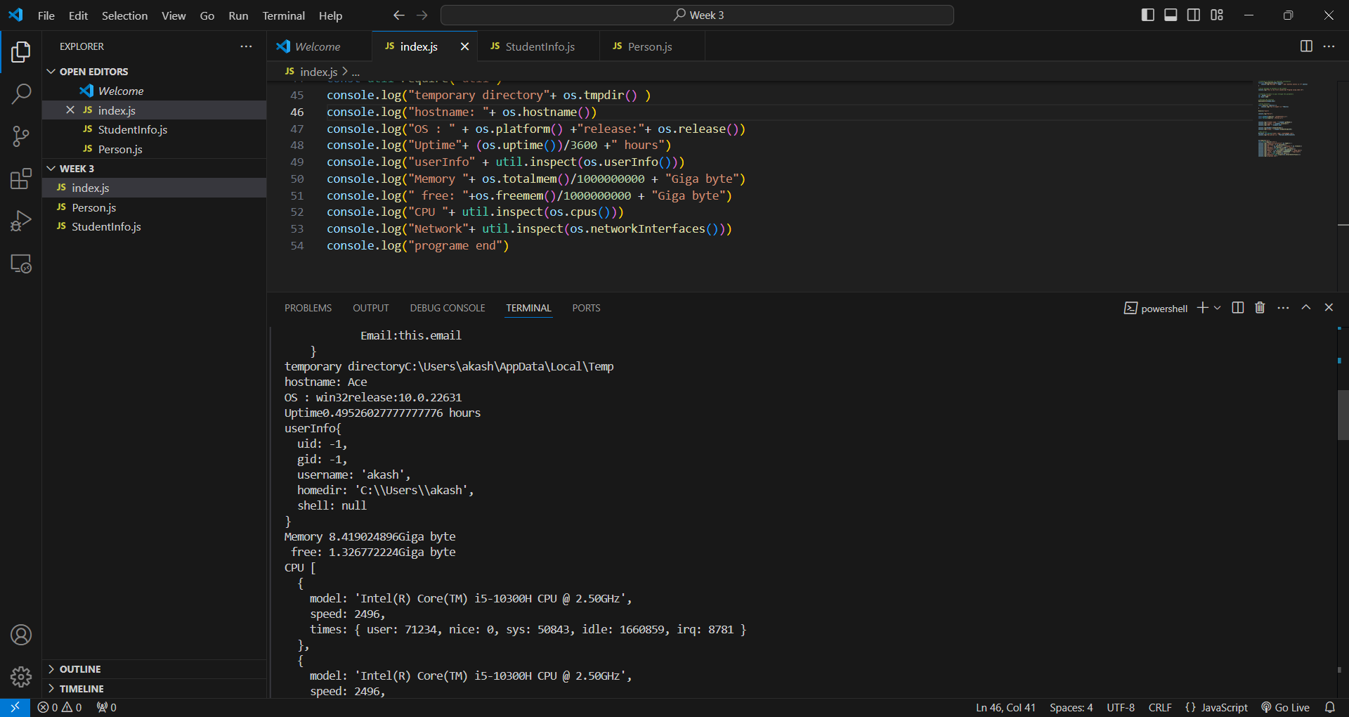

**1. Learning Objectives**

This week’s focus was on understanding the use of functions and modules in JavaScript, as well as getting hands-on experience with Node.js modules. The objectives were to learn how to create and export functions, use JavaScript’s arrow functions, and understand how to work with both local and core modules in Node.js. Since modules are crucial in structuring JavaScript applications, this lab introduced me to concepts that will help build organized and reusable code, making my future web development work more efficient.

**2. Key Learning Points**

* **Defining Functions and Arrow Functions in JavaScript:** My initial task was to define a function in JavaScript to display employee information. I created a function, EmployeeInfo, that took in parameters like name and salary, then printed a message using console.log. I found this task straightforward and enjoyed seeing how JavaScript functions can encapsulate specific tasks. Later, I redefined a function using arrow function syntax. Arrow functions offer a more concise way to write functions, which I appreciated as a modern JavaScript feature that’s both readable and efficient. I added an arrow function EmpSkills to log employee skills, which felt intuitive once I understood the syntax.
* **Creating and Importing Local Modules in Node.js:** Next, I learned how to create my own JavaScript modules. I created two separate files: StudentInfo.js and Person.js. In StudentInfo.js, I defined functions for getting student names, campus location, and calculating grades based on marks. Exporting these functions using exports made them accessible to other files. I also created Person.js to define a Student class with properties like name, age, and email, and used module.exports to make the class available for import. Using modules this way introduced me to object-oriented programming concepts in JavaScript and reinforced the idea of keeping code modular and organized.
* **Using Node.js Core Modules:** Lastly, I explored Node.js core modules, particularly the os module, to retrieve system information. By using functions like os.platform() and os.totalmem(), I could display details about my laptop’s operating system and memory in the terminal. Integrating these core modules into my code highlighted the extensive functionality available in Node.js. It was fascinating to see how easily I could access system information with just a few lines of code, making me realize the power and utility of Node.js in backend development.

**3. Challenges Faced**

Working with JavaScript and Node.js presented a few challenges. First, I struggled a bit with the syntax for arrow functions, as they omit the function keyword and use different formatting. I found myself initially writing the syntax incorrectly, which led to errors. Through trial and error, I started to understand the specific structure of arrow functions, and now I can write them more confidently.

Creating and importing local modules required careful attention to file paths and exports. Initially, I forgot to prefix module file names with ./, which caused my code to fail when trying to import StudentInfo.js and Person.js. Once I corrected this, the imports worked smoothly. Additionally, using exports and module.exports was new for me, and distinguishing between exporting individual functions and a whole class took some time to understand. By the end of the lab, I felt more comfortable with these practices.

Working with the os core module was mostly straightforward, though I did have to experiment to get the output formatted neatly. This experience was a good reminder that even small adjustments, like dividing the uptime by 3600 to display it in hours, can make the output more readable and user-friendly.

**4. Reflection**

Reflecting on this week’s work, I feel that I’ve gained a deeper understanding of how to structure and organize code in JavaScript. Learning about modules has been eye-opening because it taught me how to break down my code into logical, reusable sections. This modular approach will be invaluable as I tackle larger, more complex projects. Arrow functions also felt like a positive step toward writing modern, efficient JavaScript, helping me appreciate the nuances of the language.

The experience with Node.js core modules added an extra layer of excitement. Seeing my laptop’s operating system details printed in the terminal felt empowering, as it made me realize how Node.js interacts with the underlying system. Moving forward, I aim to explore additional Node.js modules and become more proficient in organizing code across multiple files. This week has shown me the importance of writing modular, reusable code, and I look forward to applying these practices to future projects.

https://github.com/u2524845/CN5006-week3.git

# Weekly Reflection: Week 4 - Building a REST API with Node.js and Express

This week, we will develop an Express web application. To begin, we will install the package.json file using the npm init command in the terminal, executed within the directory of our Week 4 work. We will install the Express package for this application to function. Initially, we will output a basic greeting phrase to our application:

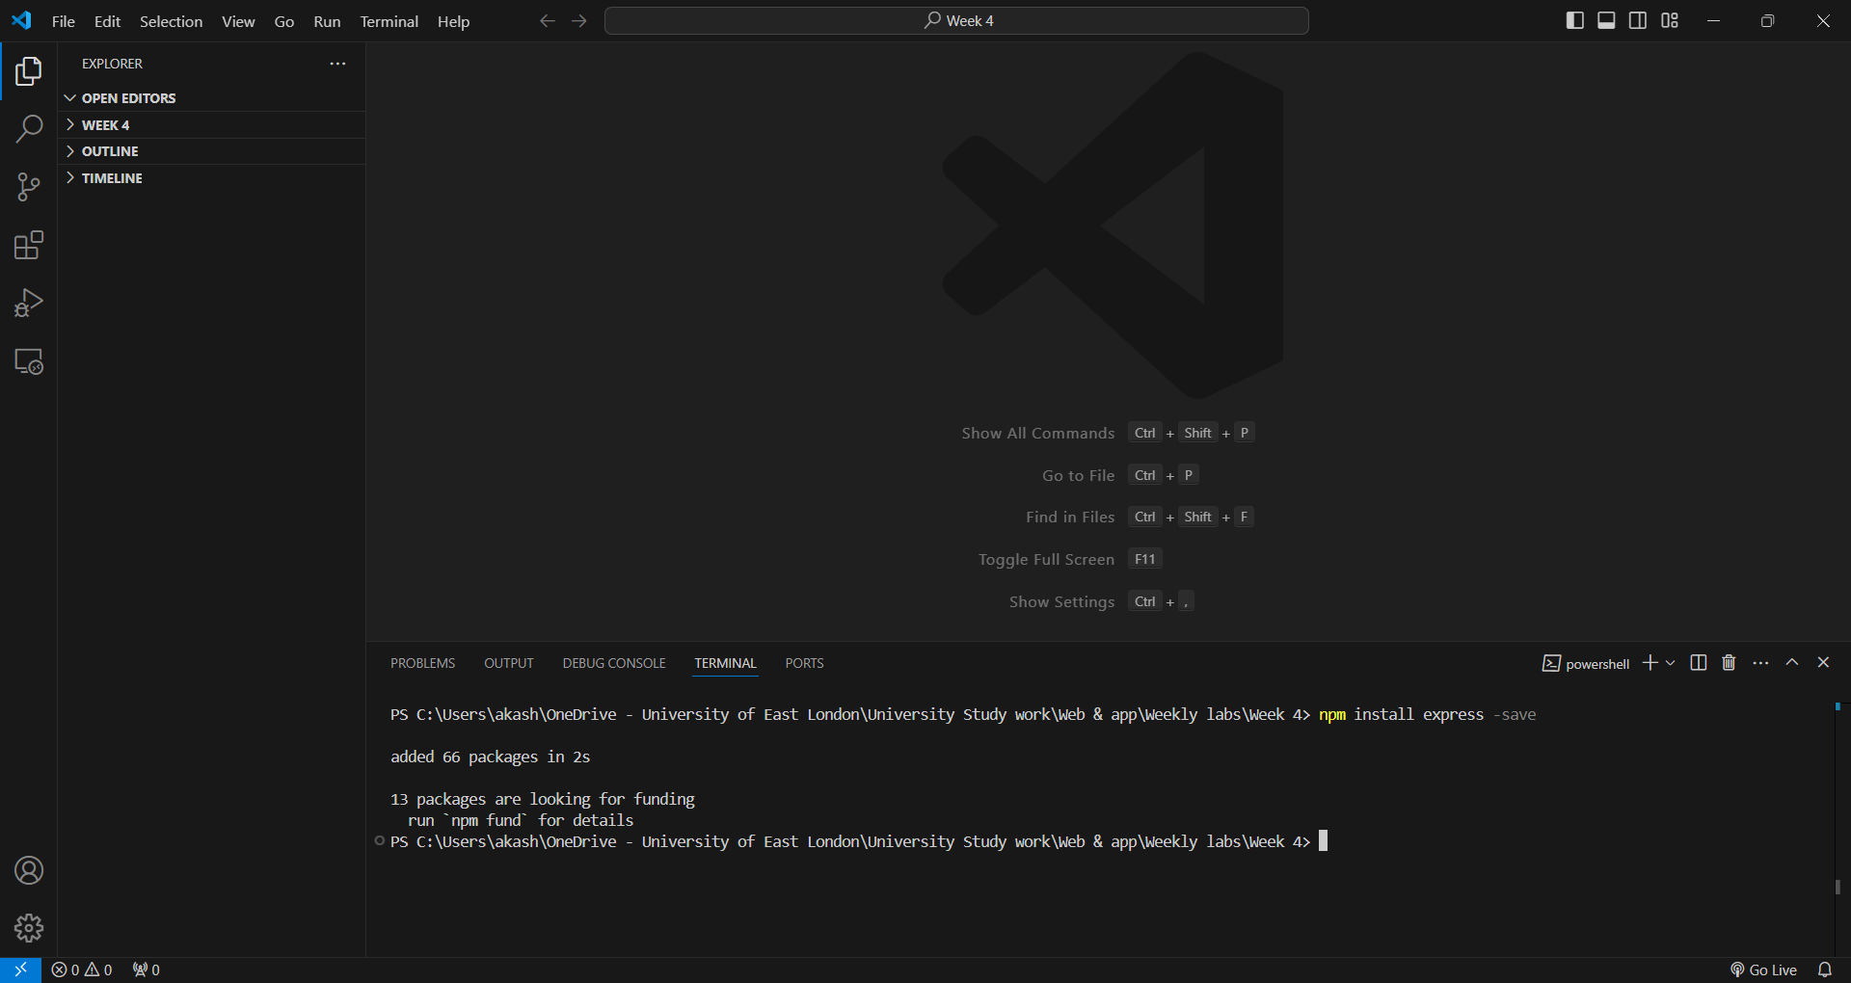

Exercise 1:

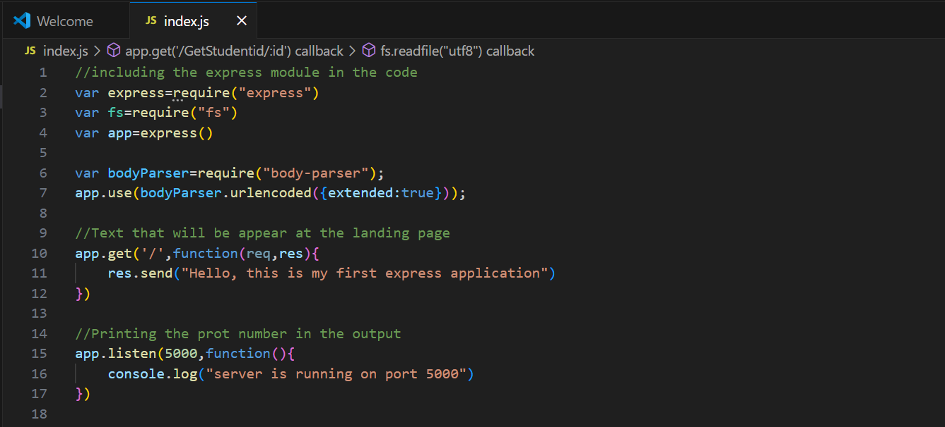

* The output of the code will be:

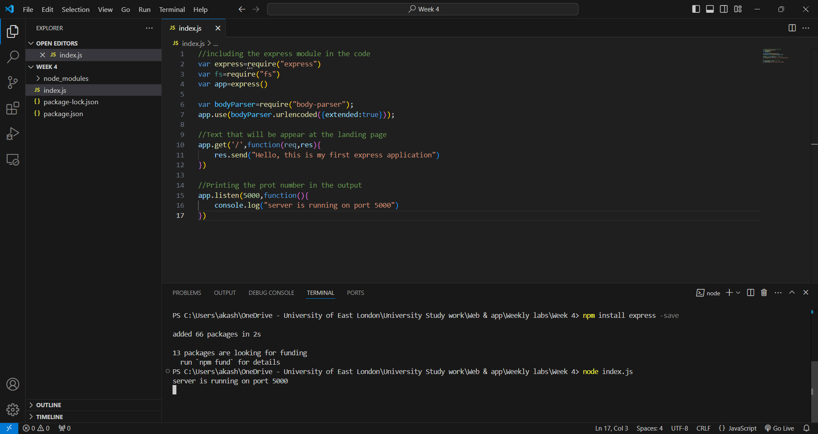

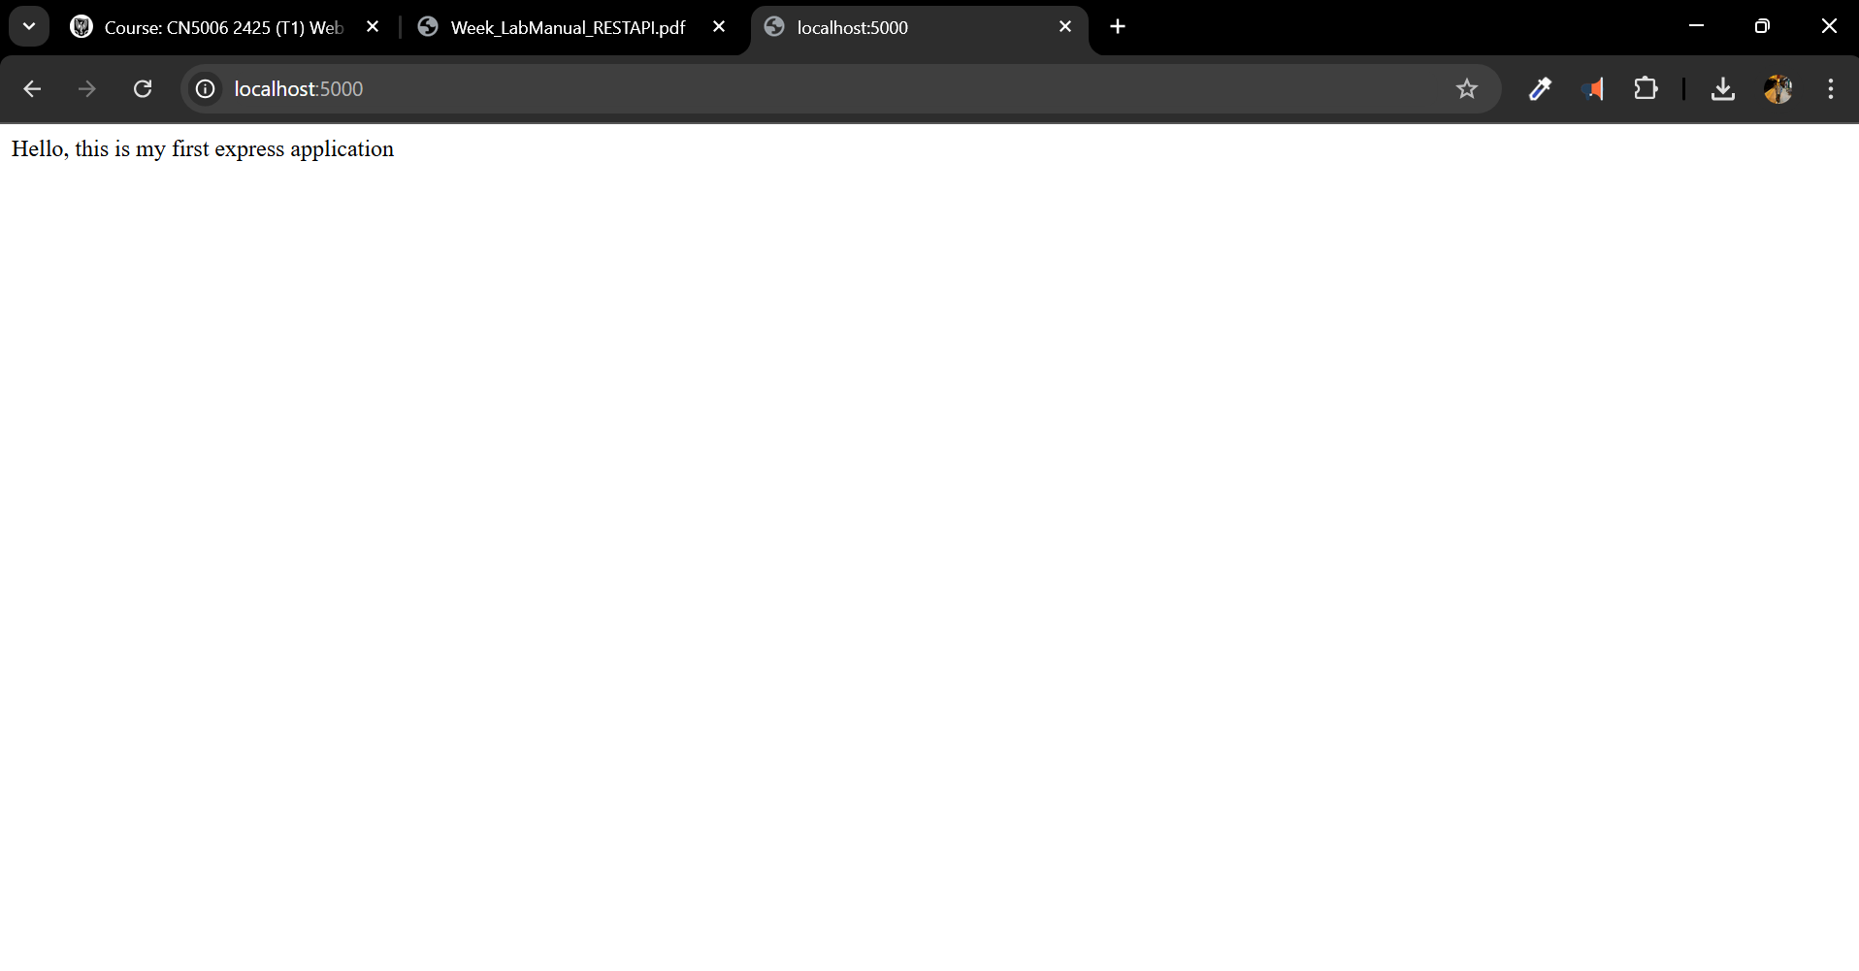

Exercise 2:

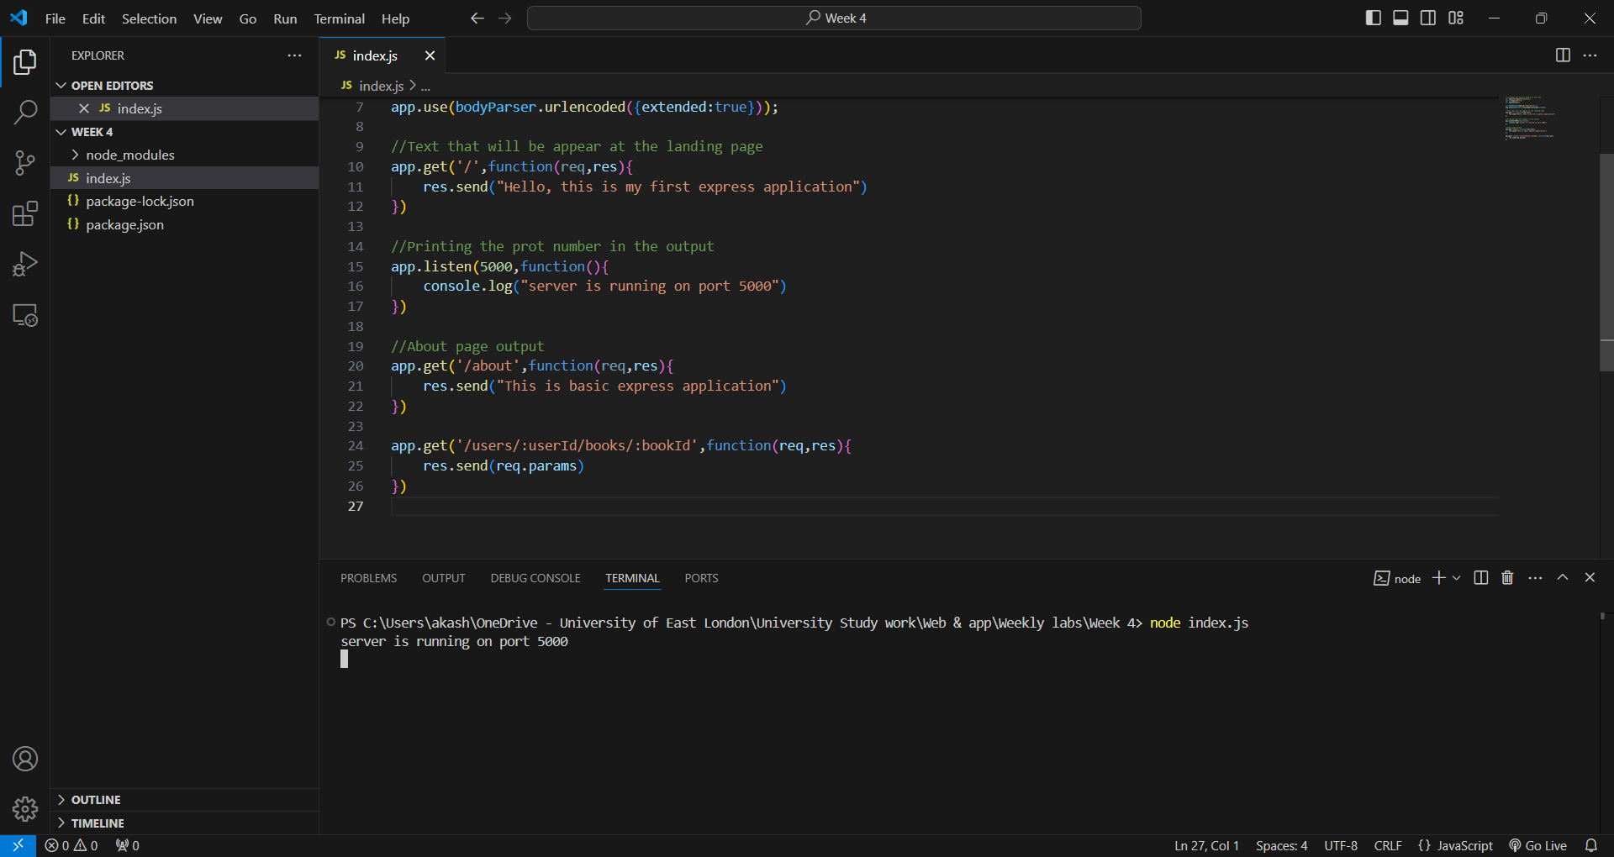

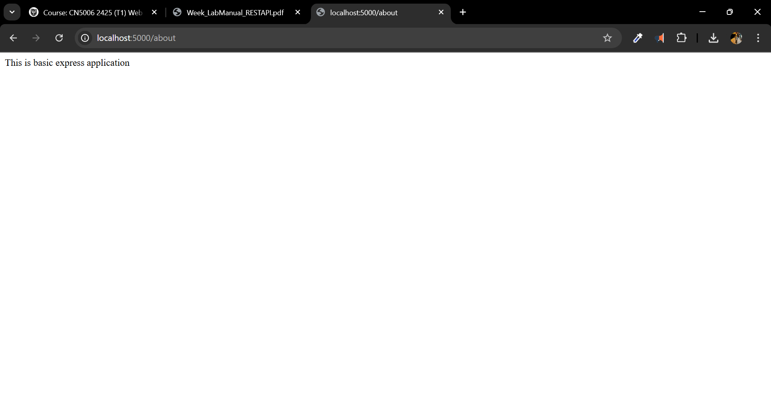

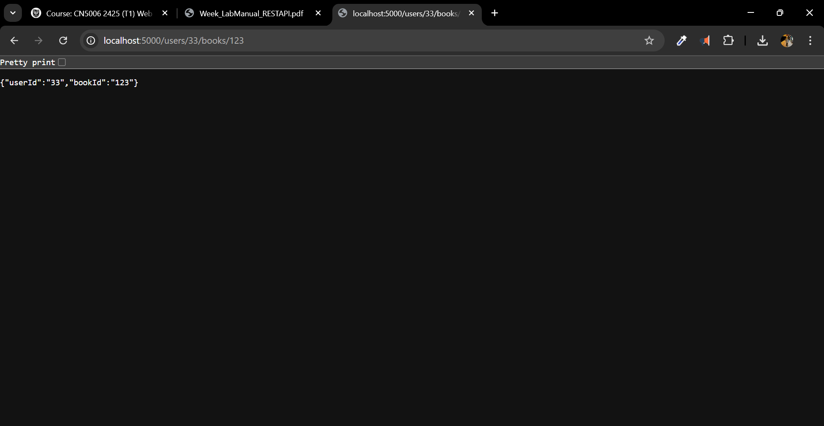

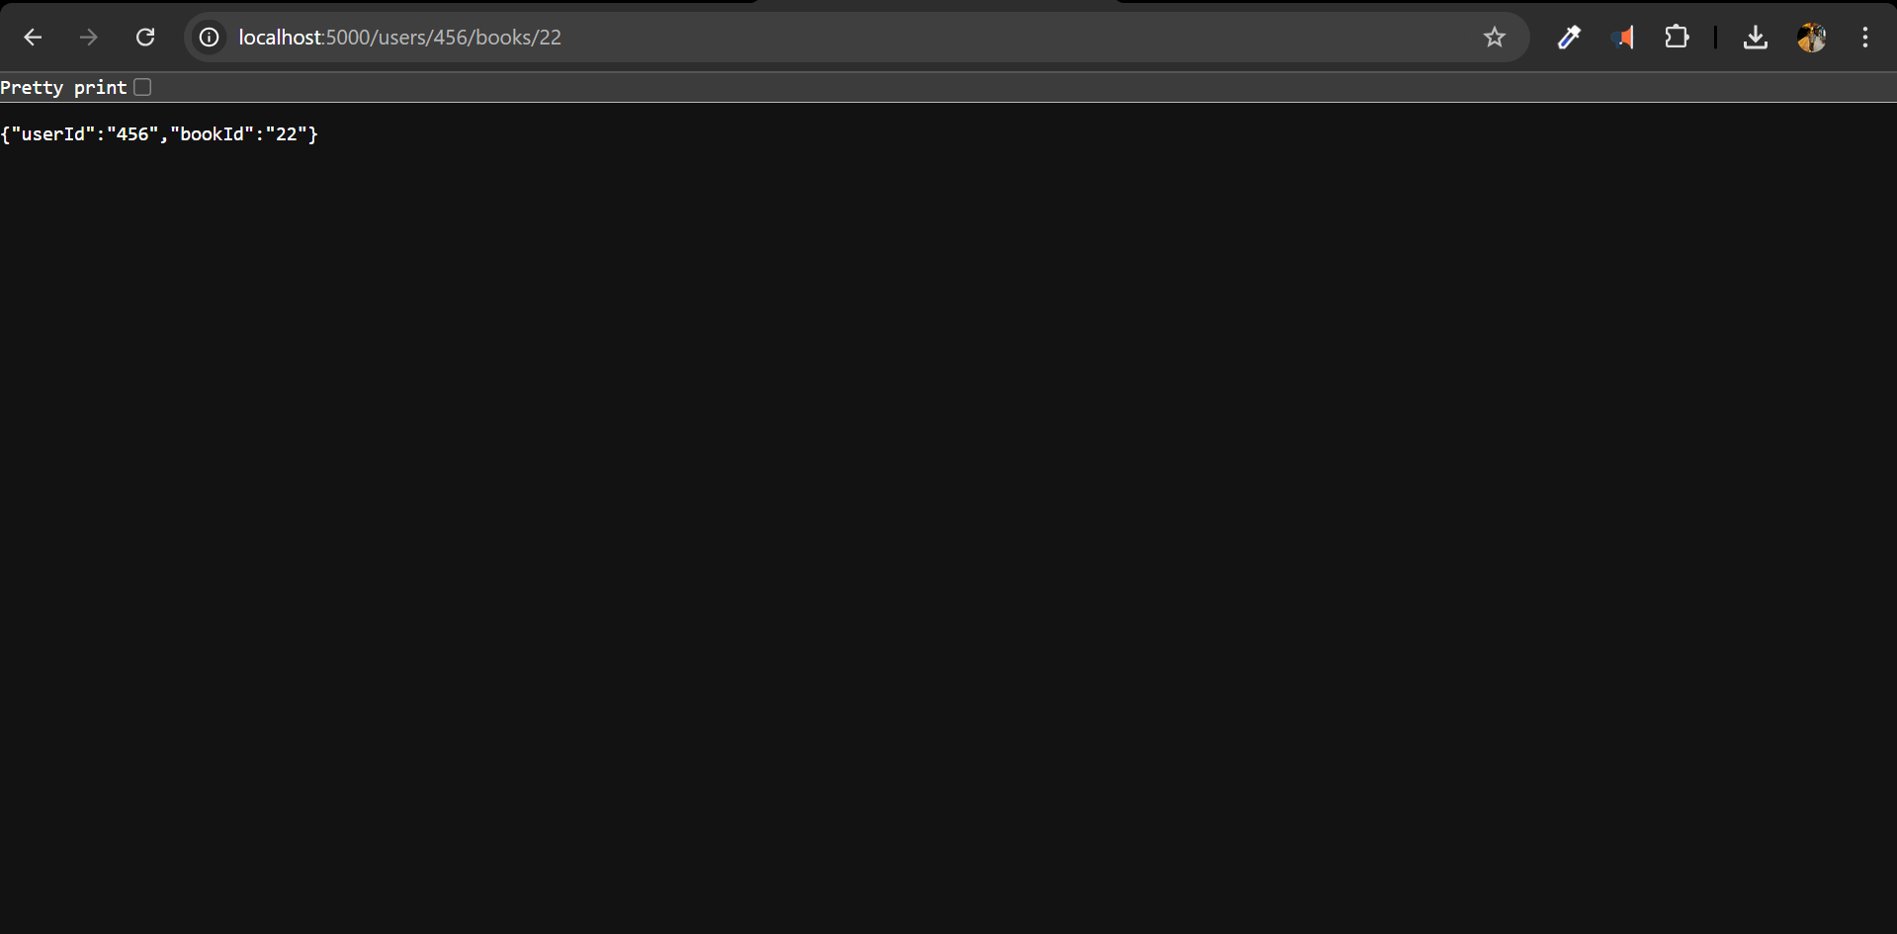

Exercise 3:

* In this exercise we will create a student.json file in which we will add data of the students.

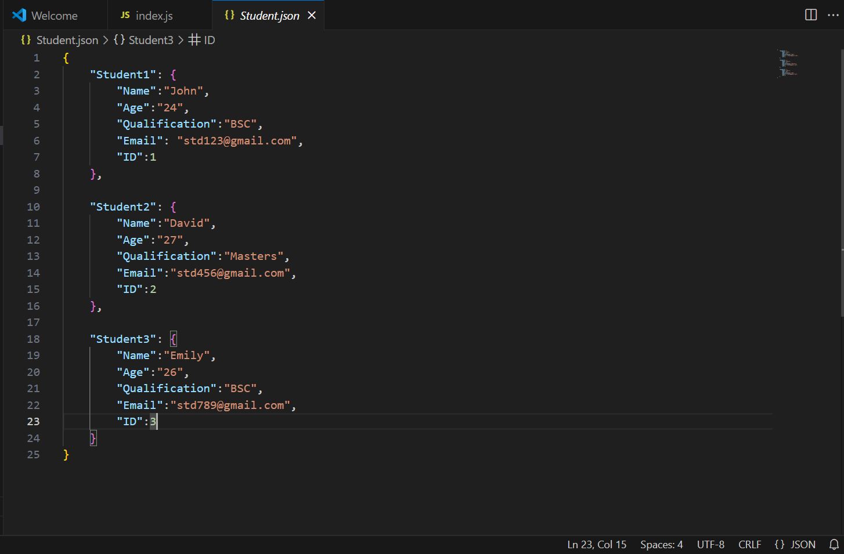

* Now, we will call the json file into the index.js file

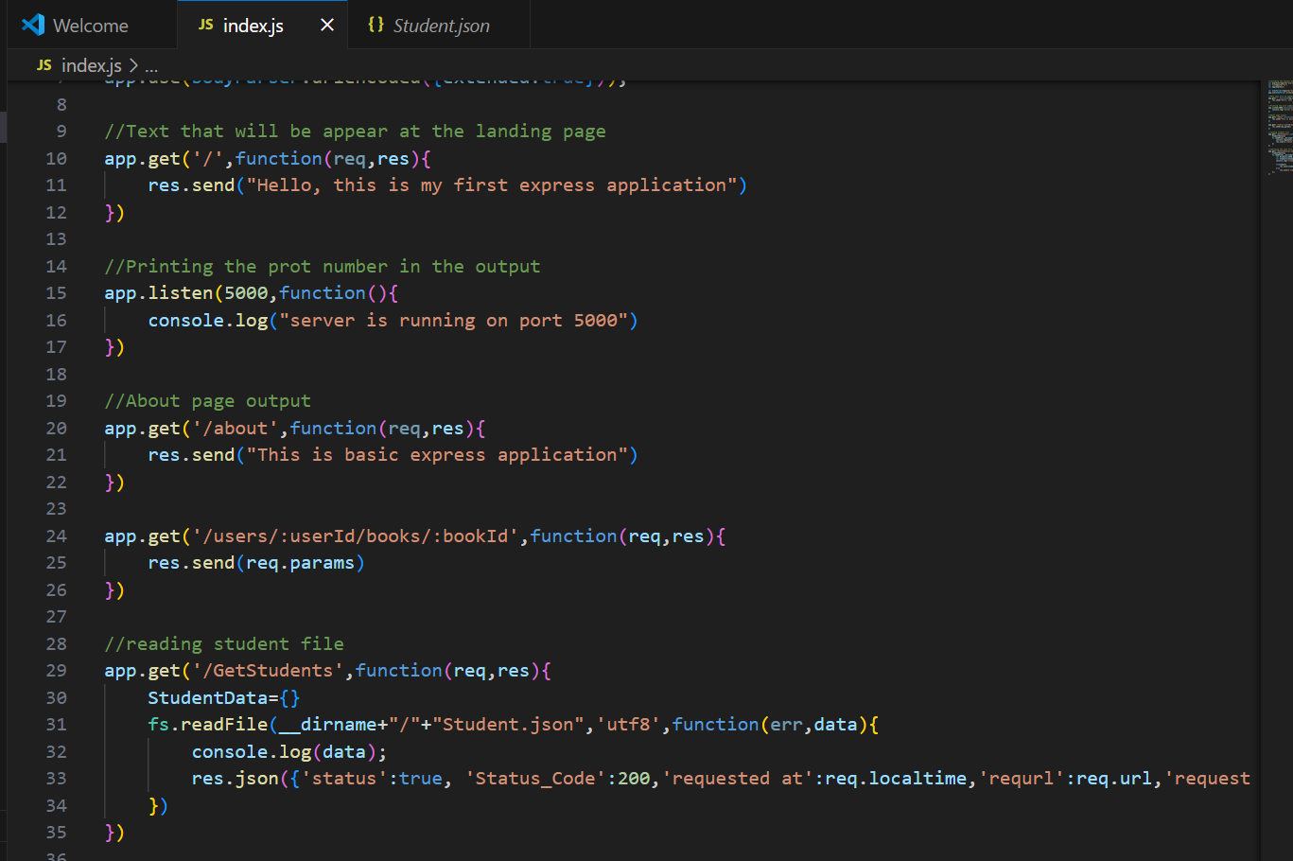

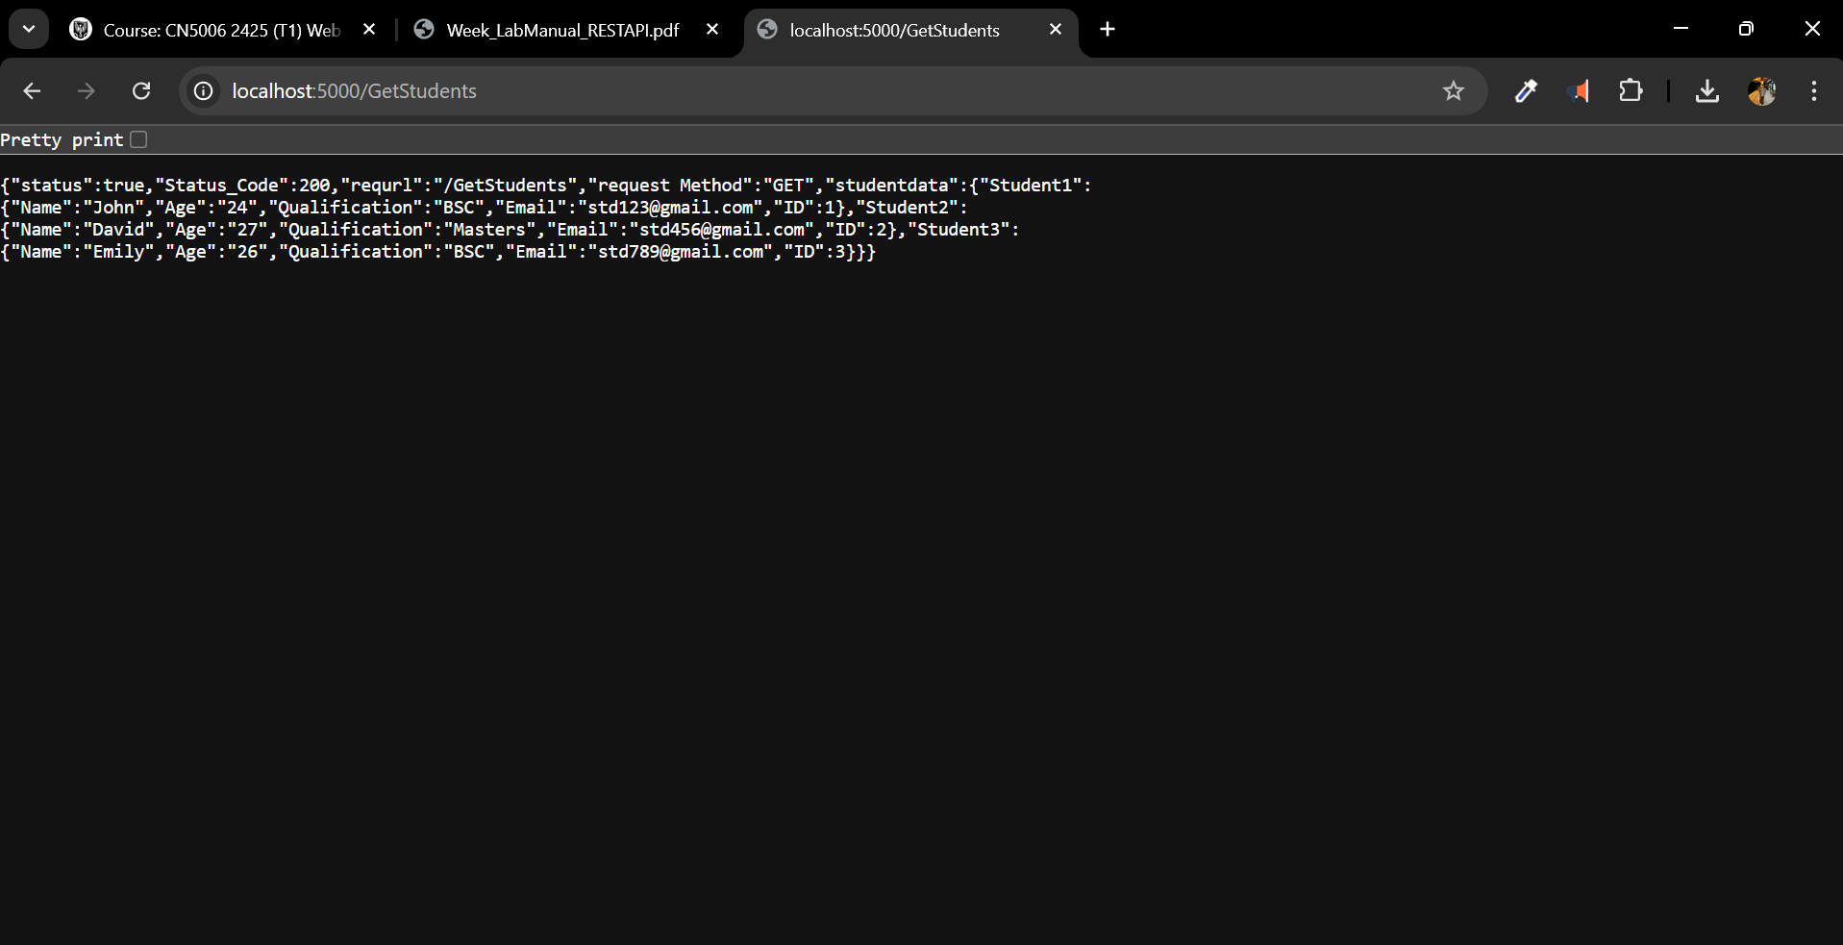

* We will now incorporate the code that enables us to search for students:

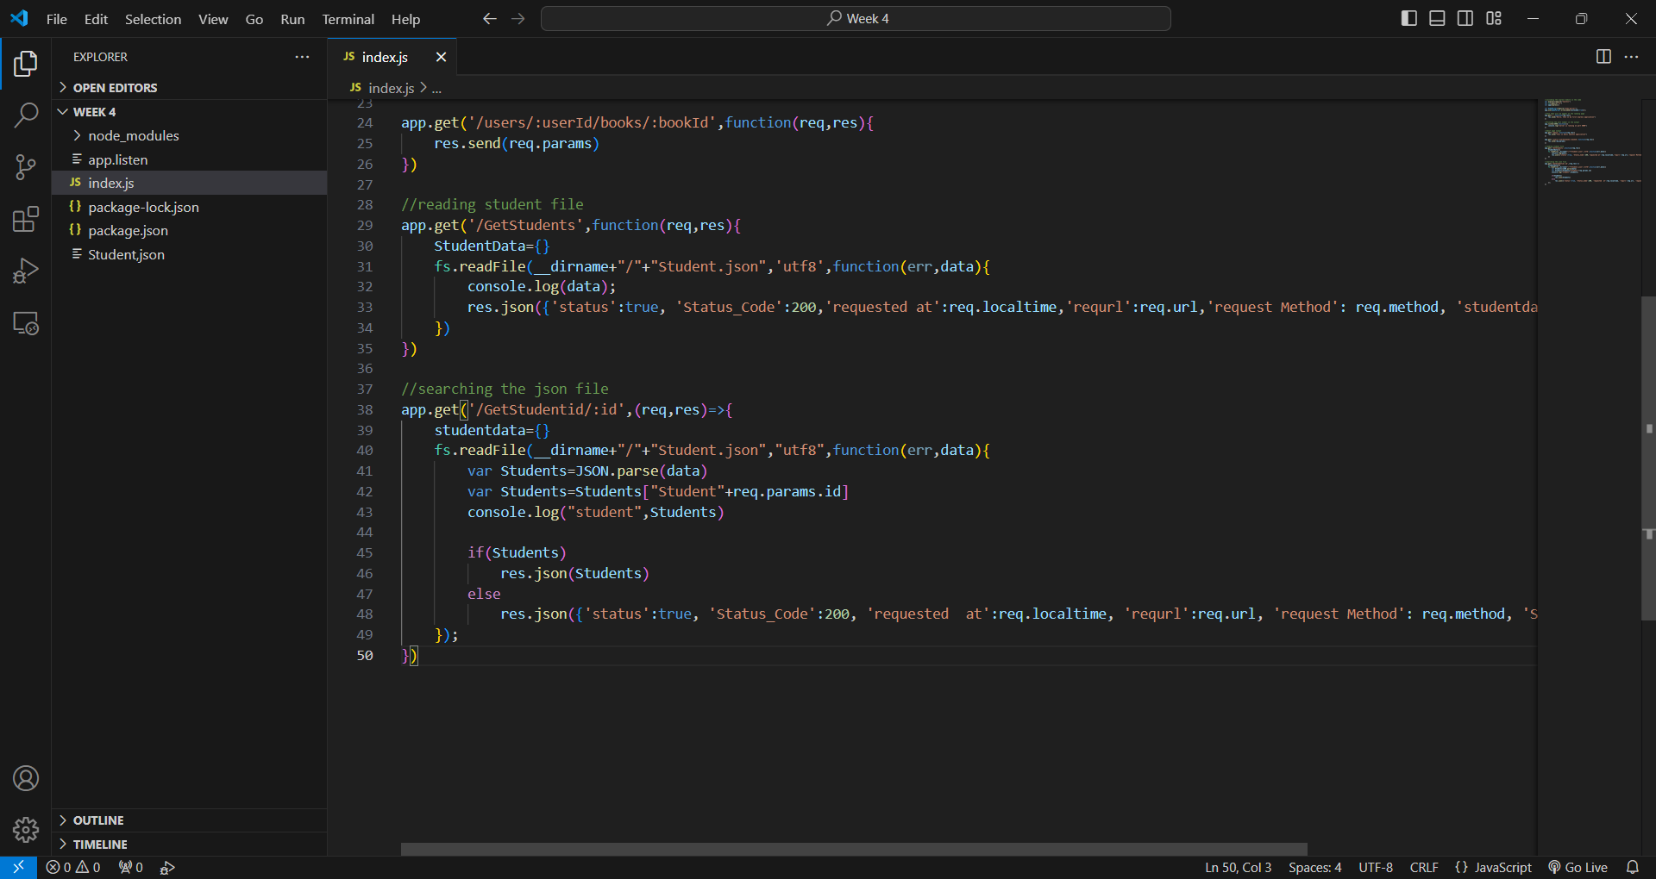

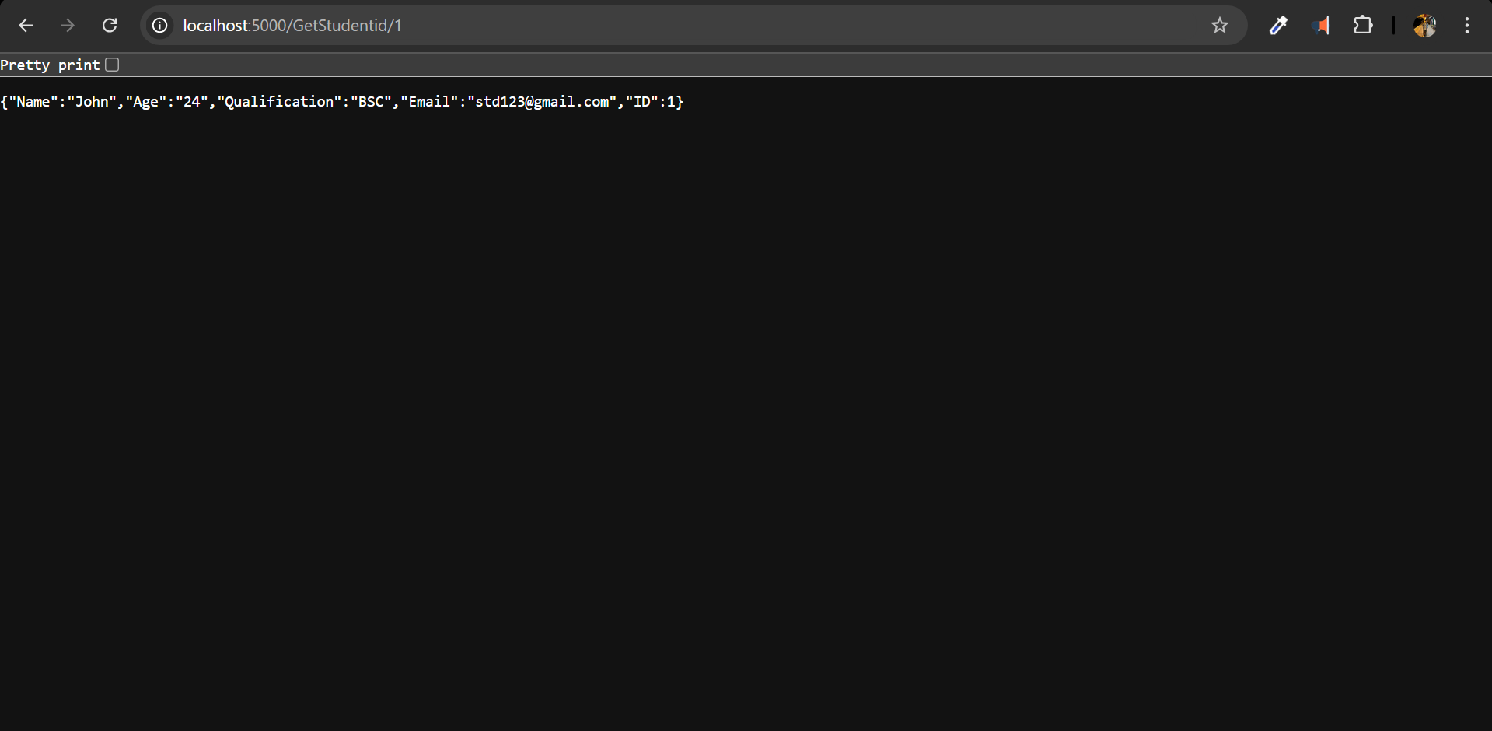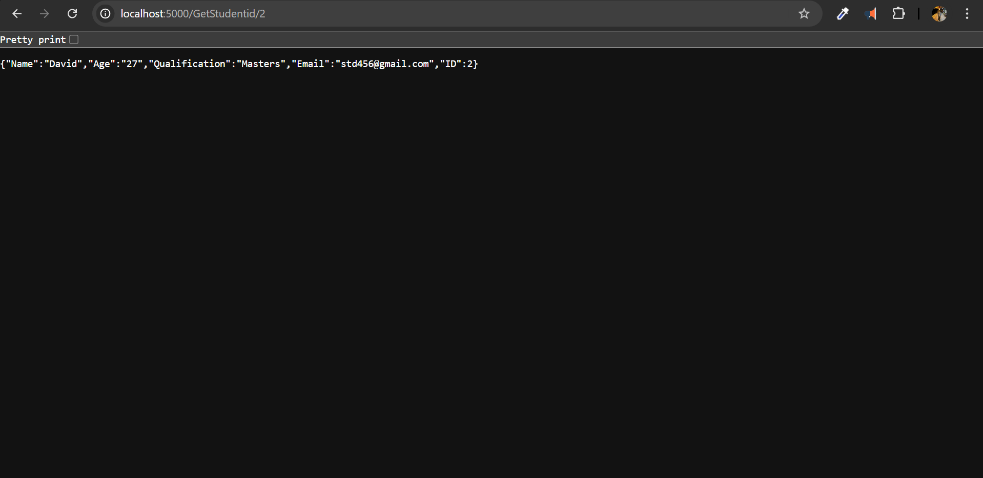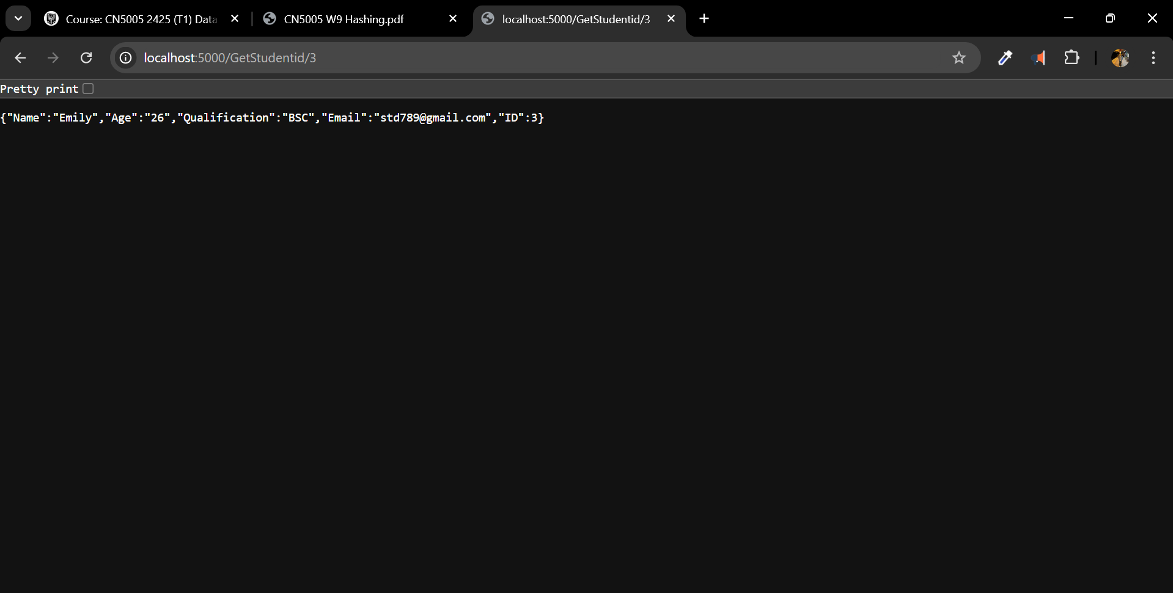

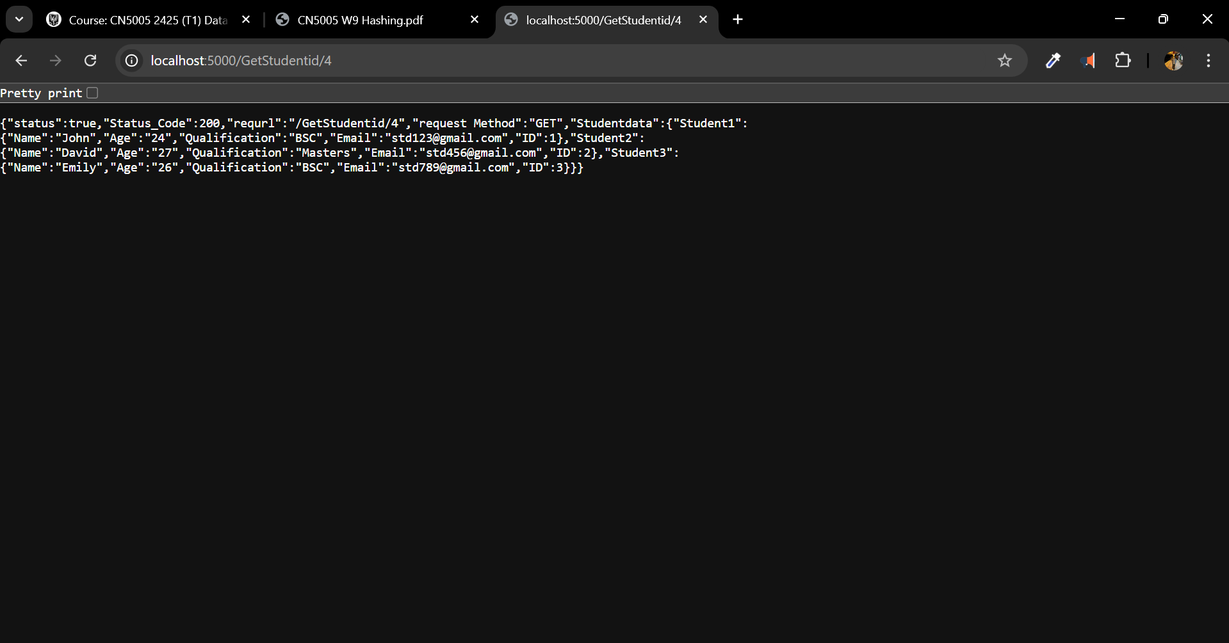

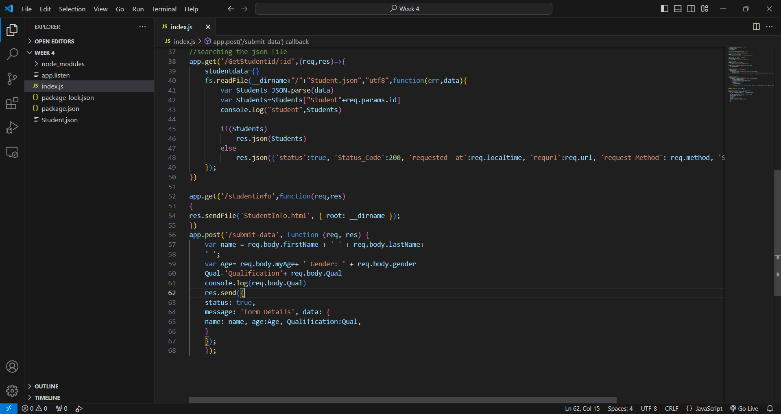

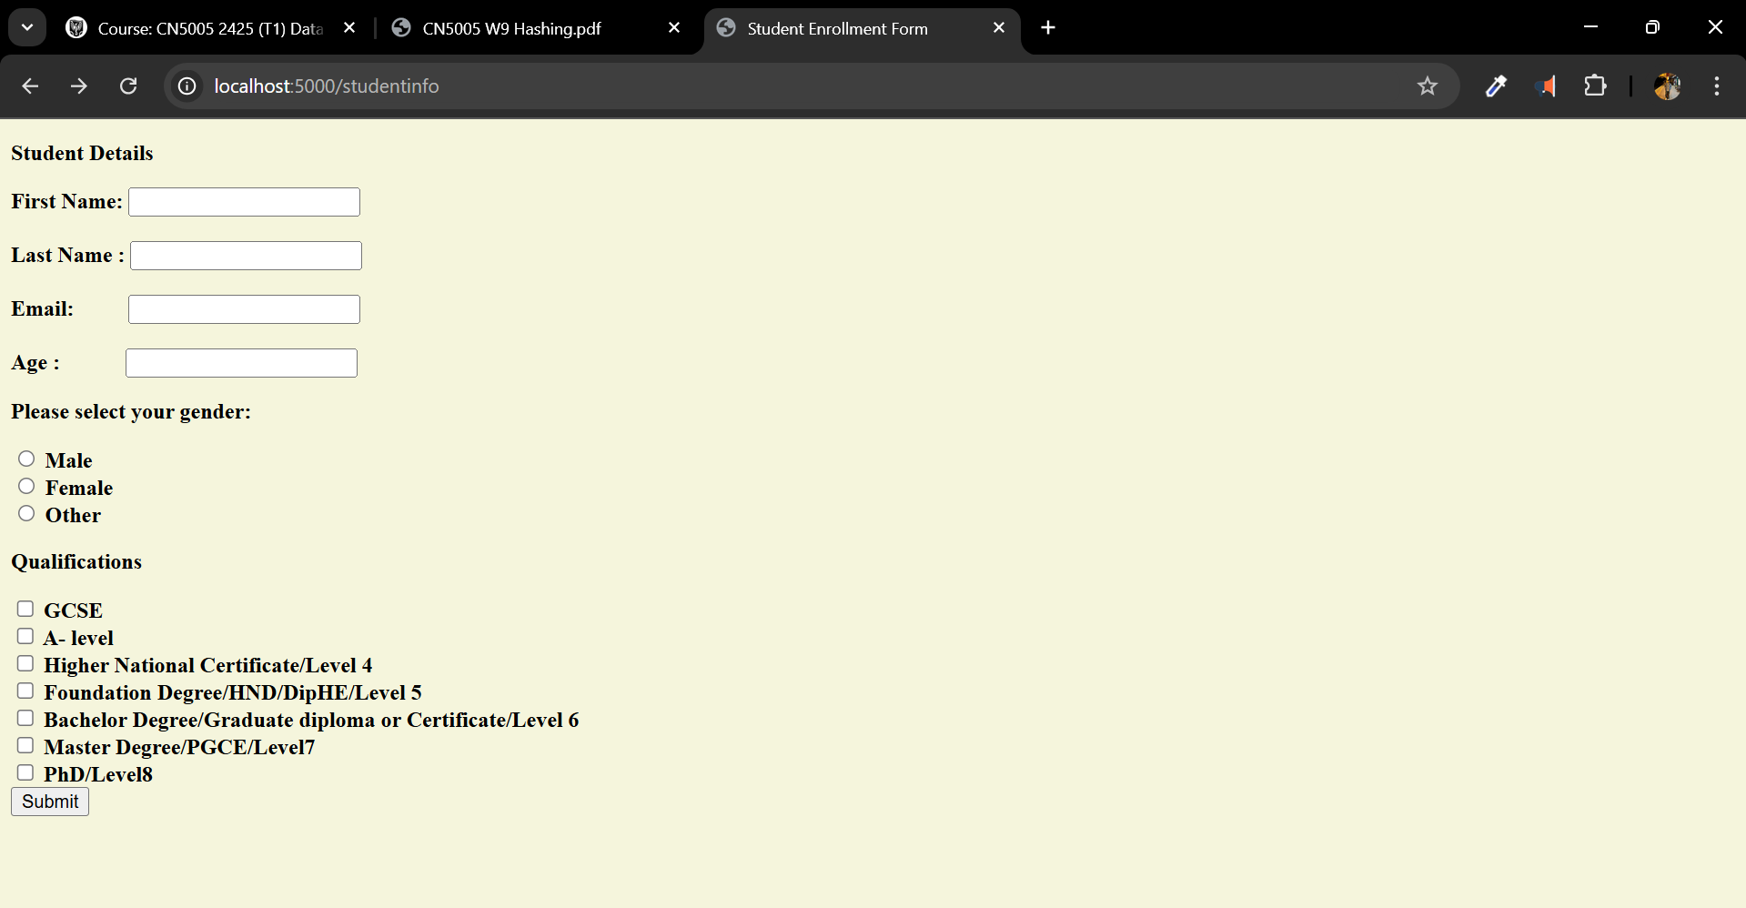

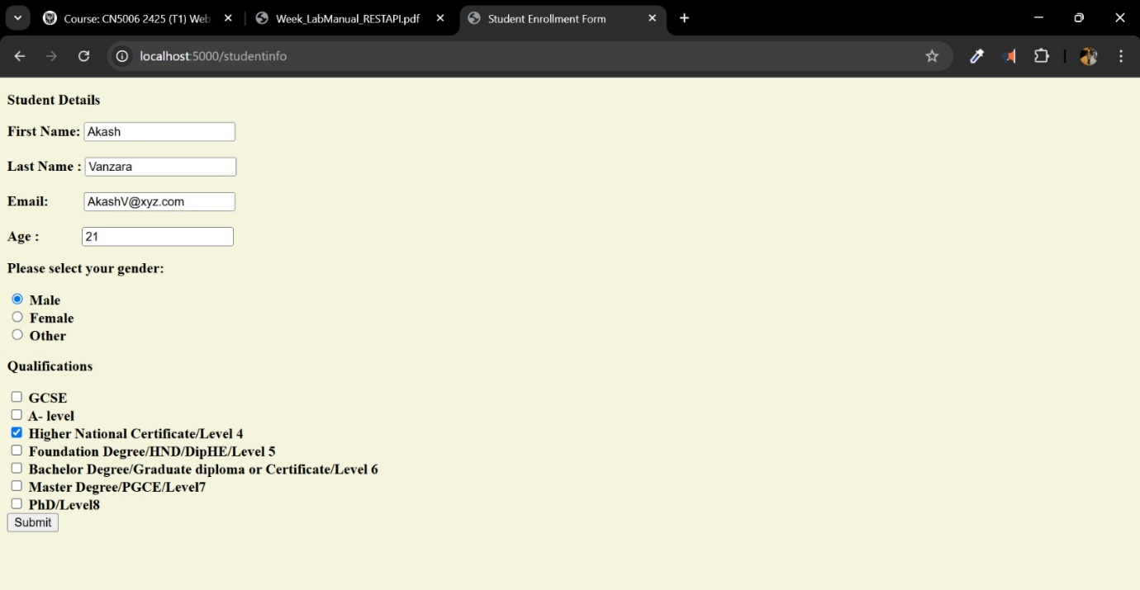

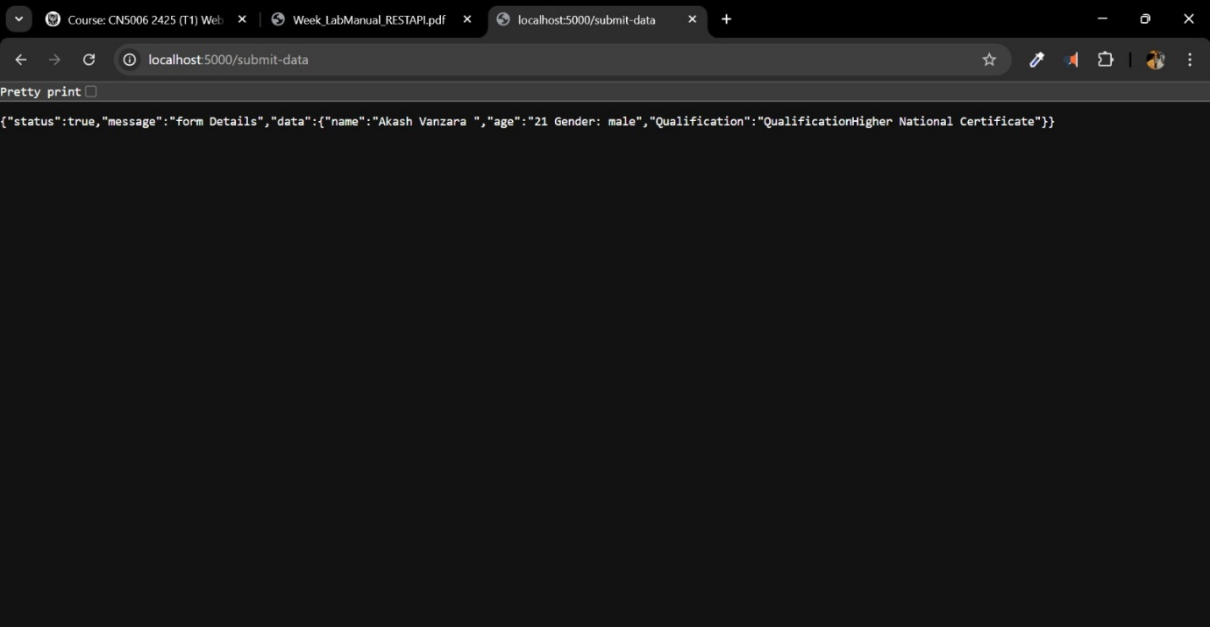

Challenge faced:

Not everything went well. I learned troubleshooting from two mistakes. First, my code failed to run: “Cannot find module 'express'”. It took some Googling to figure out that I had neglected installing the Express package! Just typing npm install express in the terminal fixed it. JSON file loading caused another difficulty. I was confused by a “Unexpected token” problem. I found an additional comma in my JSON file. Removing the comma fixed everything, and I learnt how sensitive JSON is to little errors.

Reflection:

This week, I have significantly advanced my comprehension of API functionality and the capabilities of Express for web application development. Previously, my comprehension of REST APIs was superficial; however, I now possess the knowledge to establish routes, manage parameters, and read files from the server. The blunders I experienced were, in fact, significant learning opportunities. They prompted me to verify the particulars and instilled greater confidence in my debugging abilities.

https://github.com/u2524845/CN5006-week4.git

# Weekly Reflection: Week 5 - Introduction to React

This week, we are developing a React application. Initially, we will verify the installation of Node.js on our PC. Subsequently, we will establish a directory named “React work” under our week 5 folder for CN5006. We will provide a npx command for this purpose.

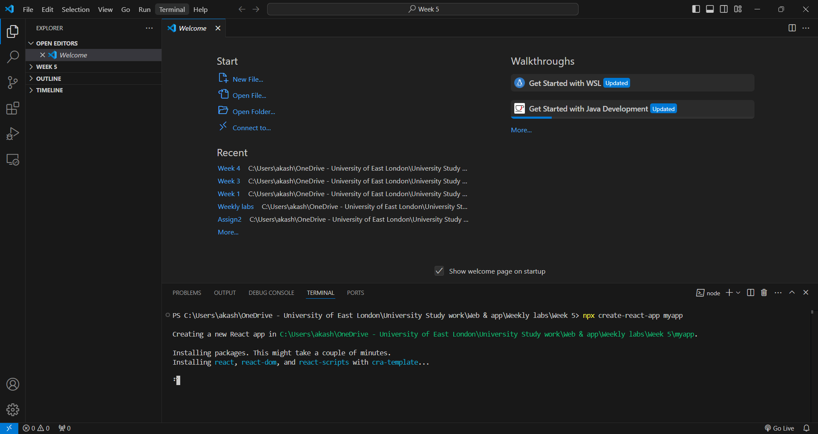

* After the creation of myapp, we will navigate to the myapp directory using the cd command and execute the npm start command.

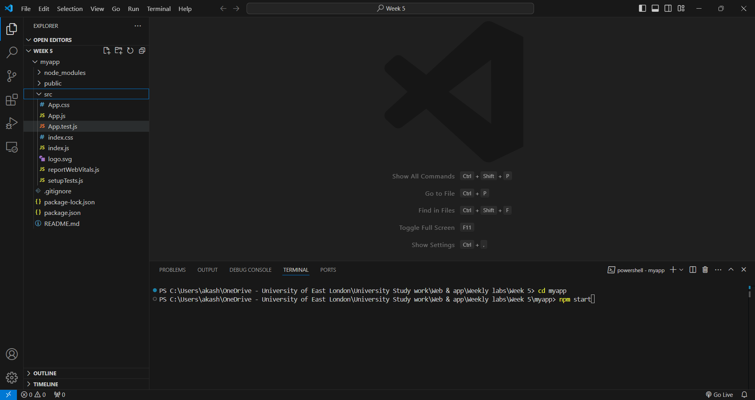

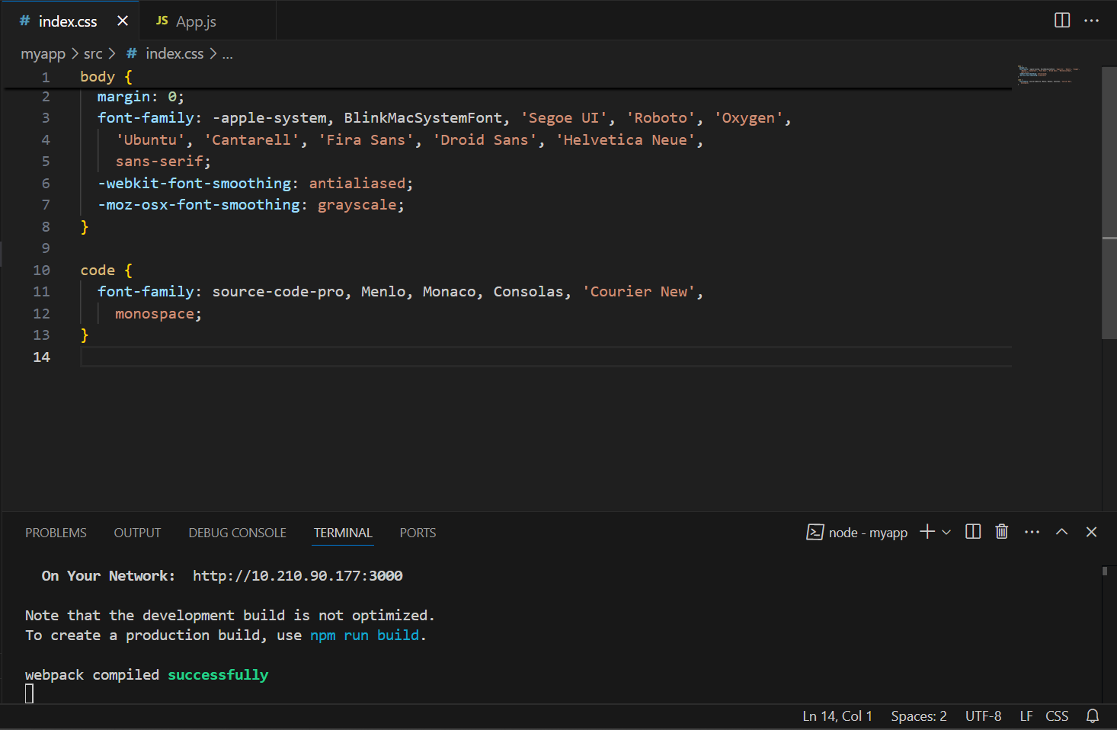

* We will execute the provided code, which will get the subsequent output:

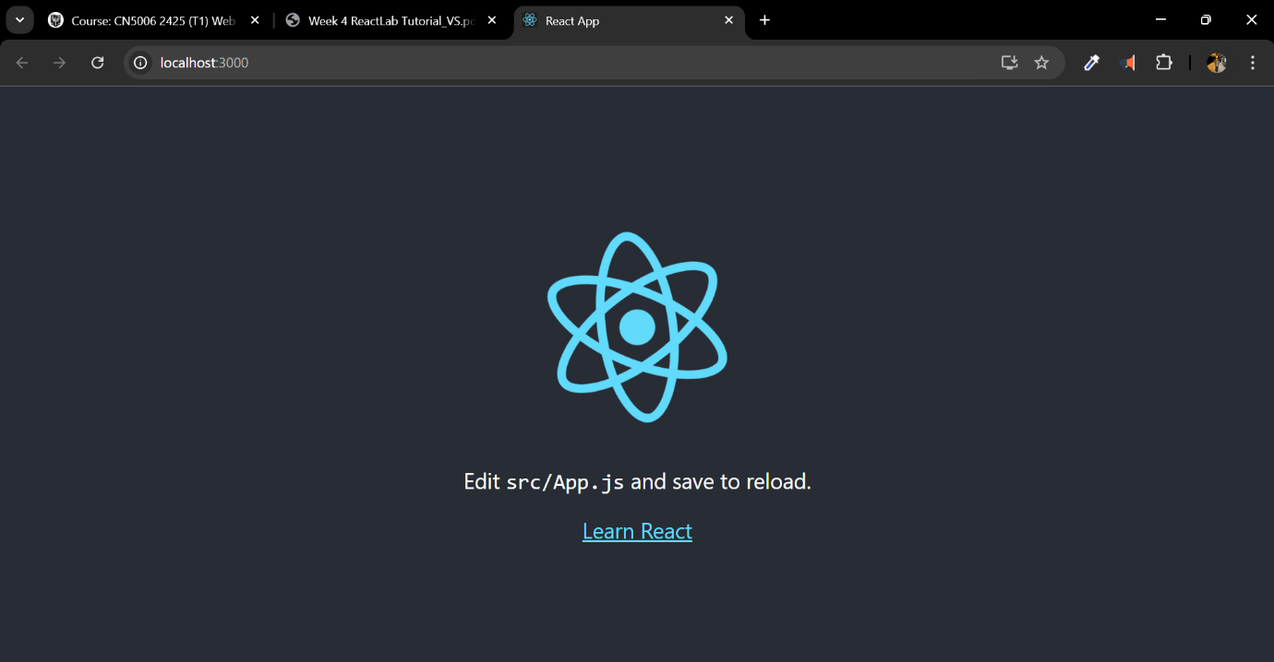

Task 1:

* We will modify the code to alter the output text.

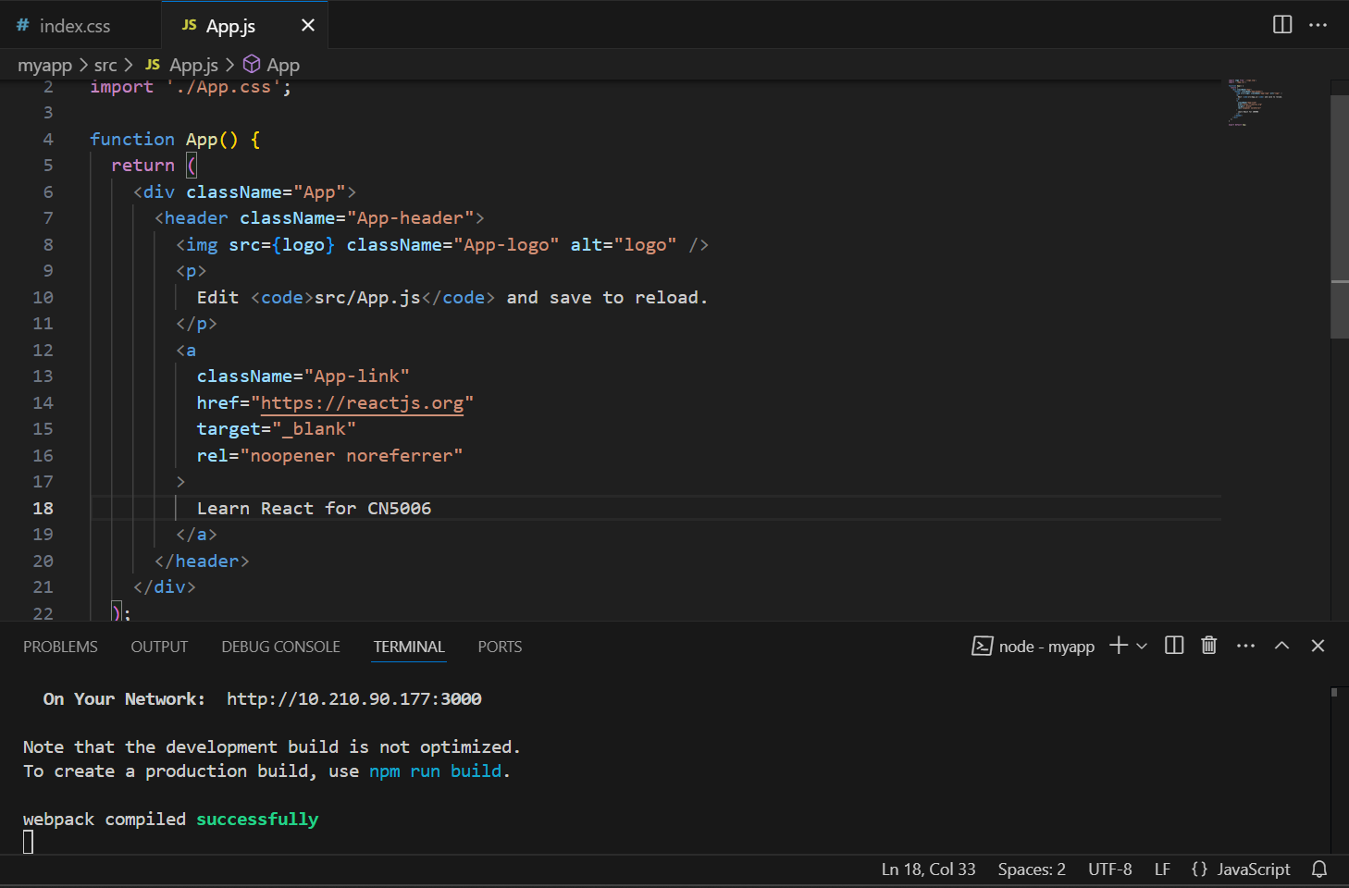 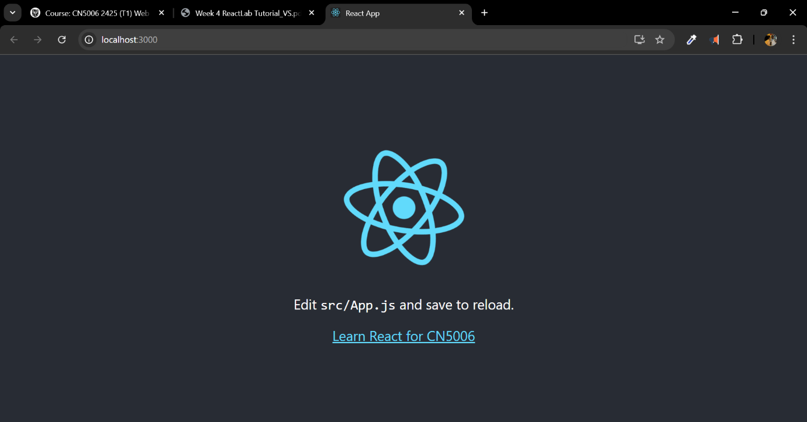

Task 2:

* We will now alter the background color by modifying the color code in the app's CSS file:

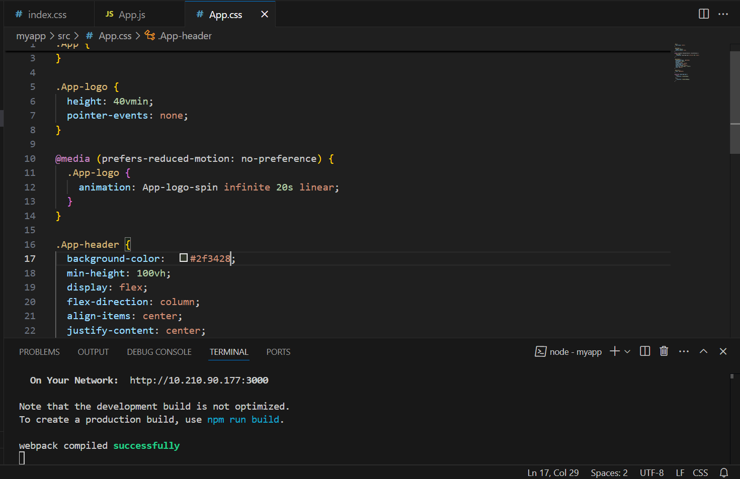

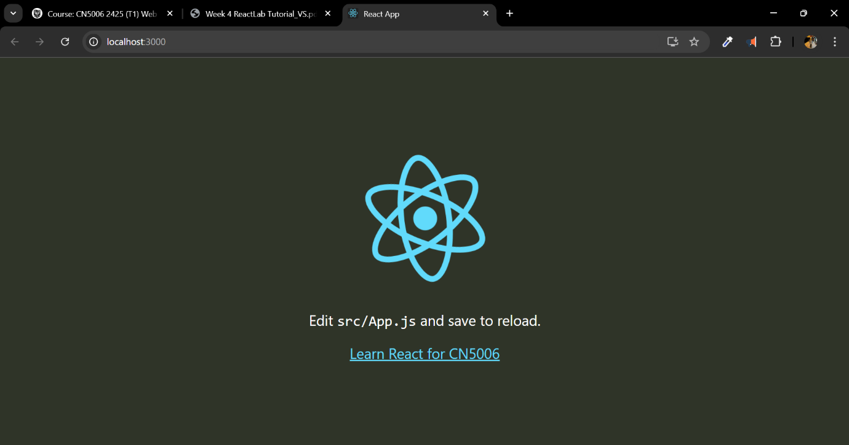

Task 3:

* We will develop a mygreetingapp for this assignment as specified in the lab job document.

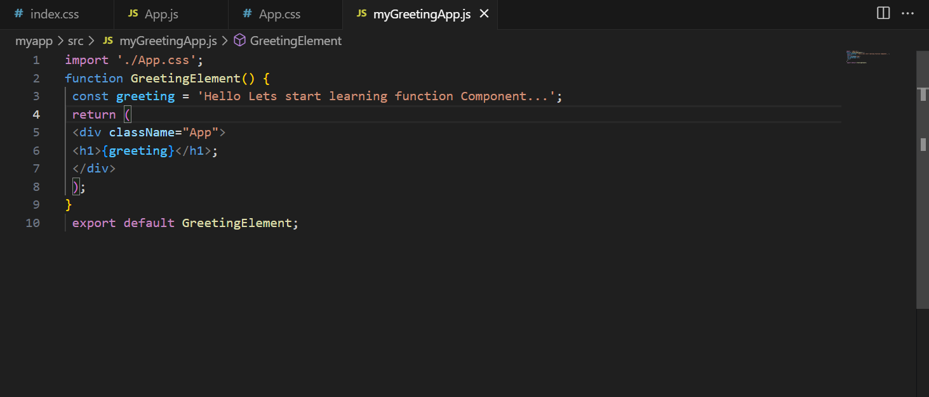

* We will now import this file into the index by inserting the import code in the index.js file:

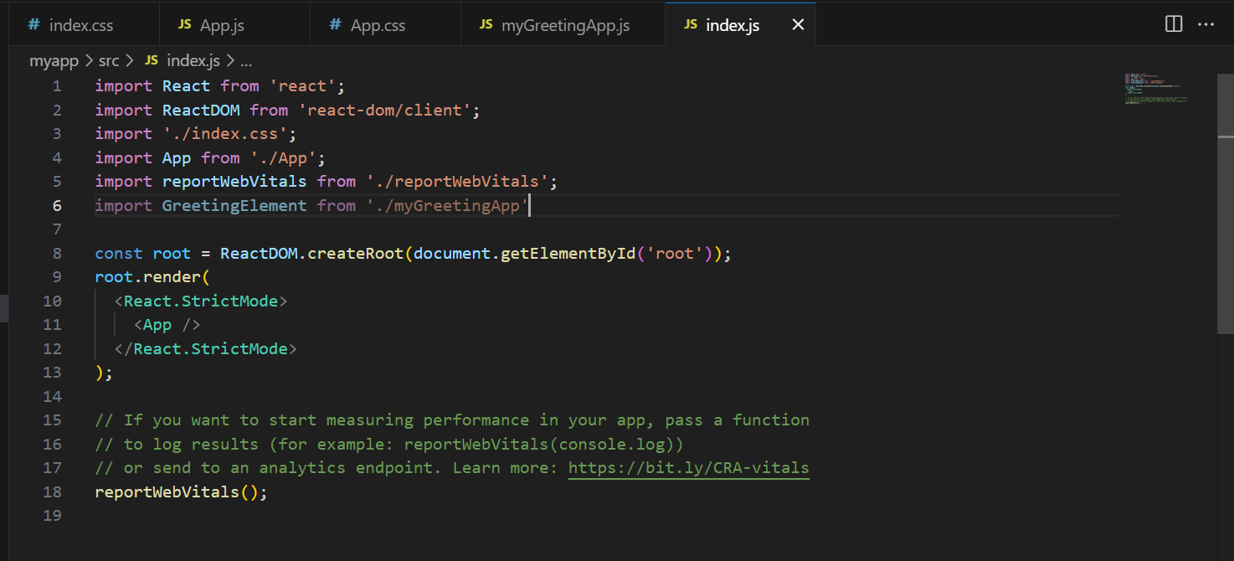

* We will now eliminate the app tag from the index file as directed in the instructional file:

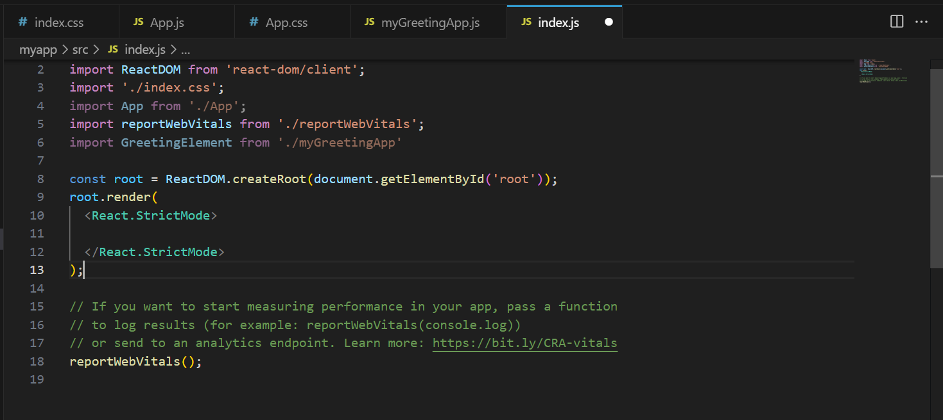

* We shall instead compose the GreetingElement tab:

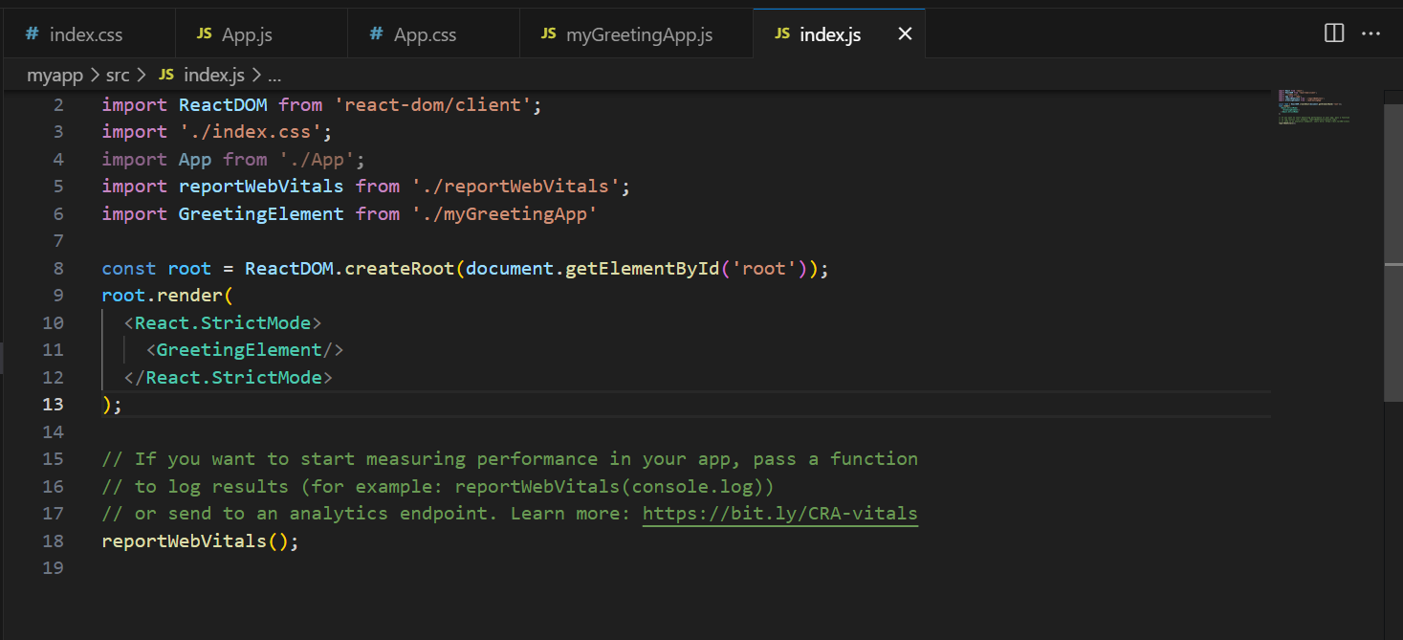

* This is the appearance of our output in the browser:

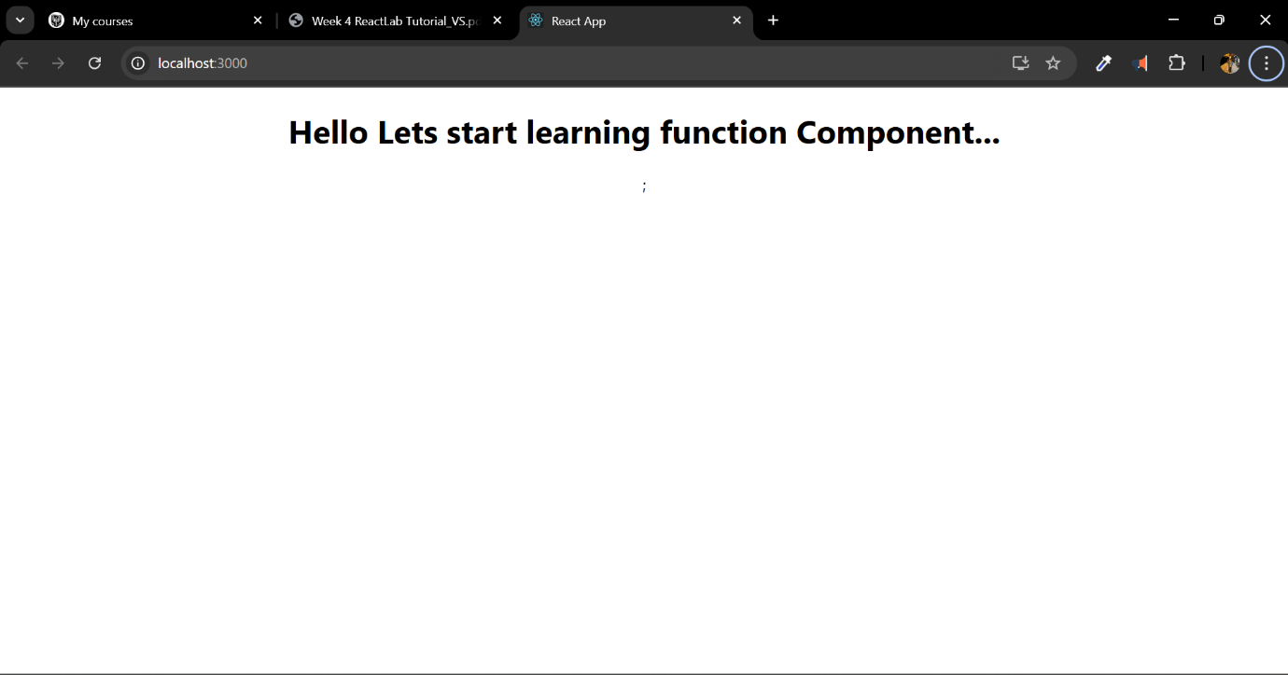

Task 4:

* We will now create a file titled mygreetingprop.js and input the code from this week's lab guide.

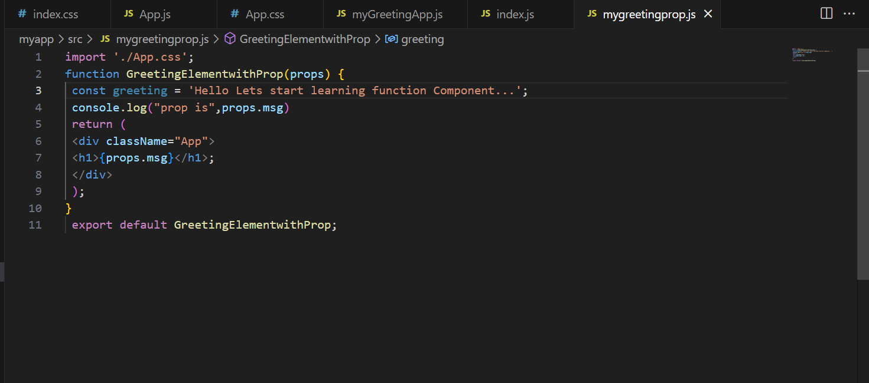

* As with the last file, we will import this file into the index.js file and subsequently create a tag for it.

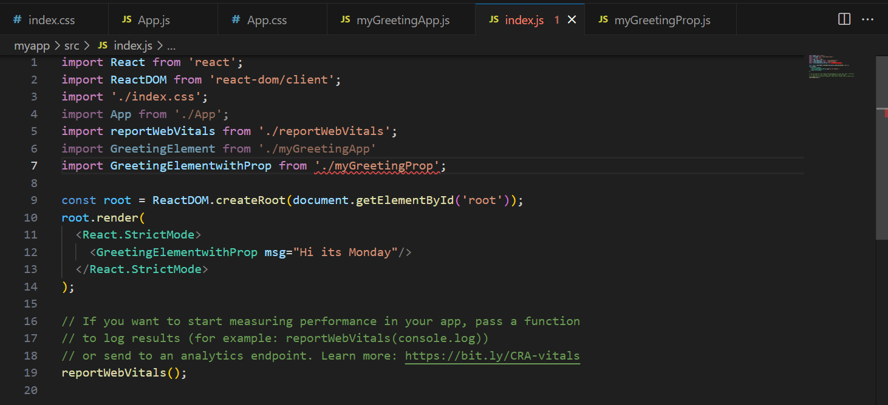

* It will give us the following results as a result:

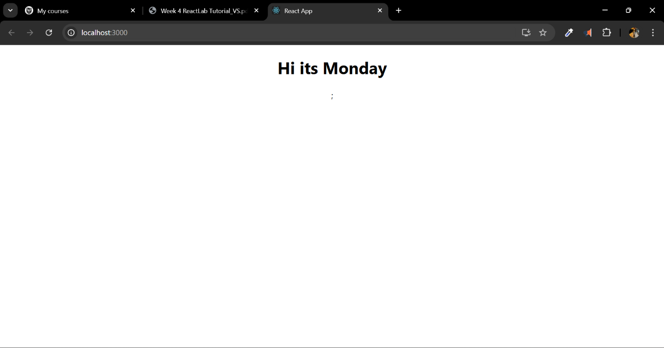

Task 5:

* To generate greetings for the whole week, we will replicate the greeting line for Monday and thereafter modify the day name in the duplicated lines to correspond with the appropriate day.
* and it will provide the following output:

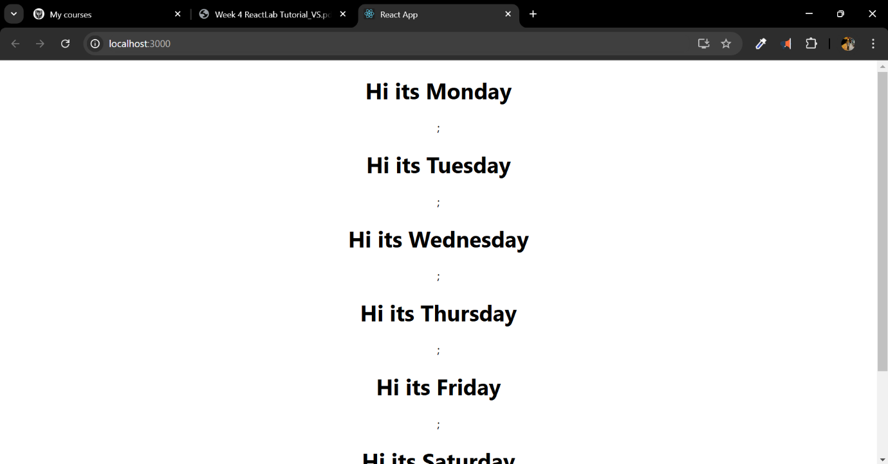

Task 6:

We will now create a file named appbackgroundcolour that will alter the background color.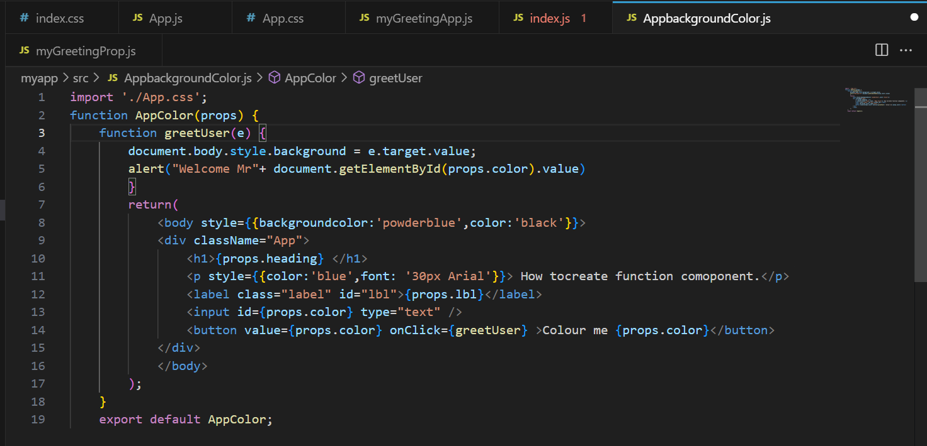

* We will now import the file into the index file and thereafter implement the modifications as performed in the prior tasks:

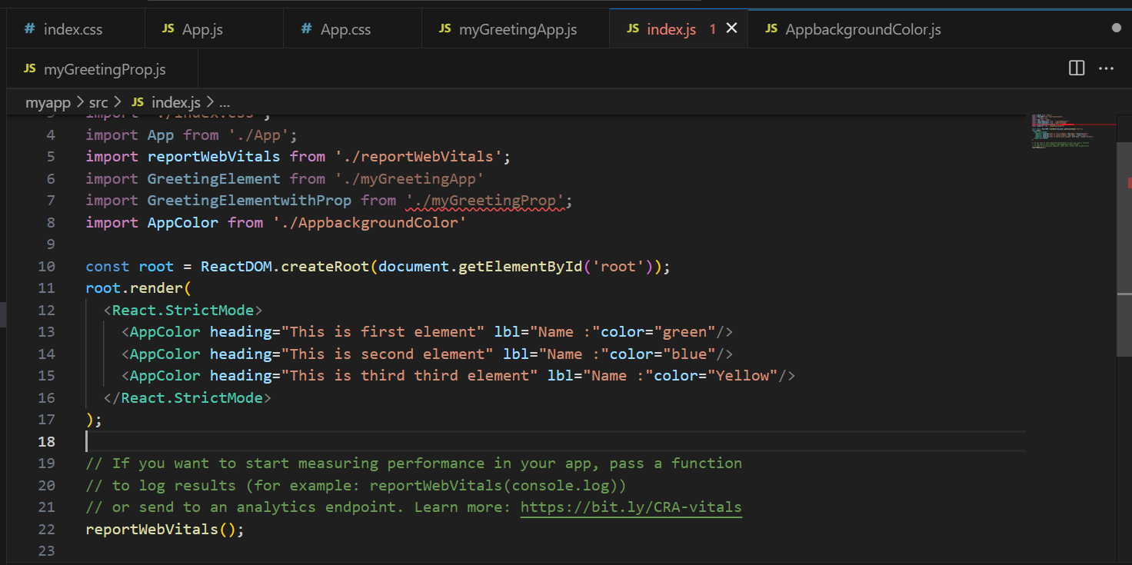

We will now proceed to the question-and-answer section.

1. What is React

Ans: React is an open-source JavaScript library developed by Facebook. It facilitates the development of user interfaces, particularly for single-page apps.

1. What do you understand by React component and what command do you use to create a React component with or without property

Ans: React component is reusable data that defines a part of user interface. When creating React component for with property we use “**function** MyComponent() { **return** Hello, World!; }” and for without property we use “**function** MyComponent(props) { **return** <h1>Hello, {props.name}</h1>; }”.

1. What command will you use to render the the newly created component named as MyReact?

Ans: ReactDOM.render(<MyReact />, document.getElementById('root'));

4. Suppose the MyReact Component has a property heading, write down the code that could be used to render the MYReact Component, and pass the message to the property heading as “this is my first element”

Ans: ReactDOM.render( <MyReact heading="this is my first element" />, document.getElementById('root') );

5. Observe this code and answer the questions below

6. <AppColor heading="This is first element" lbl ="Name :" color="green"/>

a. What is the name of the React Component

b. How many properties this component uses

Ans:

a) AppColor

b) Three: heading, lbl, and color

7. Look at the following Code: function GreetingElementwithProp(props) { return (

**Wellcome , {props.studentname}**

;

); } export default ??????

what will you write to make this export this function correctly? Hint you need to replace ?????? with the correct word.

Add a function that takes two properties as numbers ,add these numbers on the click event of the button and display the sum. Hint you will be using in jsx

Ans: To export default: **export** **default** GreetingElementwithProp;

To a function that takes two properties as numbers:

**function** AddNumbers(props) { **const** [sum, setSum] = React.useState(0);

**function** handleClick() { setSum(props.num1 + props.num2); }

**return** ( <div> <button onClick={handleClick}>Add Numbers</button> <p>Sum: {sum}</p> </div> ); }

To add these numbers on the click event of the button and display the sum:

<AddNumbers num1={5} num2={3} />

* After the application was operational, I examined React's component-oriented architecture. It was intriguing to observe how a singular application may be segmented into autonomous, reusable components. I began by altering App.js to edit the text displayed in my application. This seems straightforward, however it effectively illustrated the dynamic nature of React. Upon updating the message from “Learn React” to “Learn React in CN5006” and saving, the modification was immediately apparent in the browser without the need for a refresh. This automatic updating functionality effectively demonstrated the efficiency of React.
* I experimented with interactive components by designing buttons that could alter the backdrop color. Each button corresponded to a distinct color, and activating a button initiated a function that modified the page's backdrop. This assignment enhanced my understanding of event handling in React and demonstrated the creative application of properties.
* This week illuminated the potential of React and its component-based methodology. React's adept management of modifications and its systematic architecture elucidate its popularity in contemporary web development. Initially, I perceived JSX and the component structure as rather daunting; but, I am beginning to comprehend how these elements integrate to produce adaptable, interactive online apps.

https://github.com/u2524845/CN5006-week5.git

# Week 7 Reflection - Creating Functional React Component using Hook

This week's lab involves creating a functioning component and implementing state management with Hooks. The lesson instructed us on several things.

Task 1: We will initially establish a new React application with the create-react-app command. This will entail establishing a new directory, initializing the React project, and accessing the project folder.

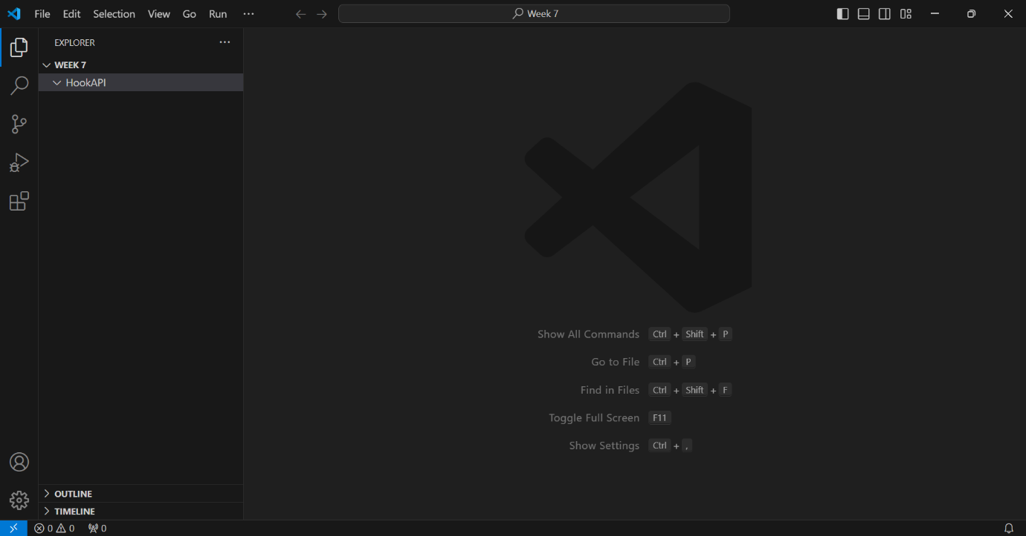

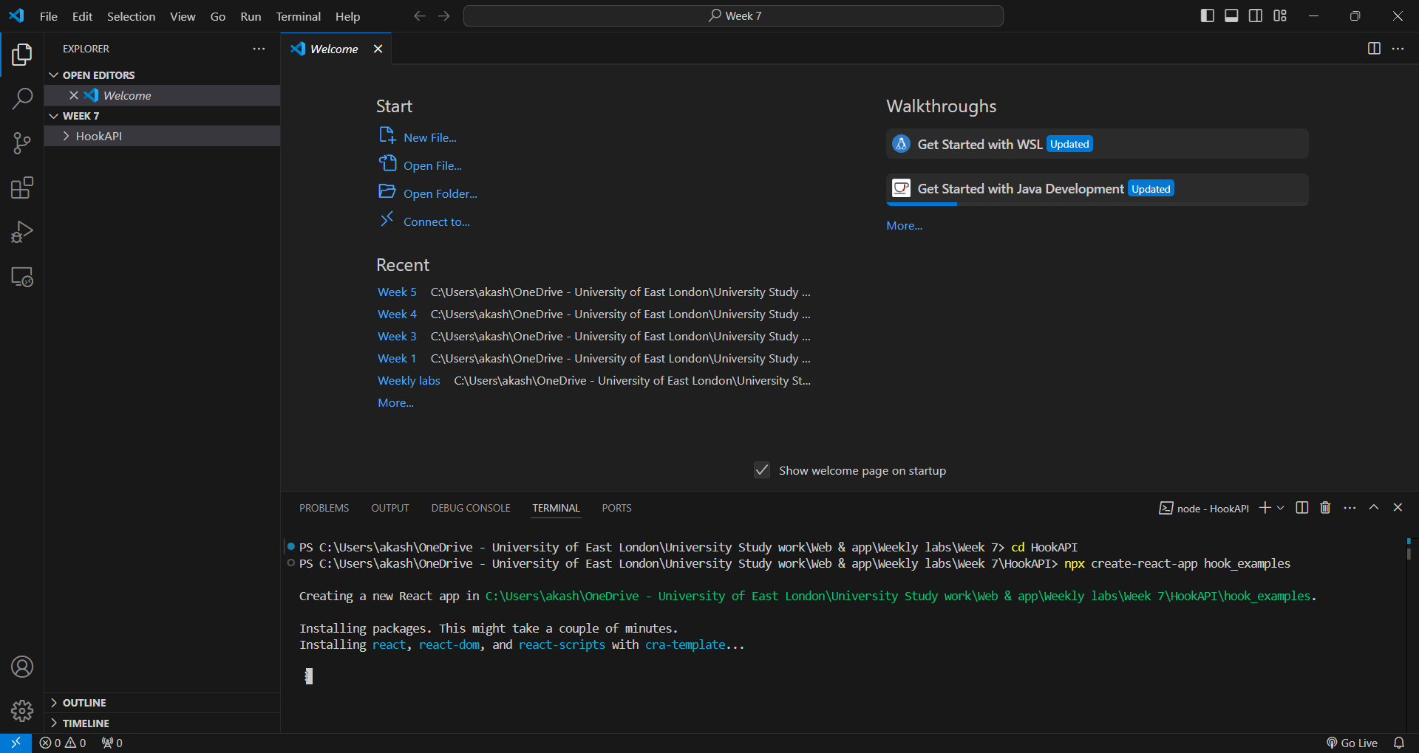

We will now establish a folder titled Counter.js under the src directory:

* We will import React and other files into the new project.
* We will define a function within this file and designate it as Hook_ControlledButtonState. This is the whole component:

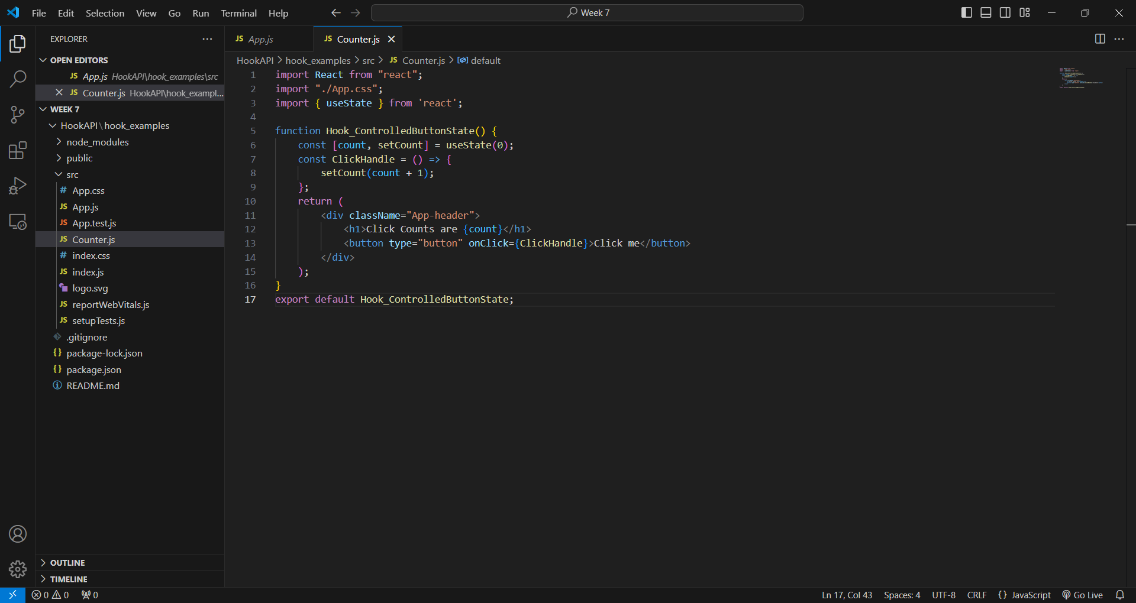

This component does a few things:

* It uses useState to keep track of how many times the button is clicked.
* It has a function called ClickHandle that adds 1 to the count each time the button is clicked.
* It shows the current count and a button to click.

Now we need to add this new component to our index.js file as well:

We saw a page with a button when we ran our app again. The number went up by one every time we pressed the button.How We Made Our Emoji Counter

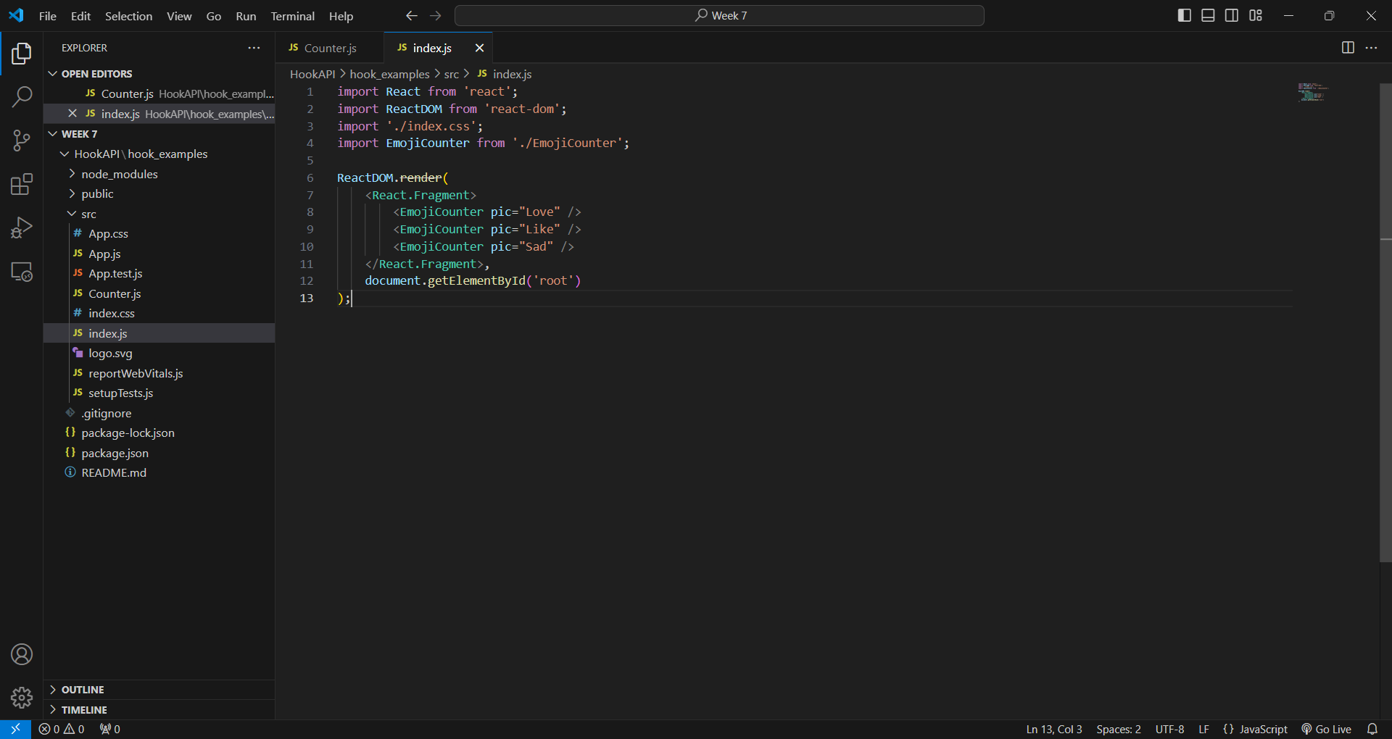

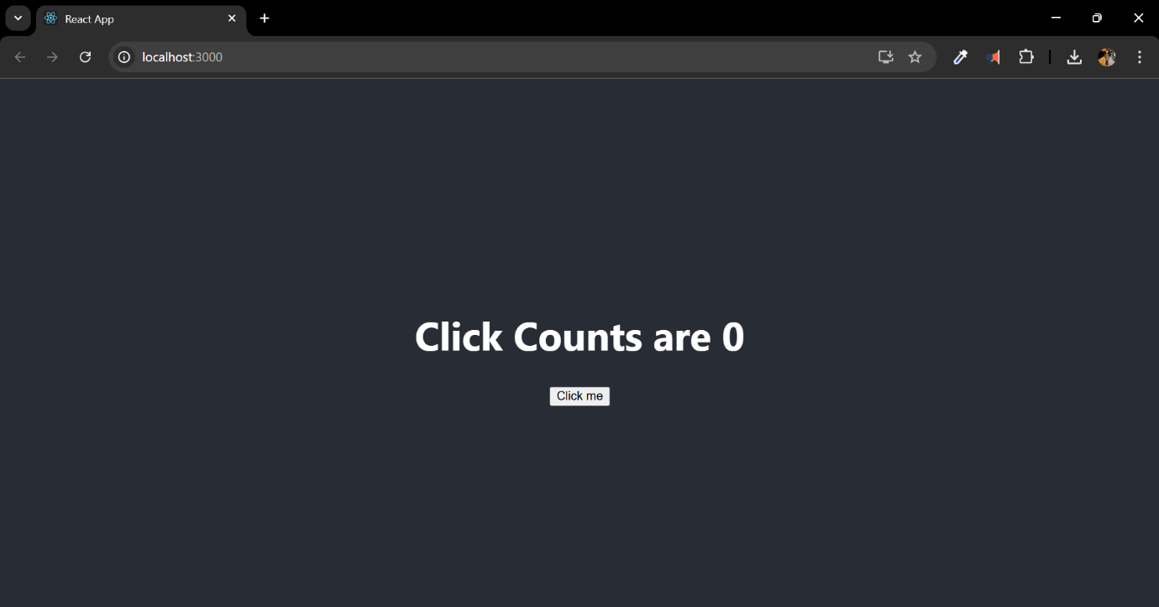

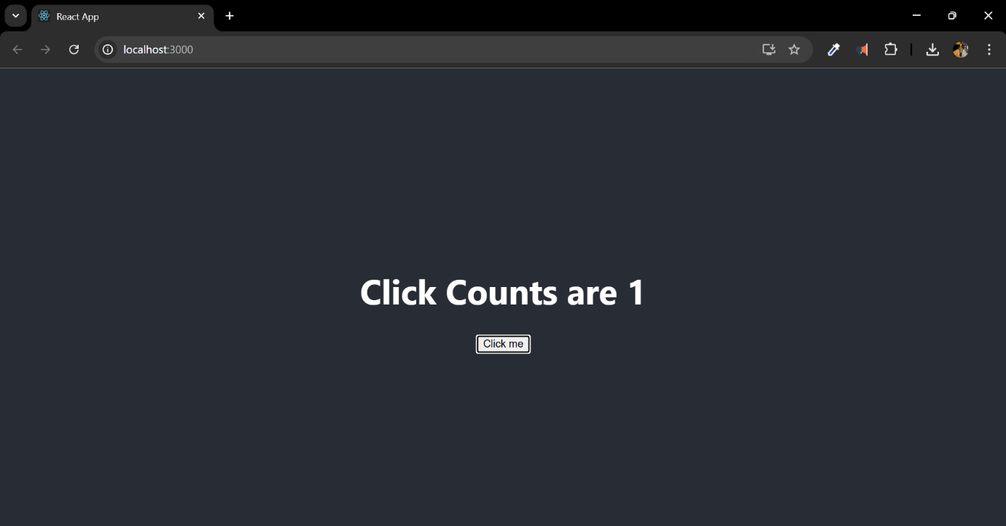

For our subsequent challenge, we developed a more intricate component that displays emojis. This is what we accomplished:

1. We created a new file named EmojiCounter.js.

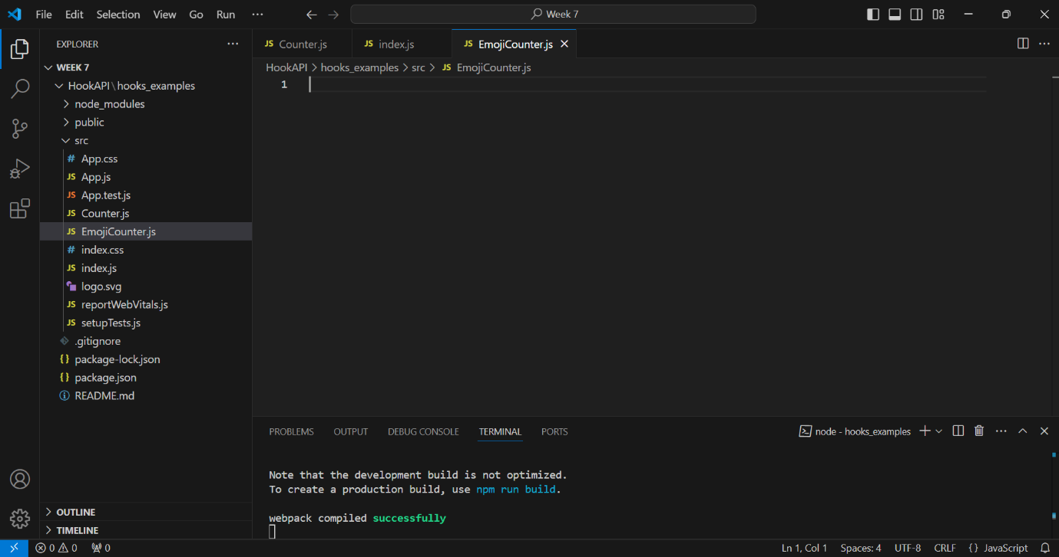

* We transferred three picture files (Love.png, Sad.png, and Like.png) into our src directory.

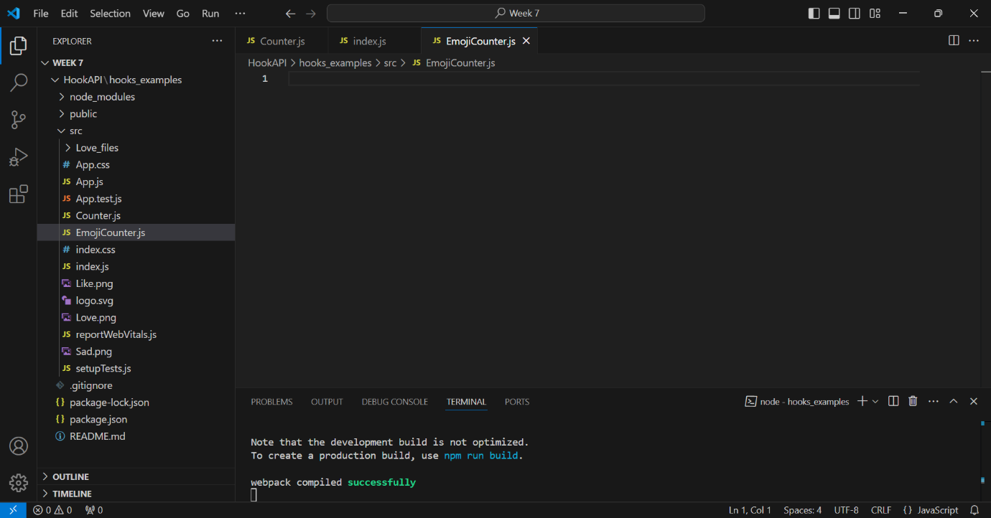

* We incorporated the following lines at the beginning of our new file:

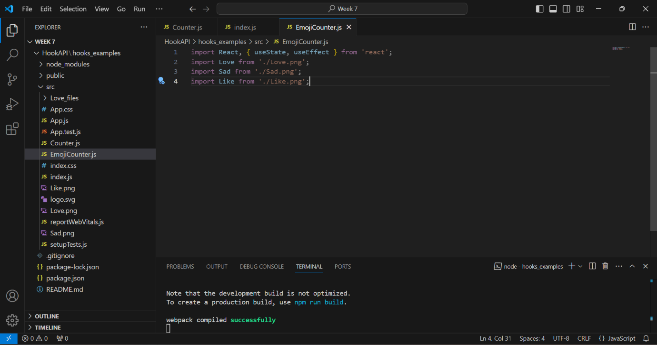

* Subsequently, we developed our EmojiCounter component. This is the whole component:

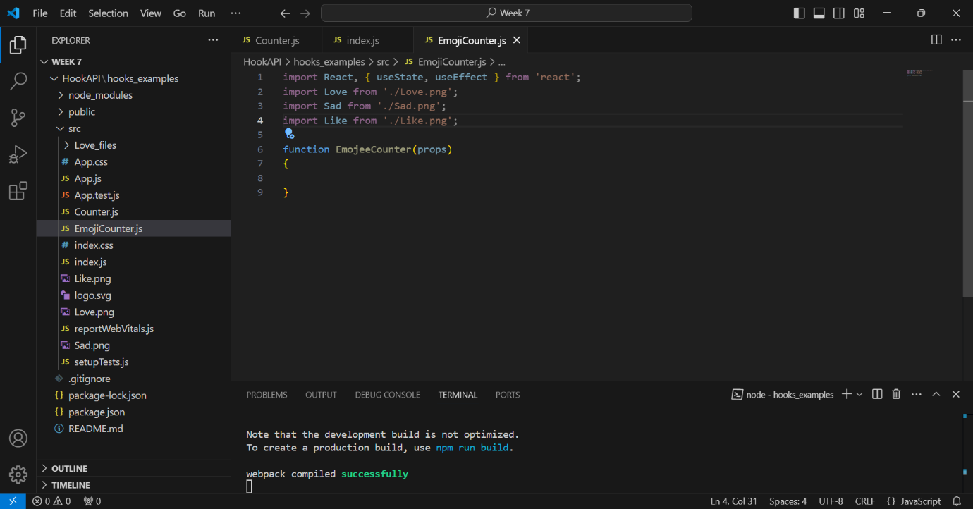

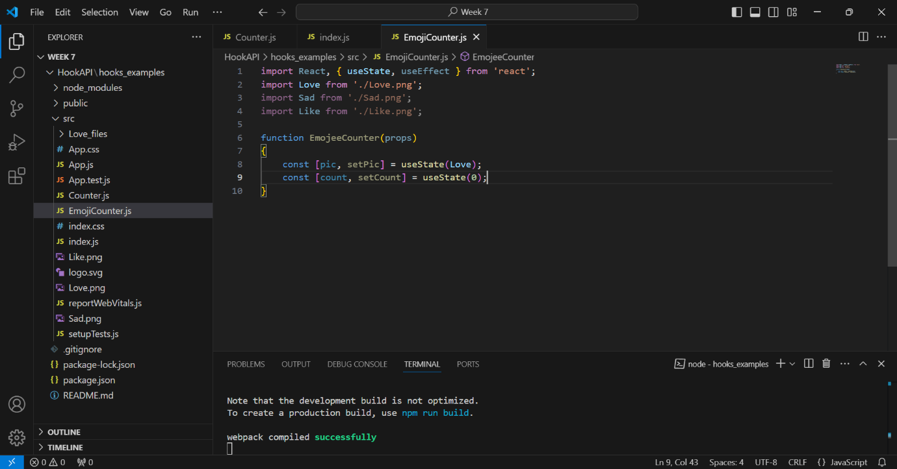

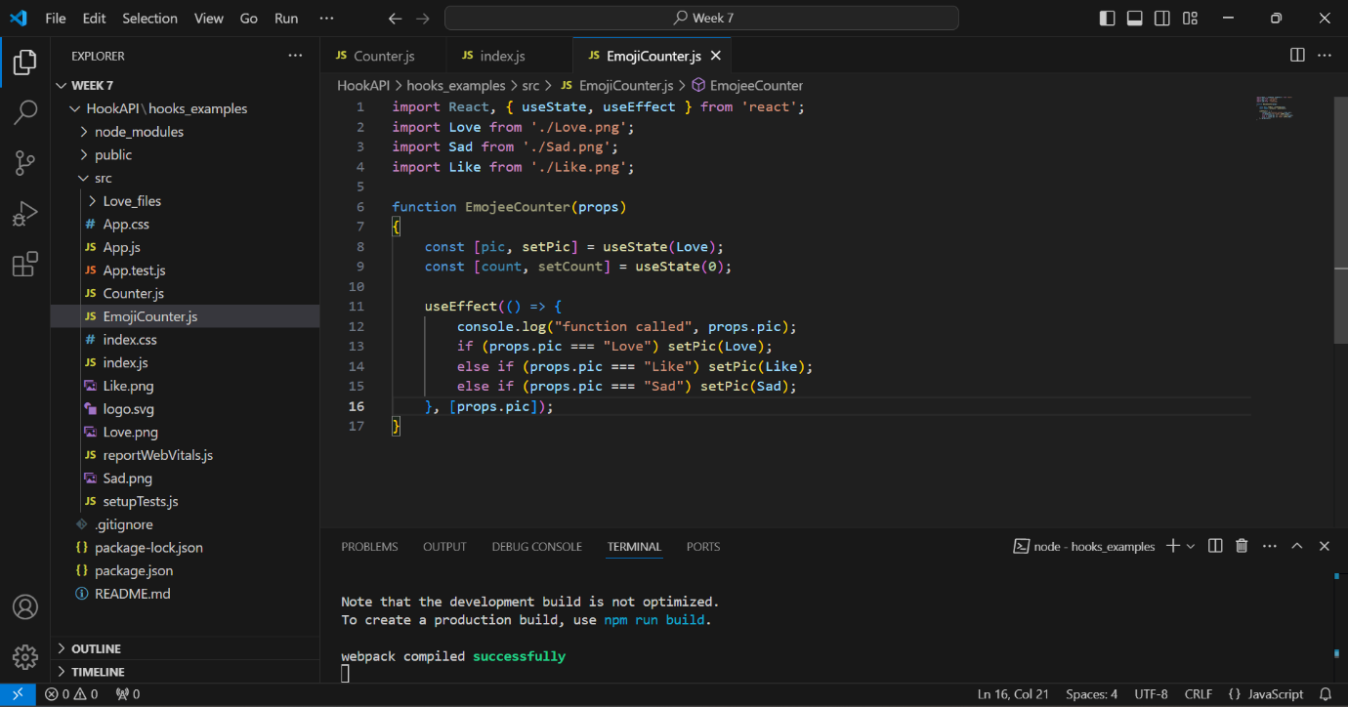

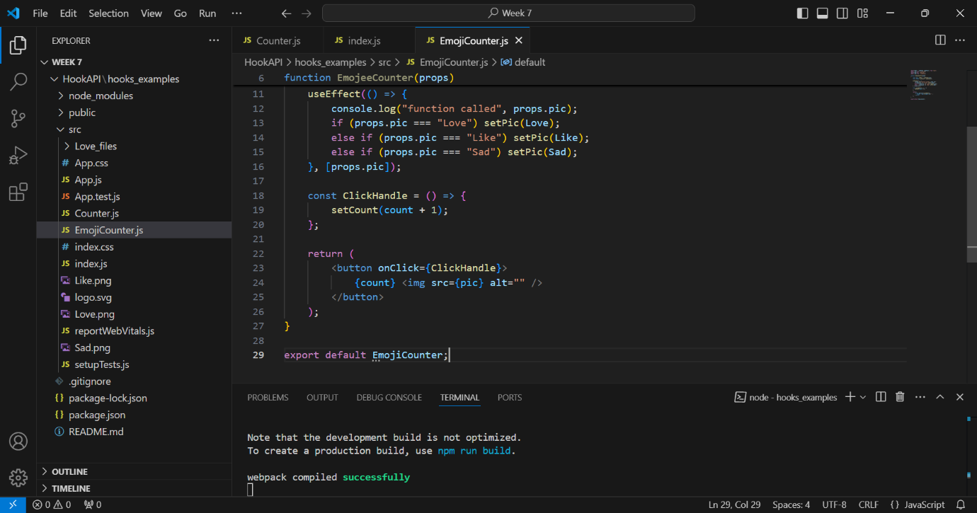

This component does a few things:

* It uses useState to keep track of which picture to show and how many times the button is clicked.
* It uses useEffect to change the picture when the props.pic value changes.
* It has a ClickHandle function that adds 1 to the count each time the button is clicked.
* It shows a button with the current count and an emoji picture.

We updated our index.js file again to use this new component:

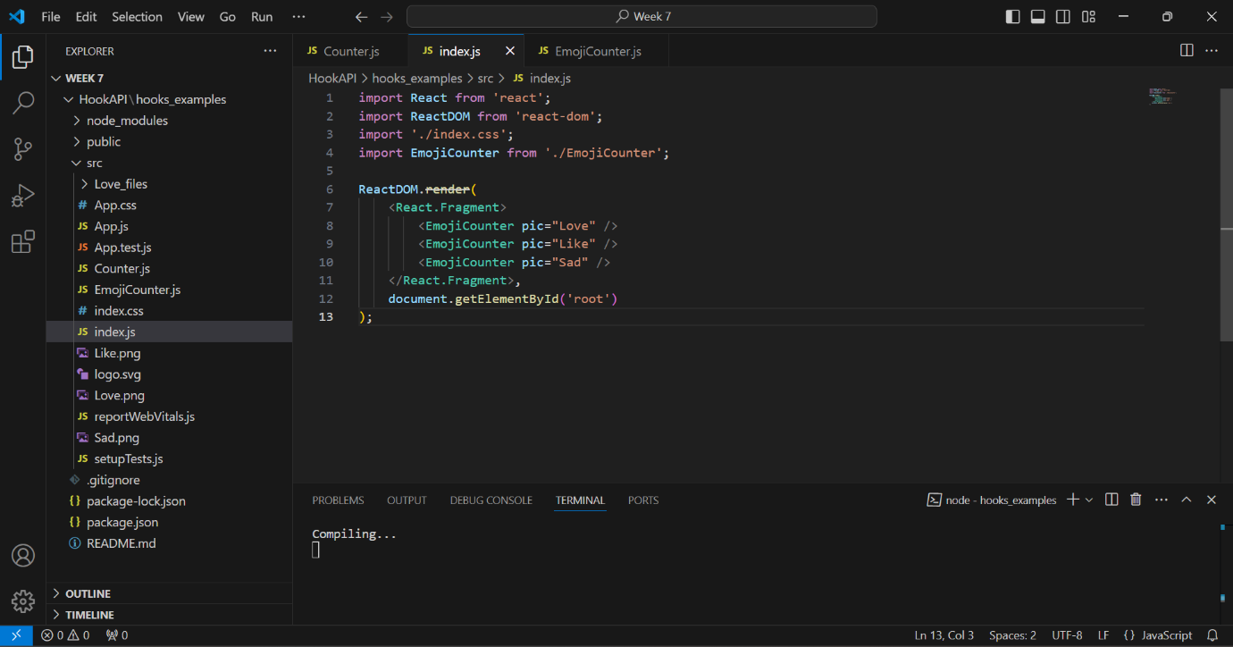

* We encountered an issue where executing the application resulted in a blank screen. The problem stemmed from a misspelling of "Emojicounter," which caused just two emojis to appear, with the Love emoji failing to display.

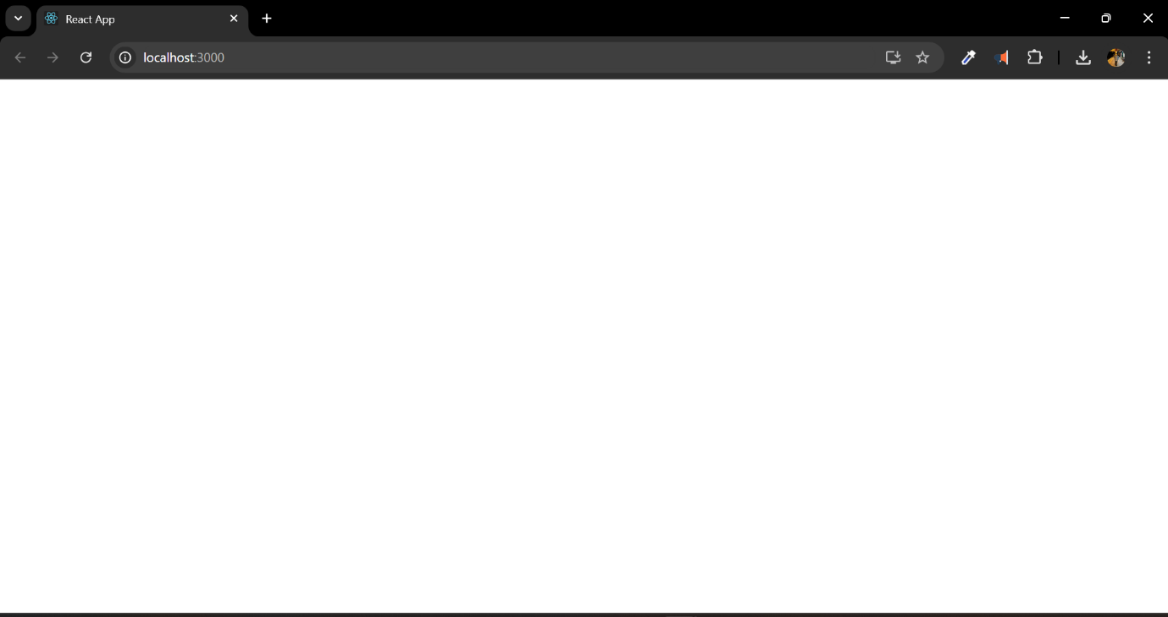

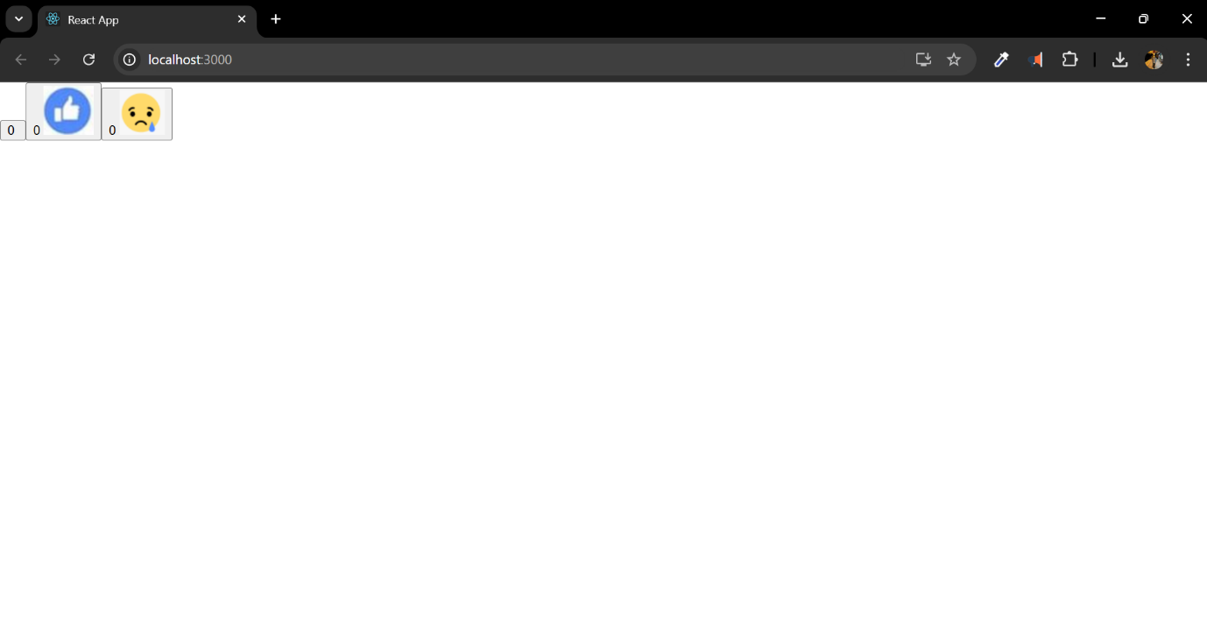

* I had a glitch while downloading the image, but after re-downloading it, the process was successful.

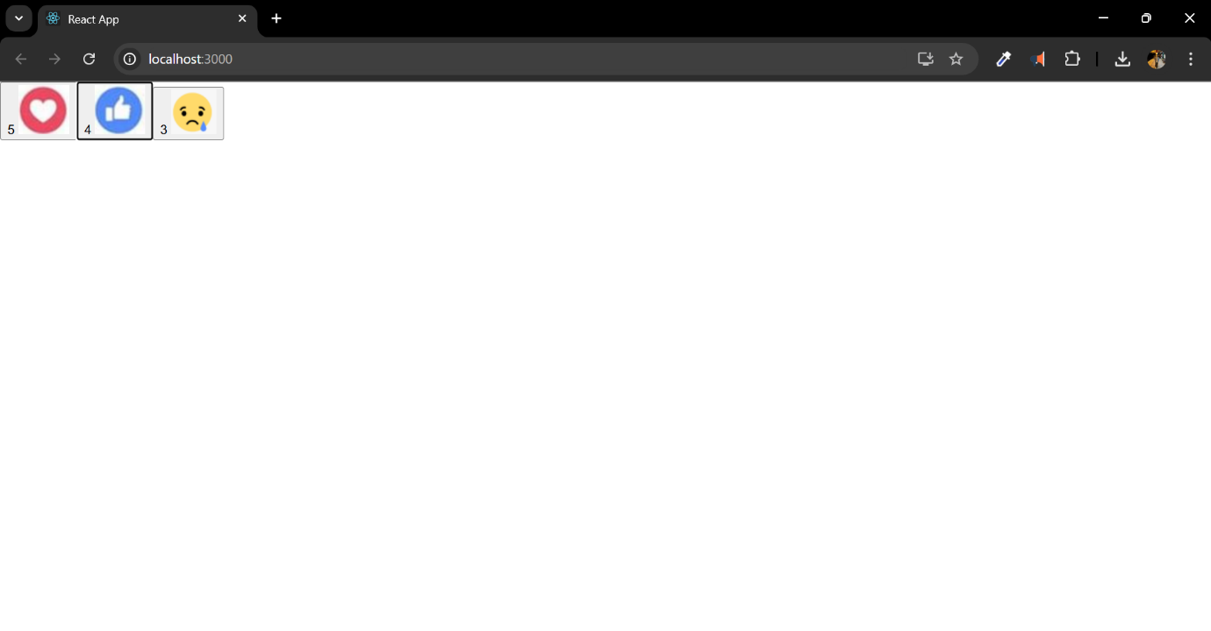

What We LearnedIn this lab, we learned how to:

* Set up a new React project
* Make simple components that keep track of information (like how many times a button is clicked)
* Use useState to manage information in our components
* Use useEffect to do things when our component's information changes
* Show pictures in our components
* Pass information to our components using props

Upon executing our application this time, we observed three buttons. Each button had a distinct emoji. Upon clicking the button, the numeral shown on it increased.

Now here are the answers to some questions from this weeks lab:

Q1. Write one page reflective what did you learn about React Hook API during this week

Ans:

This week, I acquired substantial knowledge on the React Hook API. Herein is my discovery:React Hooks are specialized functions that enable the utilization of state and other React functionalities within functional components. Previously, this was exclusively possible in class components.

* The primary hooks I acquired knowledge about were useState and useEffect:useState enables the incorporation of state inside functional components. It is particularly useful for monitoring variables that fluctuate, such as a counter or form inputs.useEffect facilitates the execution of side effects within our components. It resembles an amalgamation of componentDidMount, componentDidUpdate, and componentWillUnmount from class components, consolidated into a single location.I discovered that hooks enhance the clarity and comprehensibility of our code. There is no longer a necessity to alternate among classes, higher-order components, and render props.A notable aspect of hooks is the ability to develop bespoke hooks. This enables the reutilization of stateful logic across many components without altering the component hierarchy.I also learnt that hooks adhere to specific rules: • Hooks should only be invoked at the top level of our components, not within loops or conditional statements.
* Hooks should exclusively be invoked within React functional components or bespoke hooks, rather than standard JavaScript methods.
* In summary, I believe hooks have rendered React development more straightforward and enjoyable. They have provided me with novel methodologies for conceptualizing and structuring my code.

Q2. Study the code in EmojeeCounters.js, Please note, You Do not need to submit the full code rather you need to answer the following questions for your this week portfolio

Ans:

The name of the component created in EmojeeCounters.js is EmojiCounter.

The lines of code that use the EmojiCounter in index.js are:  
<EmojiCounter pic="Love" />  
<EmojiCounter pic="Like" />  
<EmojiCounter pic="Sad" />

The states are declared in these lines:  
const [pic, setPic] = useState(Love);  
const [count, setCount] = useState(0);  
These lines create two state variables: 'pic' for the emoji image and 'count' for the number of clicks.

The event handler is associated in this line:  
<button onClick={ClickHandle}>

In this line, 'pic='Love'' is a prop being passed to the EmojiCounter component. It tells the component to display the 'Love' emoji.

useEffect is a hook that lets us perform side effects in functional components. In this component, it's used to update the 'pic' state based on the 'pic' prop. It runs whenever the 'pic' prop changes.

<p>{props.pic} <span></span> <button onClick={ClickHandle}>{count } <img src={pic} alt=""/> </button> </p> </div> ) } This code returns the JSX for the component. It creates a div with a paragraph that shows the name of the emoji (props.pic), a button that shows the click count and has the ClickHandle function attached to its onClick event, and an img tag that displays the emoji image.

Q3. Create a code for a Component that takes two HTML one text box and one label.

Label will be used to display the images. So it should be like this  
If I write "Happy" in the text box the label should show happy face (You can use any image)  
If I write "Like" in the text box the label should show Like icon  
If I write "sad " the label should show sad emoji.

Ans: Here's a simple React component that does what you've described:

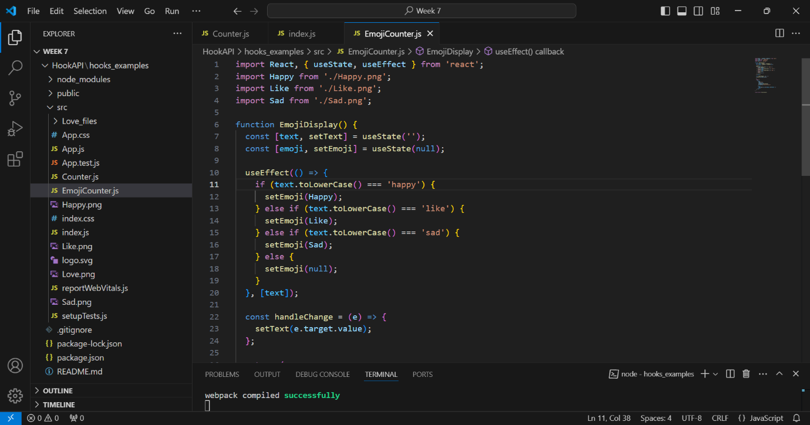

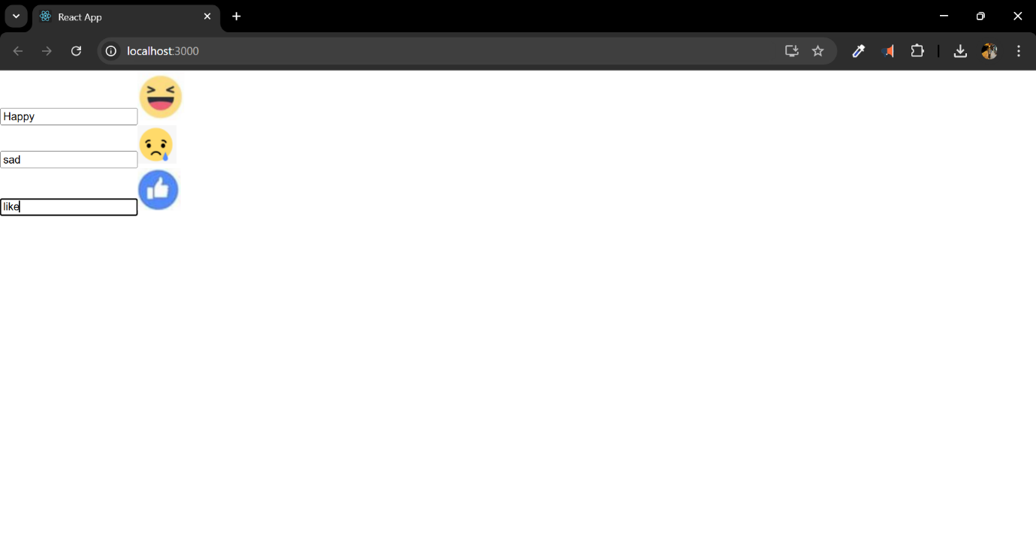

This component employs a text input and a label to show emojis corresponding to the input. It employs useState to govern the input text and the current emoji, and useEffect to refresh the emoji whenever the text is modified. The handleChange function modifies the text state in real-time as the user inputs data. The label shows the emoji picture if one is chosen according to the input.

Key Takeaways:

State Management with useState: I developed a functional component, Hook_ControlledButtonState, which manages a counter's state. By calling setCount, I was able to update and display the click count dynamically.

Dynamic UI Updates: In the EmojiCounter component, I used useEffect to dynamically load images based on props. This taught me how React responds to state and prop changes to render UI efficiently.

Component Props: The pic prop in EmojiCounter helped me understand how to pass and use data in functional components.

React-Specific Syntax: Adapting common HTML elements, like <img>, within React's JSX syntax and the importance of importing assets into the project.

Challenges and Solutions:

Comprehending useEffect: At first, I found it challenging to grasp the function of useEffect. I observed that it executes upon component mounting and if dependencies alter, ensuring the state corresponds with prop modifications.

Properly Configuring State: Managing several states in EmojiCounter (e.g., count and photo) proved challenging; nevertheless, the implementation of hooks facilitated effective management.

Reflection: This laboratory reinforced my comprehension of functional components and hooks, highlighting React's declarative characteristics. Developing interactive elements, such as counters and emoji buttons, provided a compelling method for mastering state and lifecycle management. I possess more confidence in building React apps that dynamically adapt to user interactions.

https://github.com/u2524845/CN5006-week7.git

# Week 8 Reflection - Using MongoDB CRUD Operations in a Programming Application

This week, we will concentrate on executing CRUD (Create, Read, Update, Delete) activities with MongoDB within a Node.js application. The lesson guides us in incorporating MongoDB commands into our application with Visual Studio Code. This document provides a comprehensive summary of my learnings and implementations from this week's laboratory session.

I began the process by establishing a new directory titled "MongoWeek" on my PC to organize the project files.

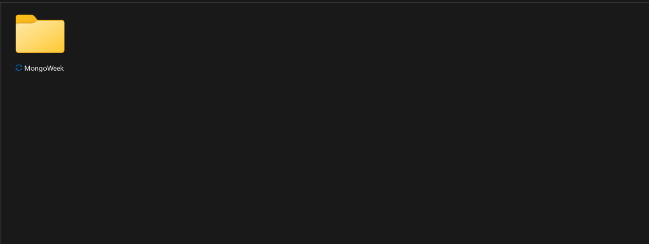

* I went to the "MongoWeek" directory after opening the termiinal. I then executed the command:

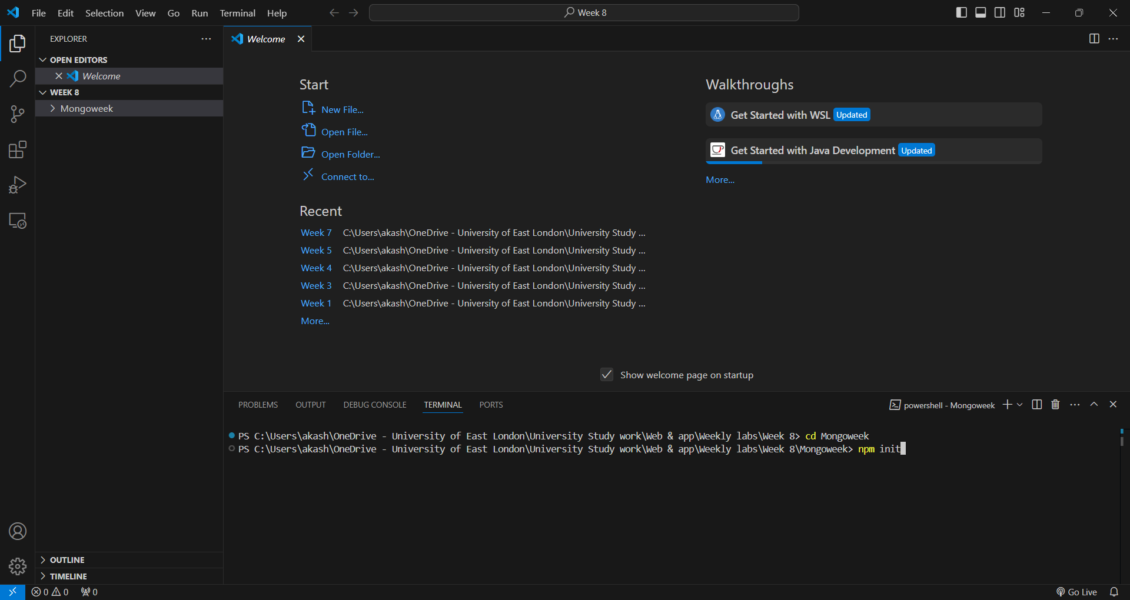

* This command initialized a new Node.js project and created a package.json file.

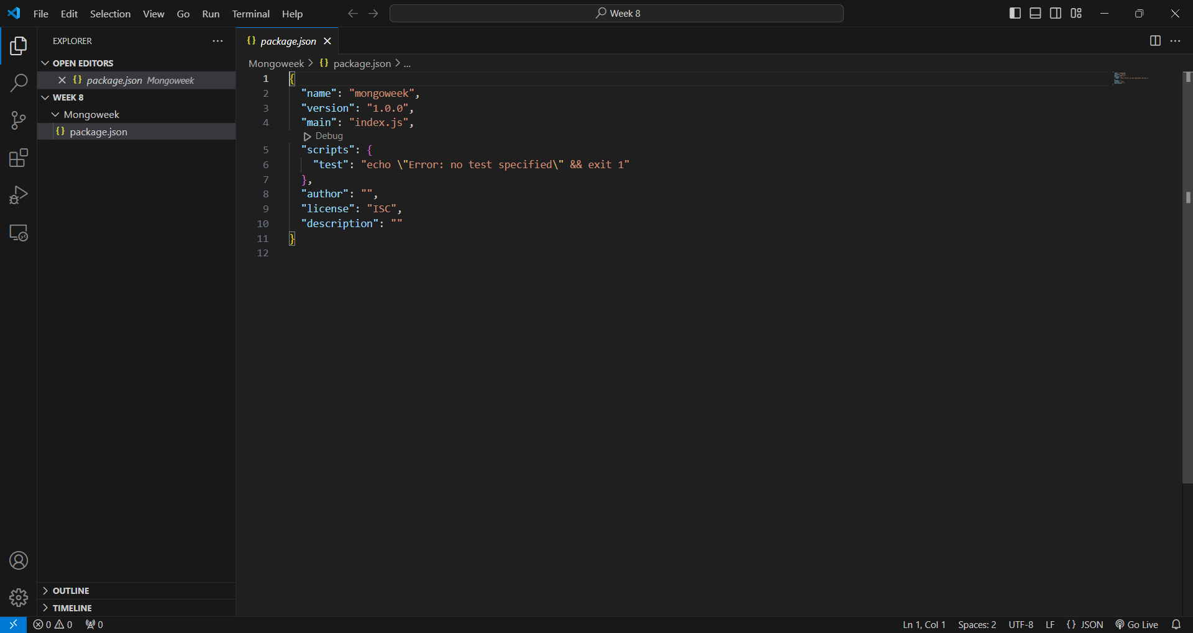

* I made a new file in the project folder called index.js. This is where all the code would go.

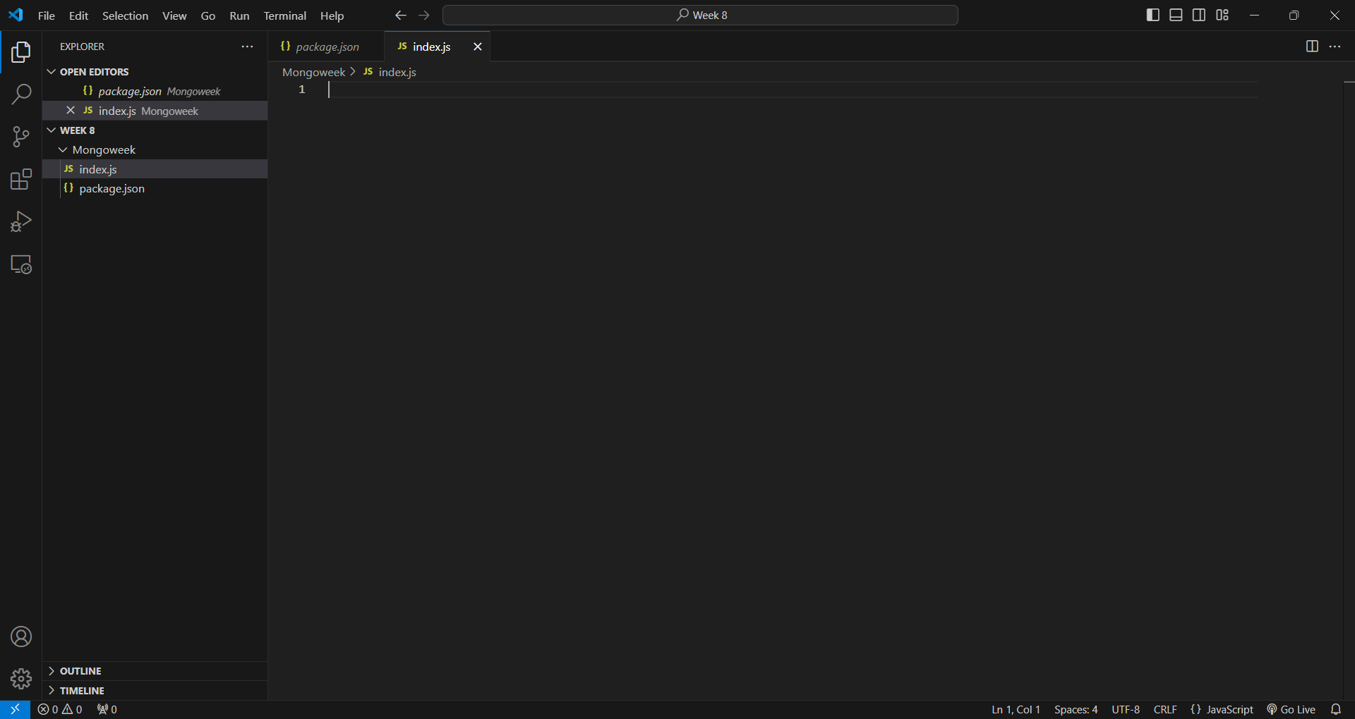

To connect to MongoDB, I needed to install Mongoose. I ran the following commands in the terminal:

In index.js, I added code to connect to MongoDB:

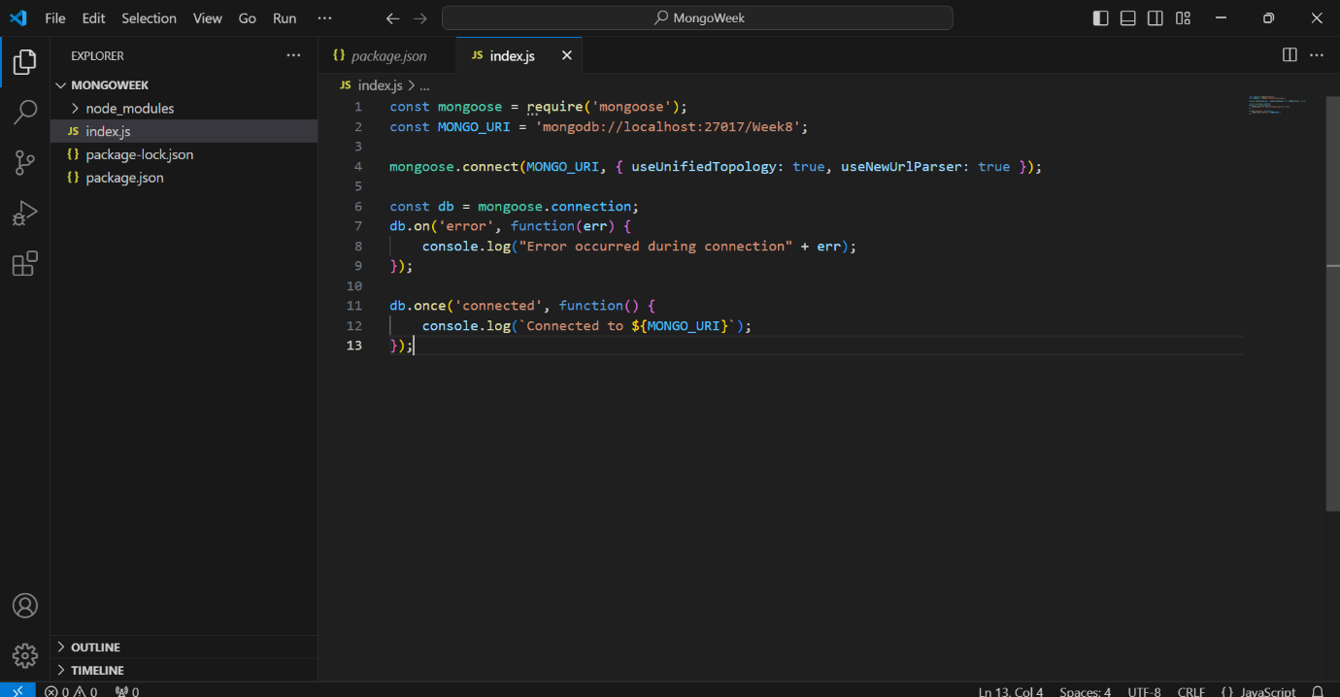

This code connects to a MongoDB database named "Week8". It also handles connection errors and logs when the connection is successful.

Next, I created a schema for storing person data:

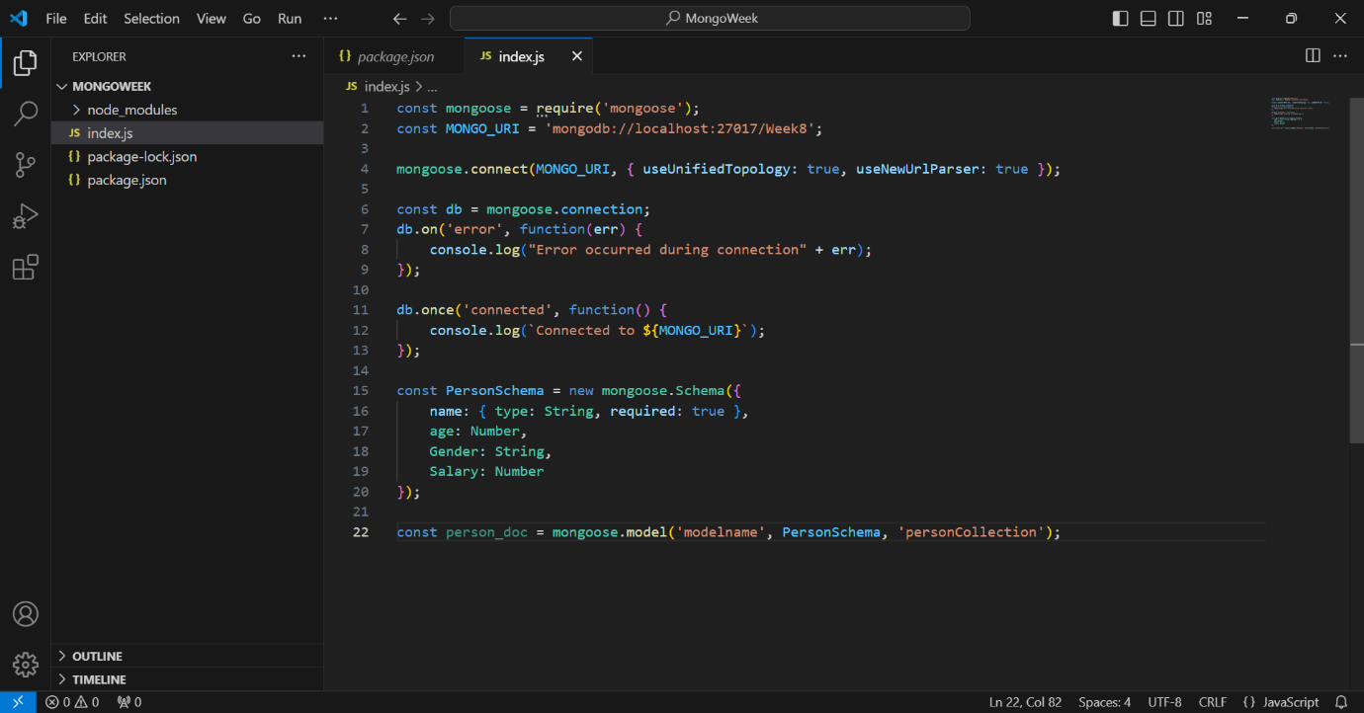

Then, I added code to create and save a single document:

The doc1.save() method saves the document to the database, and .then is used to handle successful insertion.

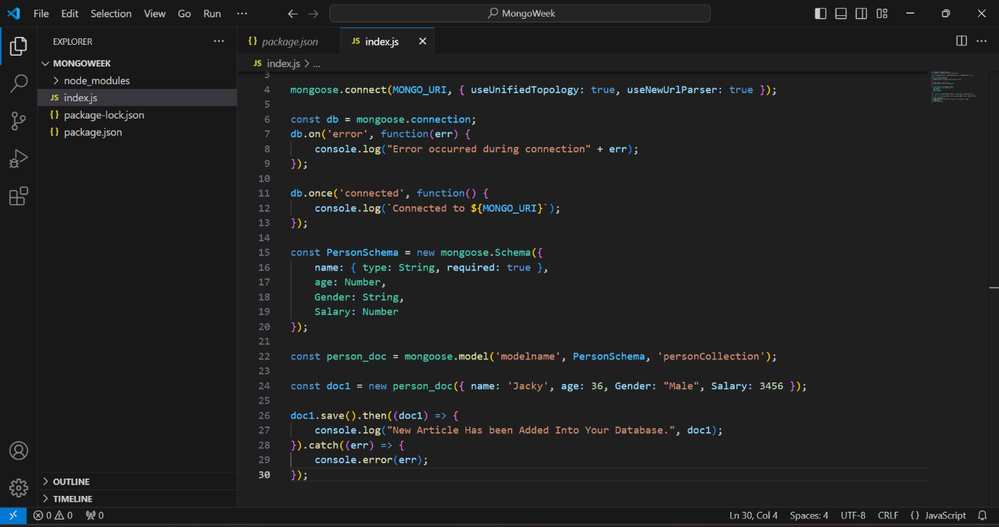

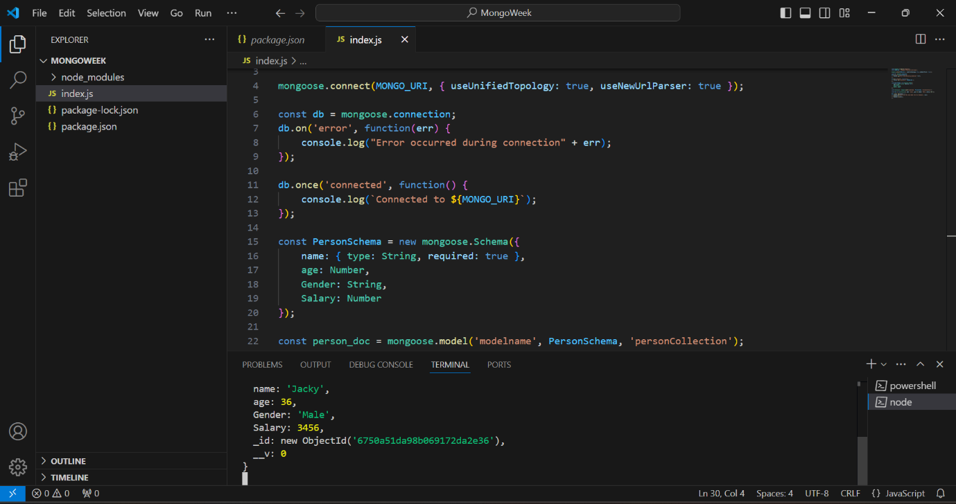

* To add multiple documents at once, I used this code:

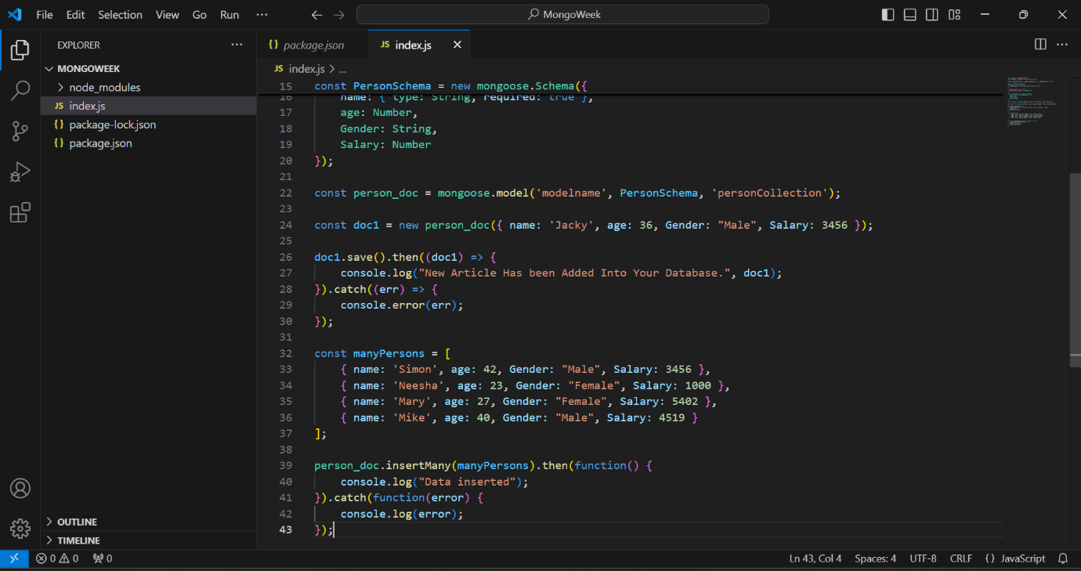

* The insertMany method is used here to insert multiple documents into the collection.
* To retrieve all documents from the collection without filtering, I added this code:

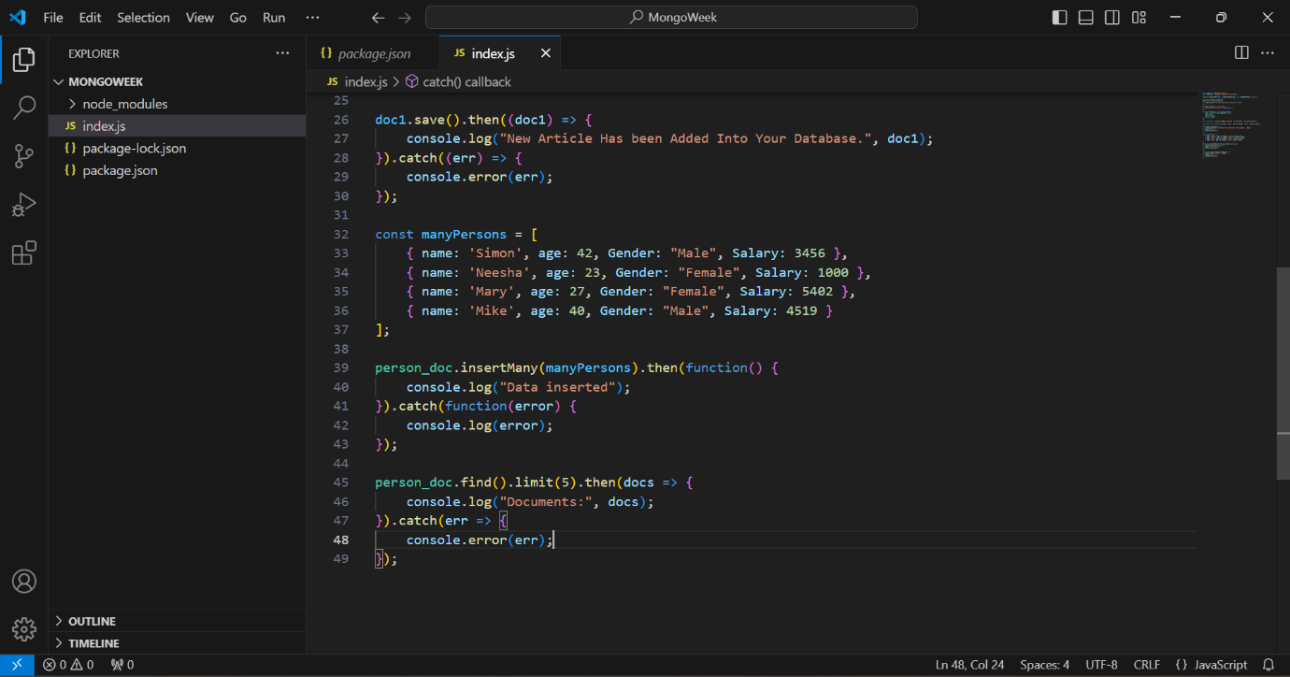

* For filtering documents based on criteria (e.g., gender), I wrote:

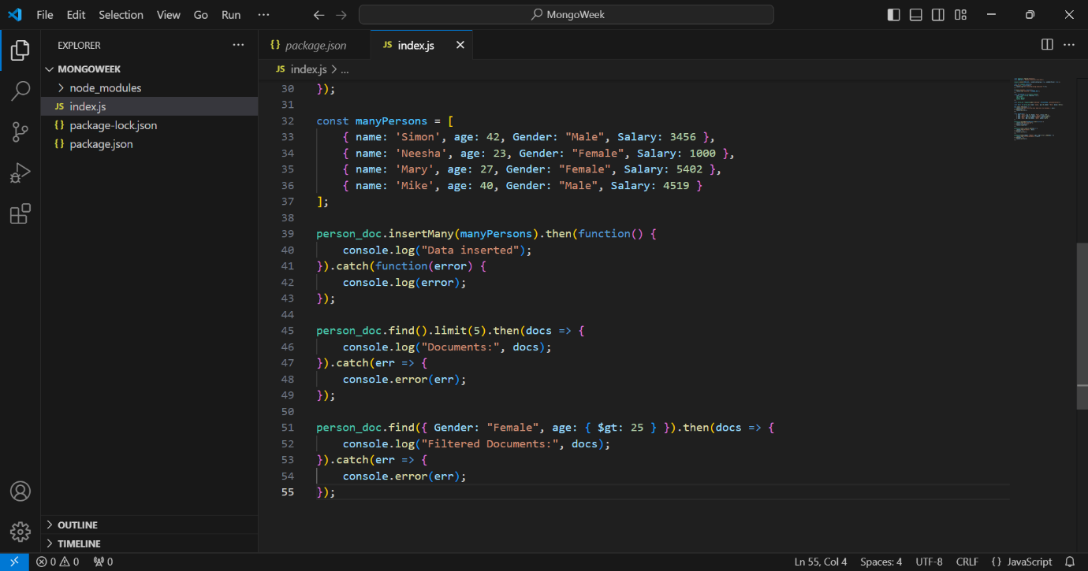

* To delete records where age is greater than 25, I used this code:

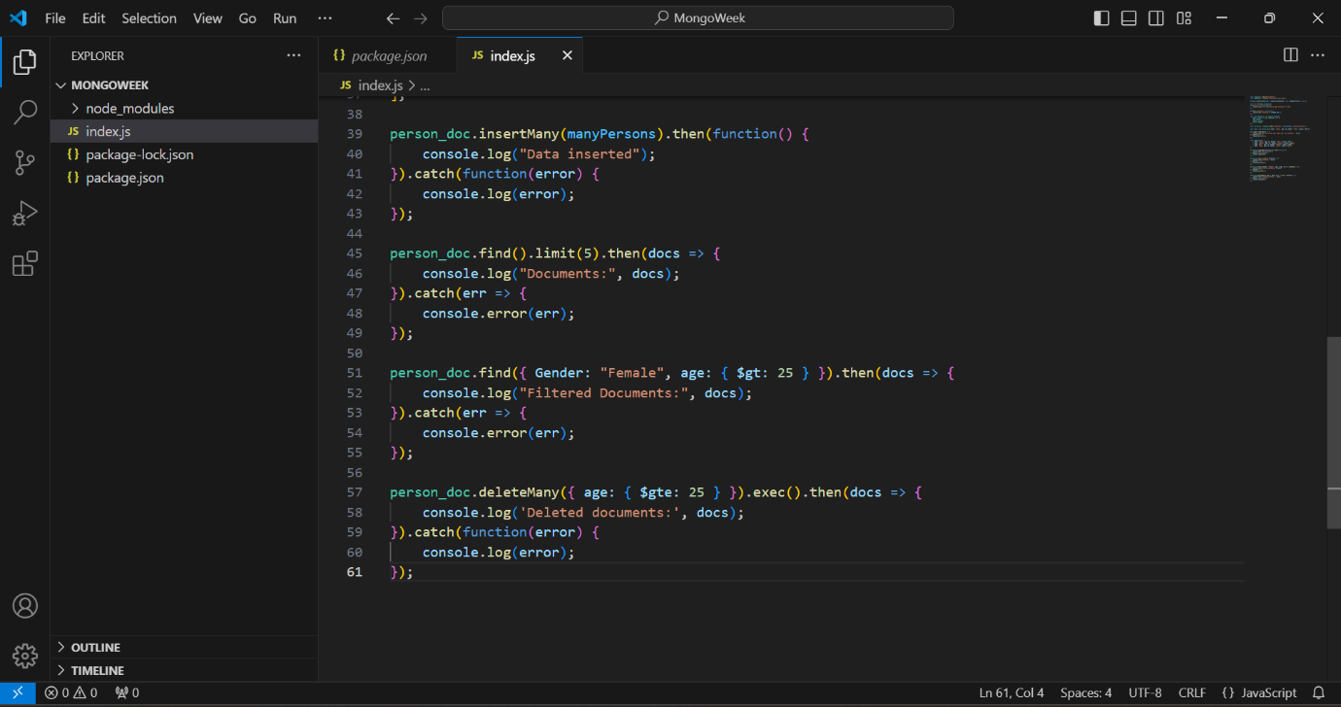

Finally, to update all female records' salaries to 5555, I wrote:

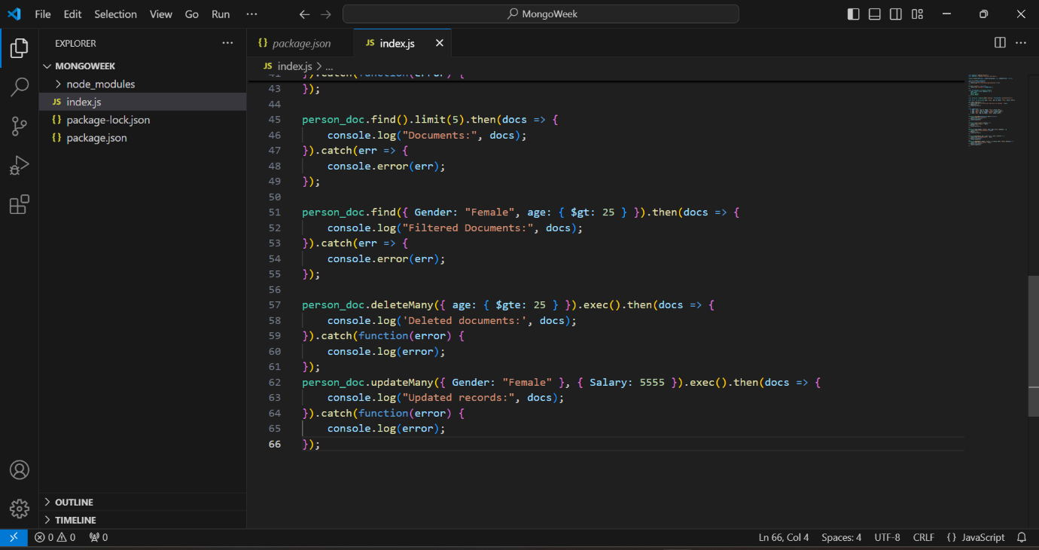

* This week, I learned how to use Node.js to dynamically perform MongoDB CRUD operations. This lab helped close the gap between what you learn in class about command-line processes and how you can use them to make dynamic, interactive systems in the real world.

Key Learnings:

* Making a Connection to MongoDB: I learned how to use the Mongoose tool to connect to a MongoDB database, control models, and make it easier to work with the database. Using mongoose.connect to make a connection and db.on and db.once to handle errors helped set up the connection.

Actions for CRUD:

* Create: I was able to add single documents by using the save method, and I was able to add multiple records at once by using insertMany. Learning these ways made me realize how important promises are for making sure that database tasks are finished before moving on.

https://github.com/u2524845/CN5006-week8.git

# Week 9 Reflection: How to create React Class Components

This week, we will learn to design and utilize React class components. In the initial phase, we will generate a React application using the npx create-react-app command within our week 9 directory, followed by the development of a class component that captures Facebook emotions such as love, like, and happy emojis. We will generate a file titled Facebookemoji.js and thereafter compose code within it utilizing the week 9 lab PDF as a reference.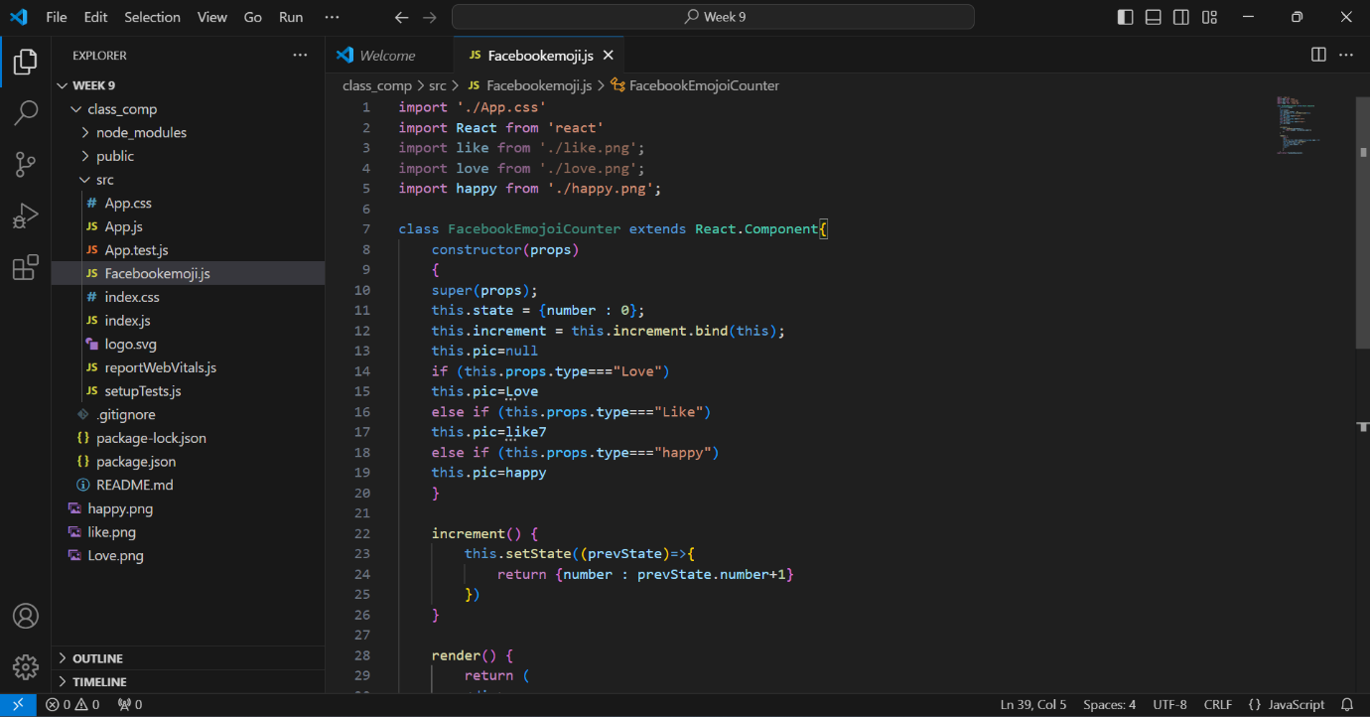

We will now invoke this component in our index file by importing it. First, we will import the class into the index file using the import command. Subsequently, we will eliminate the app tag and substitute it with FacebookEmojiCounter, calling it three times to modify the type of the prop being utilized.

Calling the component in the index file:

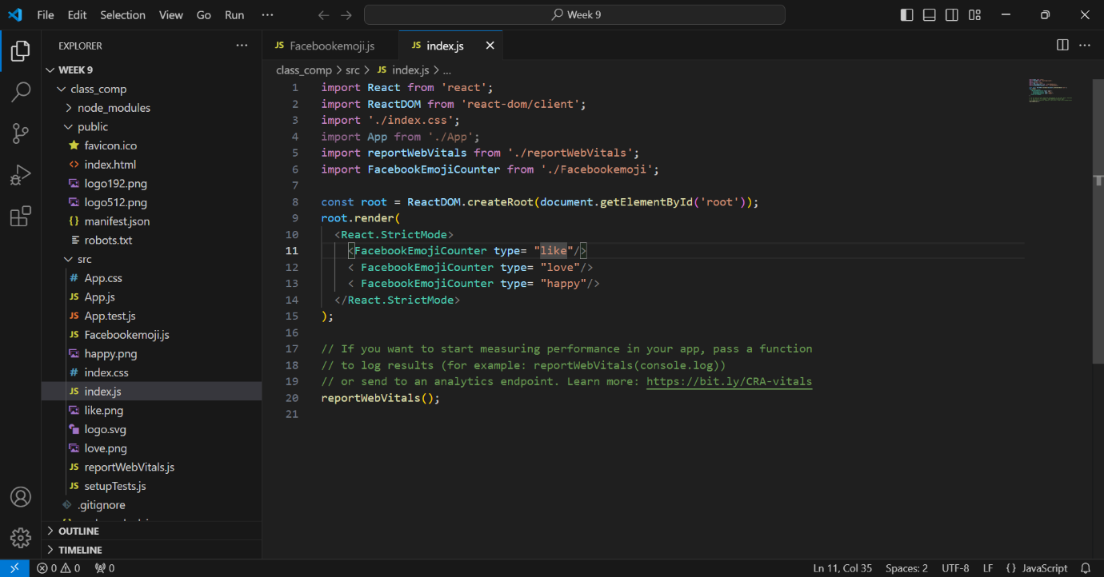

* We will execute the application using the npm start command, resulting in:

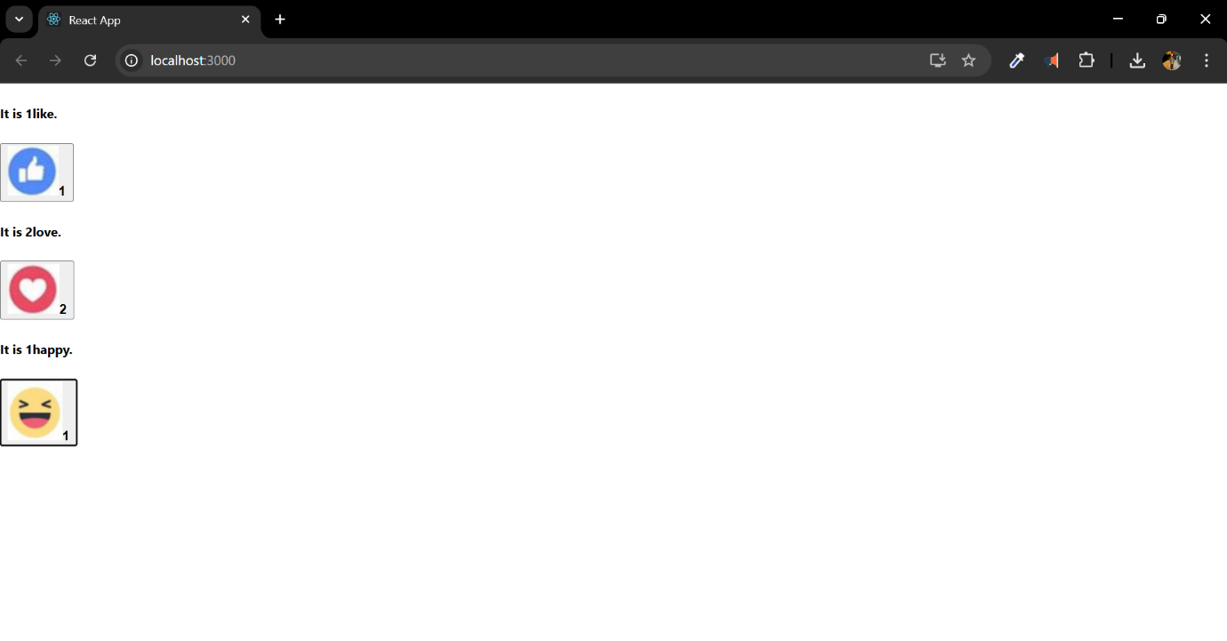

* We will now make a file called ToggleModeComponent.js and add the code from the lab job PDF to it:

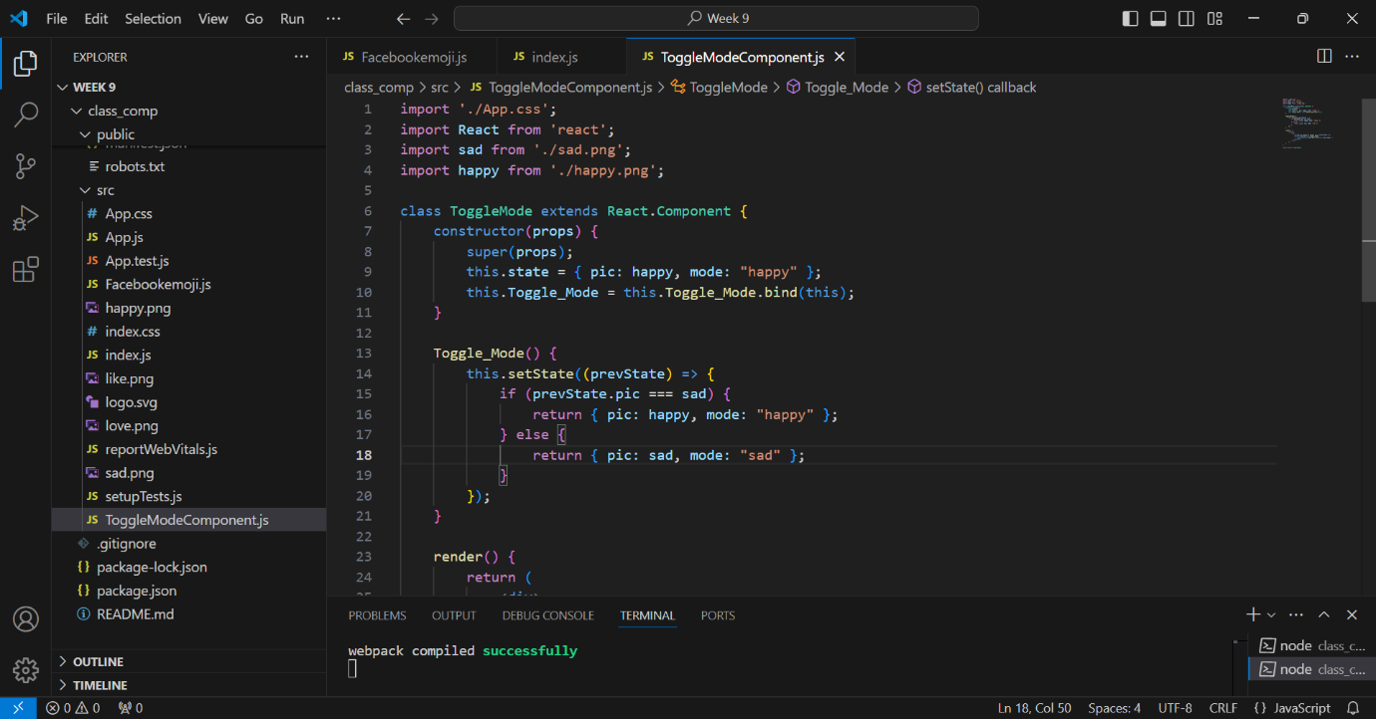

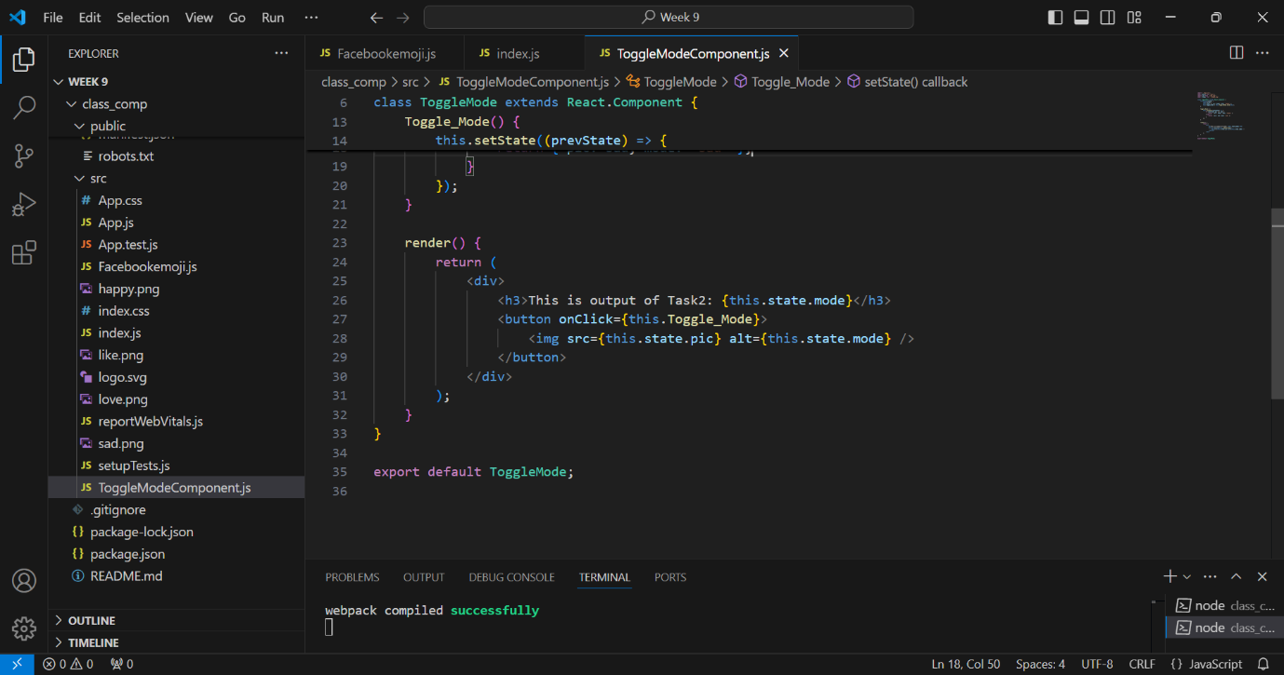

* I encountered an issue with my code, necessitating modifications in other files as well.

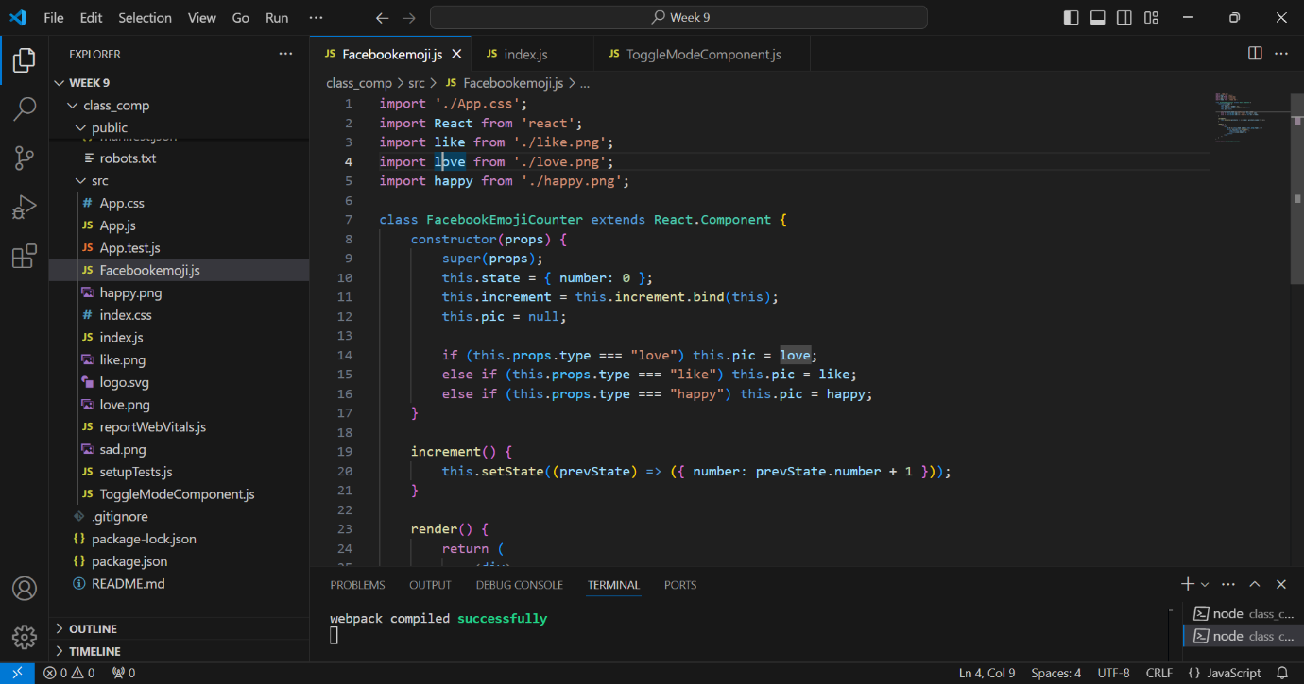

* And last, this is our program's result:

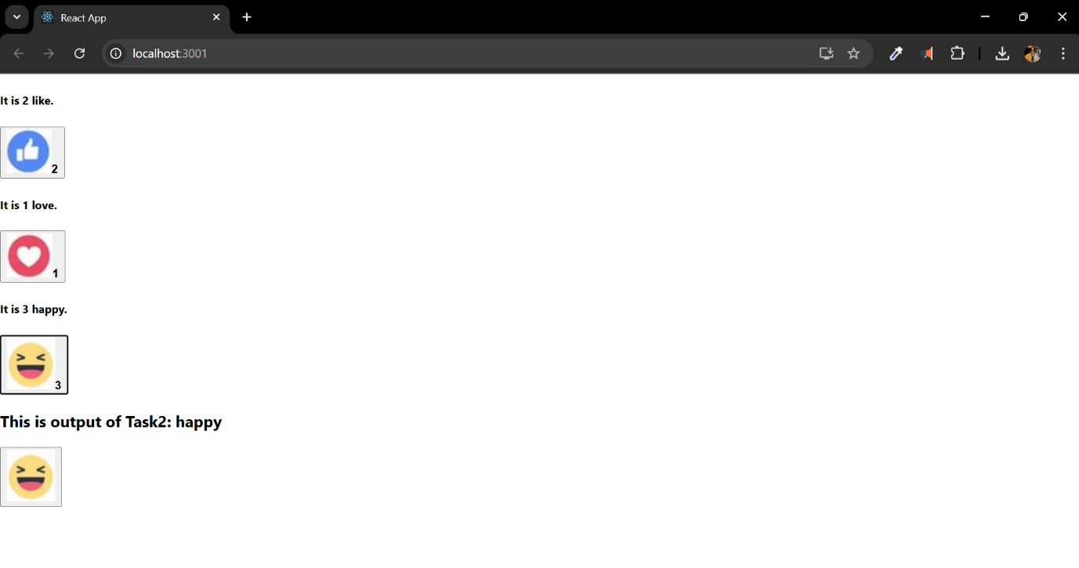

Key Learnings:

* Class Components: I knew that class components have more advanced features than functional components. For example, using this.state to manage the component's private state directly. They are different from functional components because they have functions like render() and constructor().
* State Management: I could keep track of and change changeable data with the this.state object. For instance, in the FacebookEmojiCounter class, I kept a number state to keep track of click counts and used this.setState to quickly change it.
* In the constructor, I used the bind method to connect the increment method to the button's onClick event. This made sure that the component context was handled correctly.
* Dynamic Props: I rendered pictures and text dynamically based on what the user typed in by giving the type prop. The code block if (this.props.type === "Love") showed how props can be used to change how a component acts.
* Component Lifecycle: The constructor method helped set up the state and bind methods, which shows how class components change over time.

Challenges and Solutions:

* Being aware of this.setState: At first, it was hard for me to keep track of state changes when using this.setState, especially when they happened at different times. I made sure that state changes were correct and stable by playing around with the prevState parameter.
* Props for Handling On the fly: Careful use of conditional logic was needed to change the pic property based on the type prop. Debugging this reasoning made it clear what props are used for when changing components.
* Binding to events: I fixed the mistakes that came up because I forgot to bind methods in the constructor by looking over the structure of the class component.

https://github.com/u2524845/CN5006-week9.git

# Week 10 Reflection**:** Developing an online Library React Single Page application with MongoDB Mongoose, Node express and axios

We will be making a server application in this week's lab. To start, we will make a folder for week 10 and open the VS code to run the npm init command:

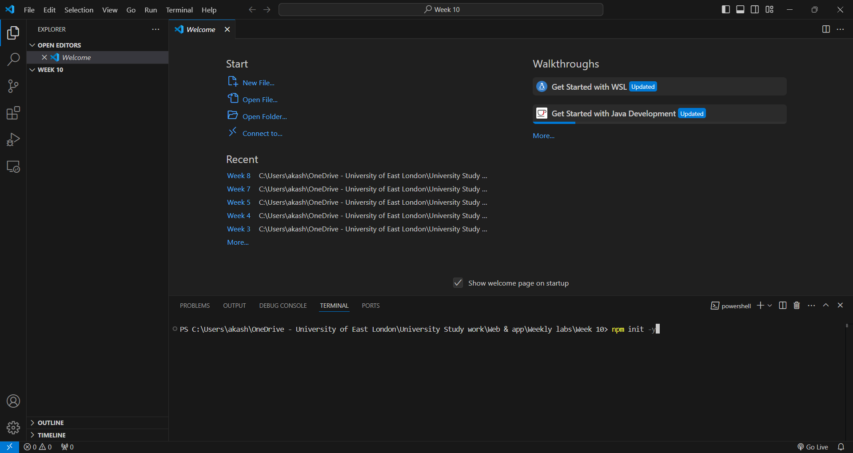

* This made a package Jason file in our folder for week 10:

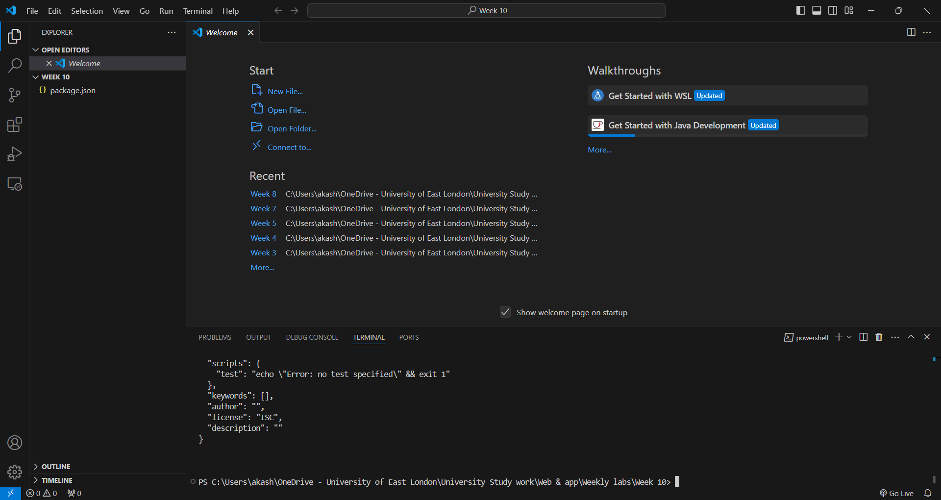

* Now, we'll use the following command to add the other package we need to the file:

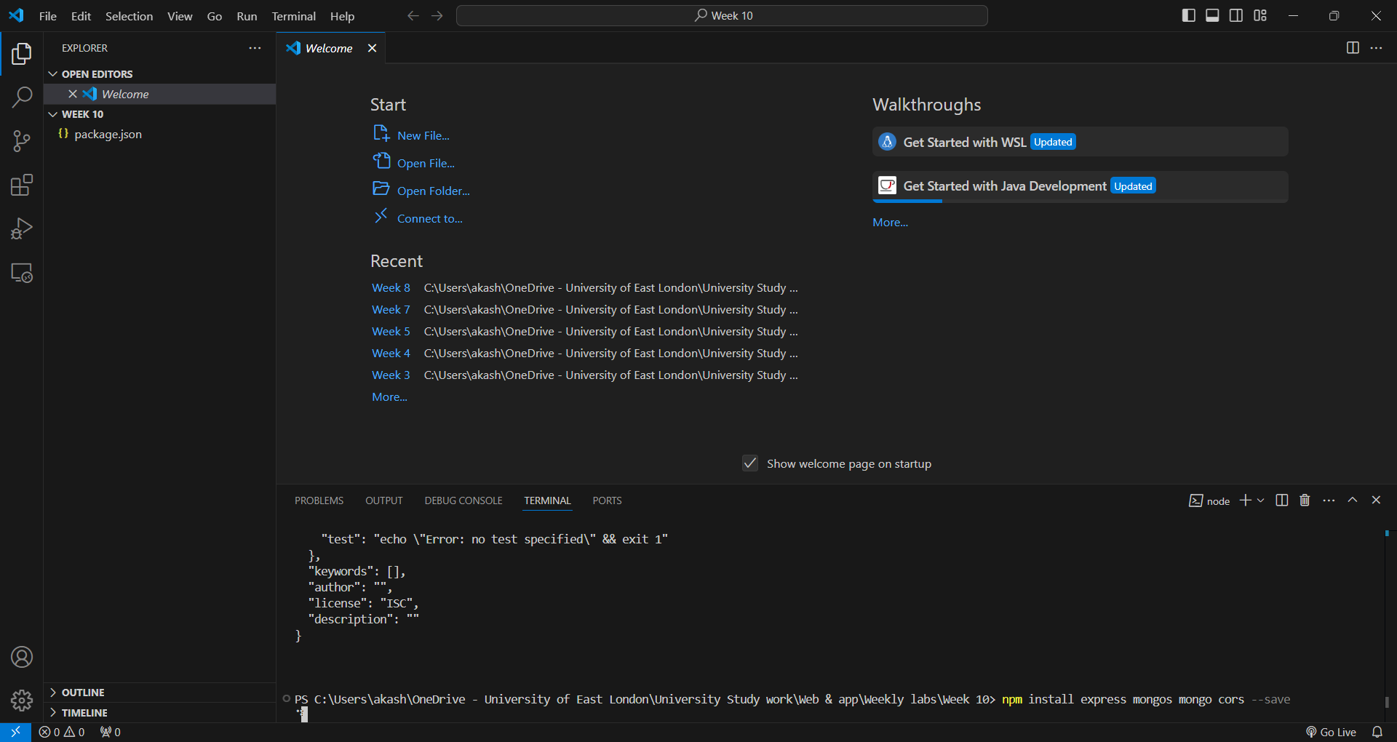

* We are now going to make three files for our server app:
* With the lab PDF's help, we'll add the code to the files:

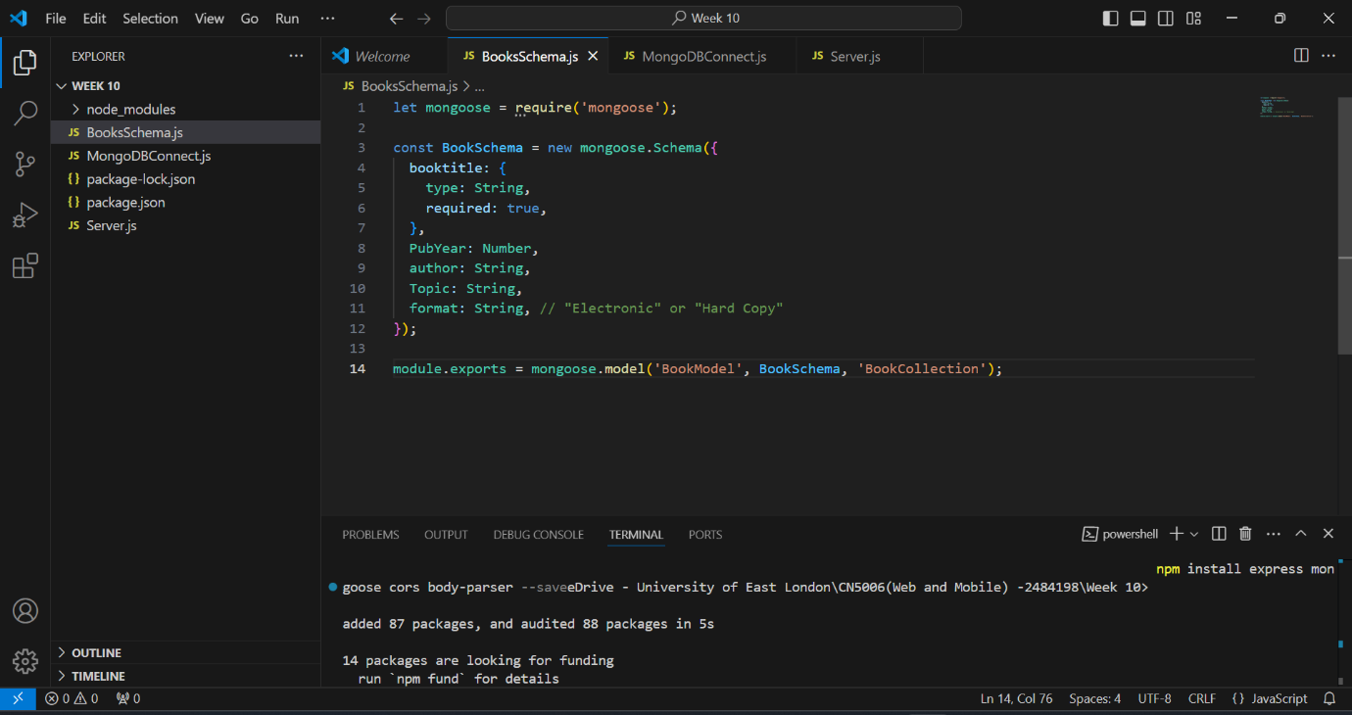

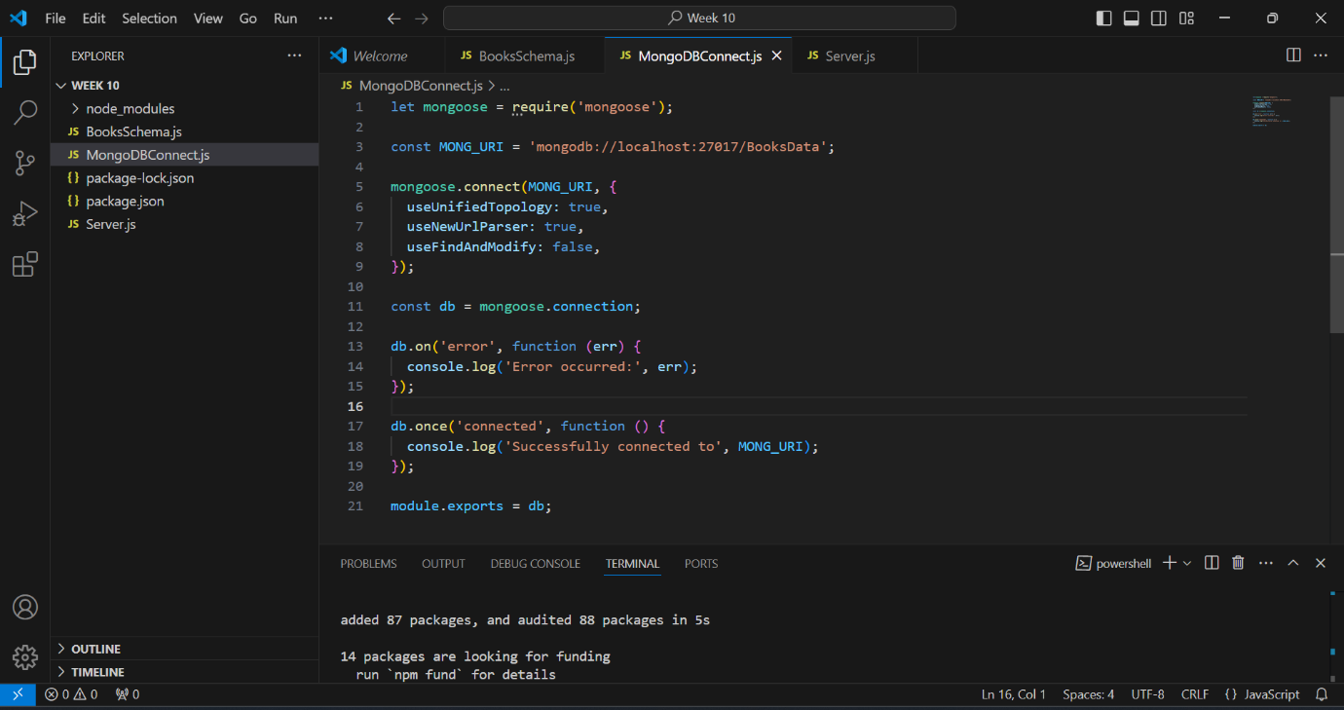

* In the server.js file, we will first set up REST API routes and make an entry point for the backend server:

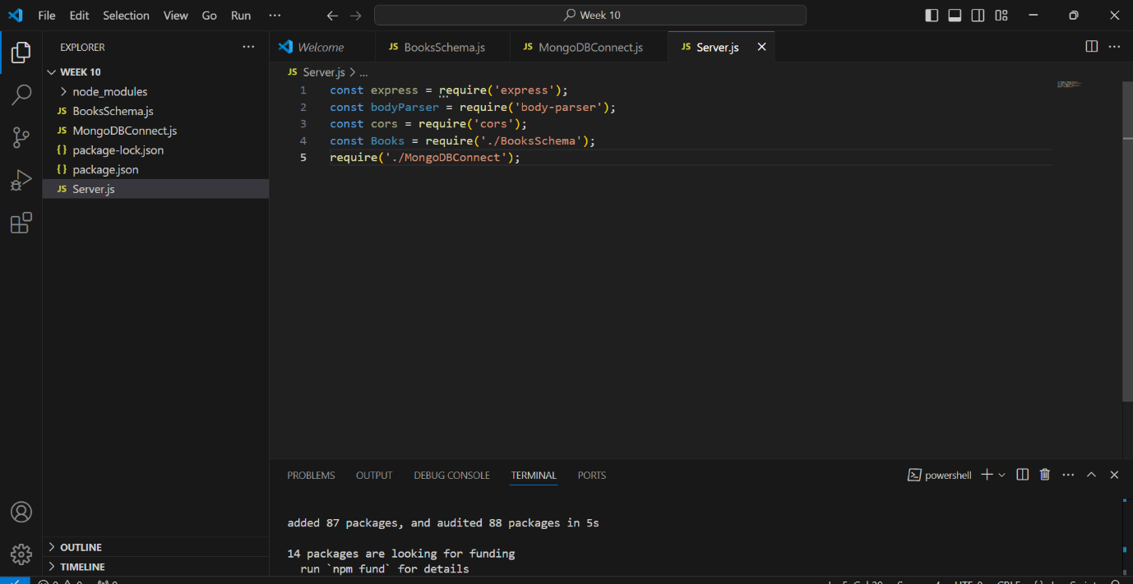

* The server will then be started using the following:

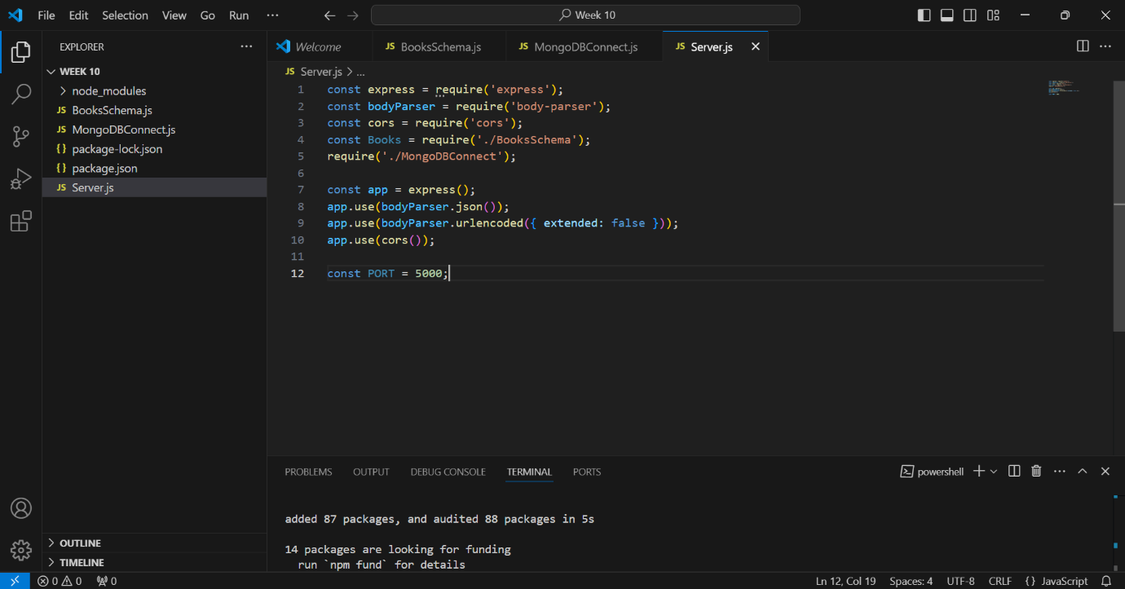

* Then we will define REST API endpoints to:
* Get all books:

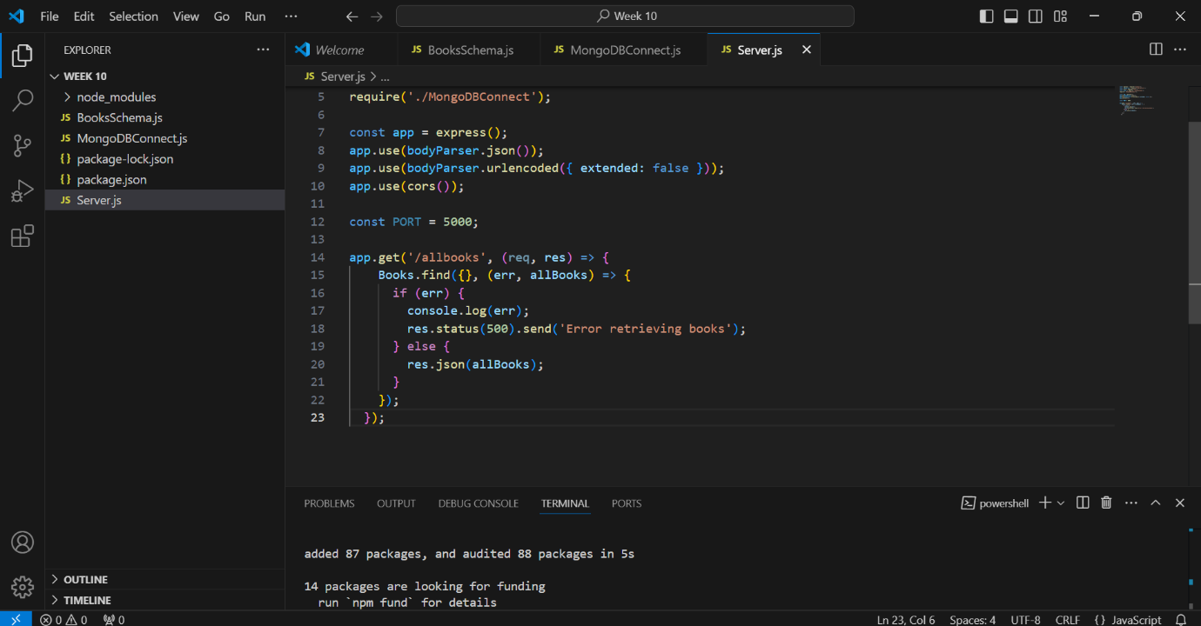

* Get a single book by ID:

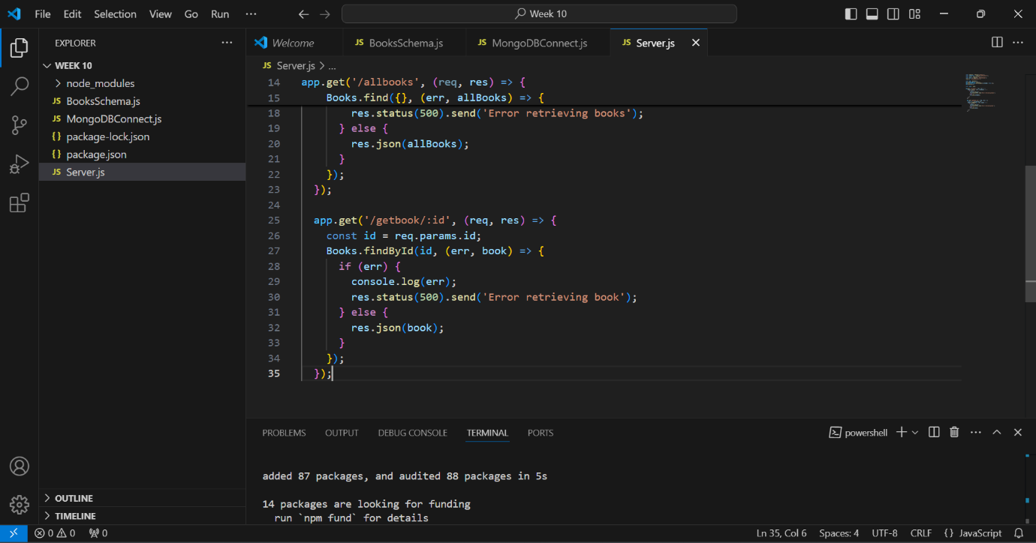

* Add a new book:

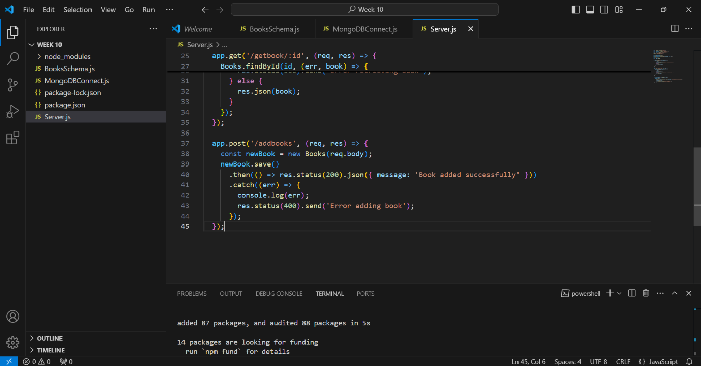

* Update an existing book by ID:

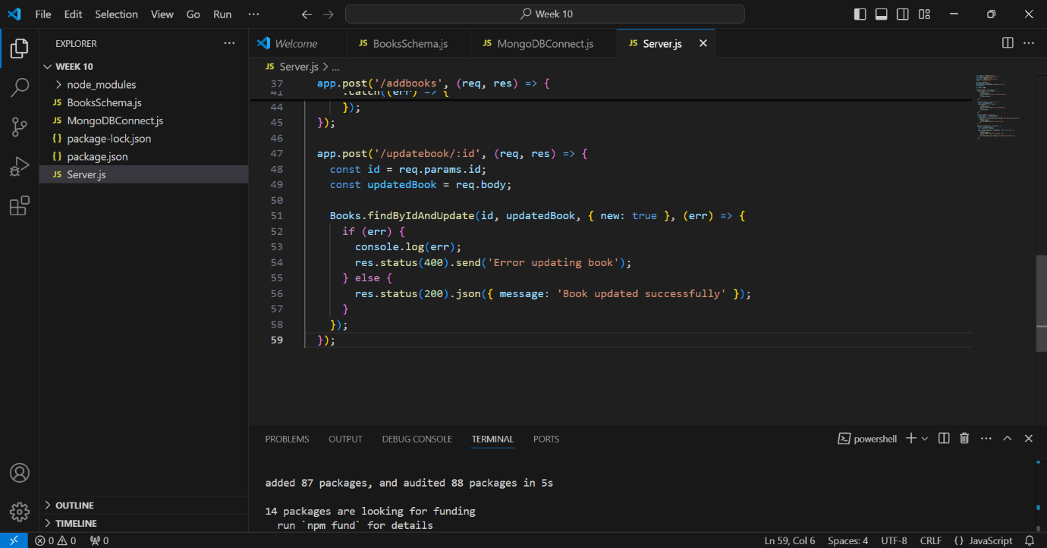

* Delete a book by ID:

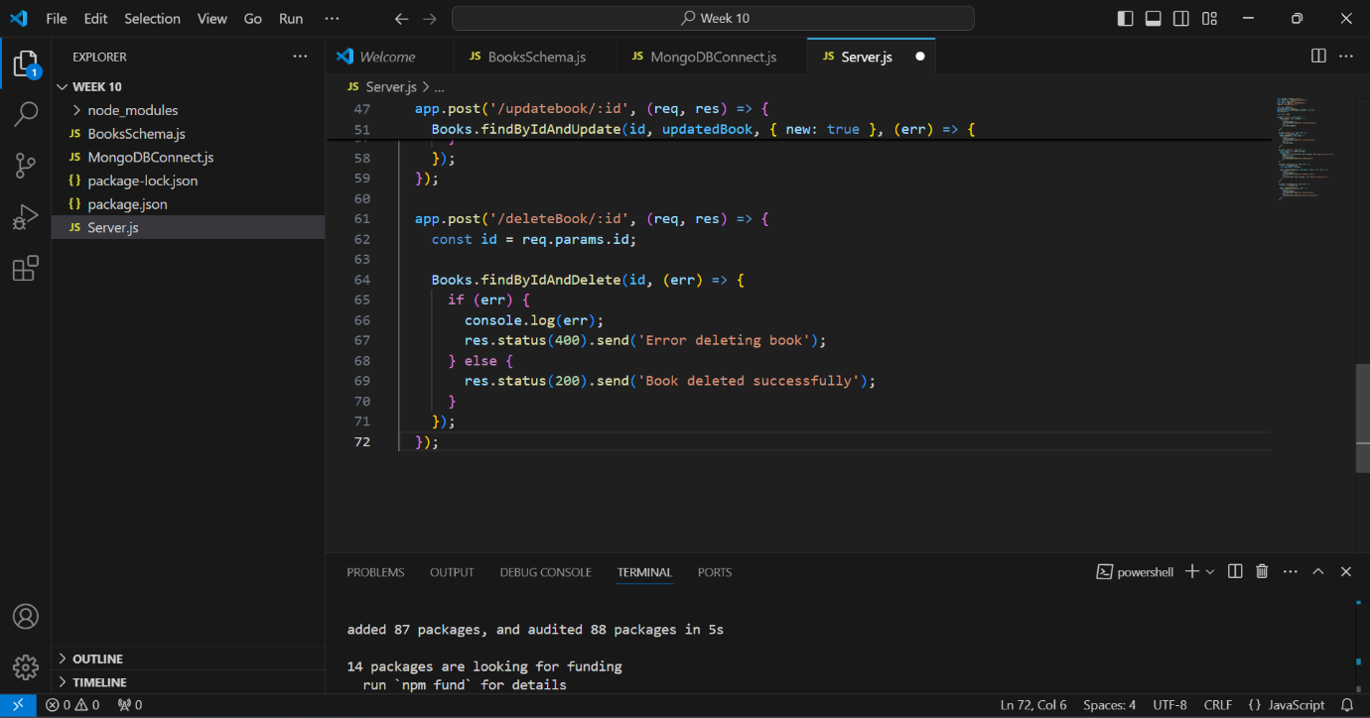

* And at the end start the server:

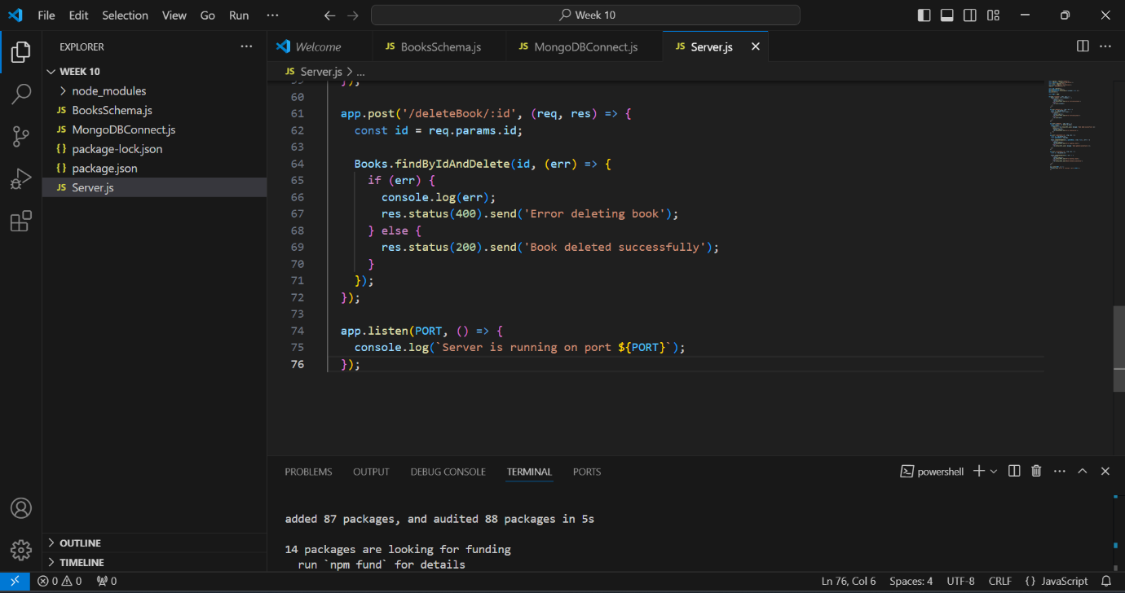

* We will now execute the server file using the npm command:

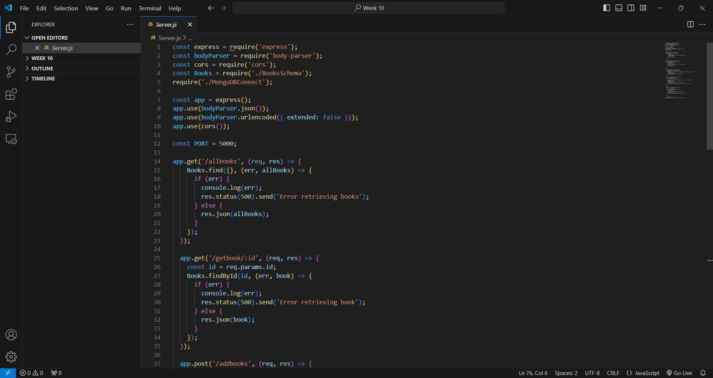

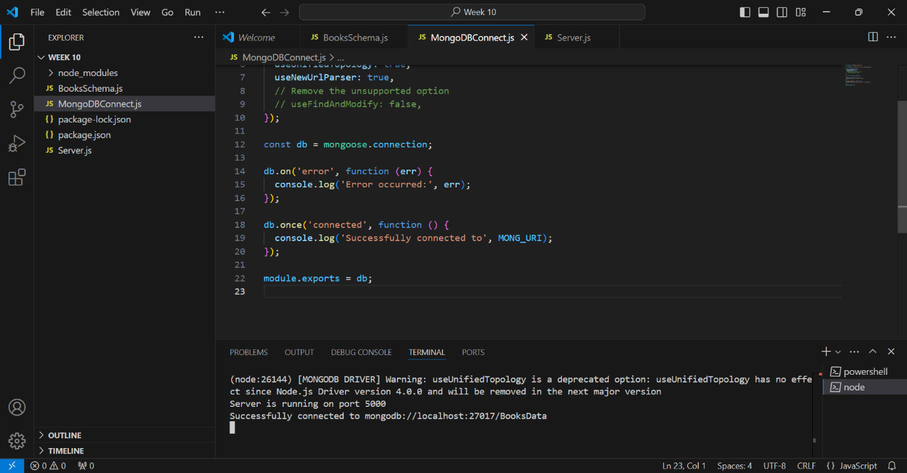

* For the backend of my online library project, I am utilizing Node.js with Express for the server and MongoDB for the database, administered through Mongoose. The backend will provide many REST API endpoints to manage the essential functions of the library system.
* The initial endpoint, GET /allbooks, enables visitors to obtain a comprehensive list of all books accessible in the library. The MongoDB query Books.find({}) will be employed to retrieve all documents from the Books collection. I will establish a GET /getbook/:id endpoint to obtain details of a given book, utilizing Books.findById(id) to locate the book by its unique identifier. To include a new book into the collection, I will establish a POST /addbooks endpoint that utilizes new Books(req.body).Utilize save() to generate and save a new book entry according to the data supplied in the request body. To amend the information of an existing book, the POST /updatebook/:id endpoint will be utilized, whereby Books.findByIdAndUpdate(id, updatedBook, { new: true }) will locate the book by its ID and modify it, providing the altered document. To remove a book from the library, I will implement a POST /deleteBook/:id endpoint that utilizes Books.findByIdAndDelete(id) to identify and eliminate the book by its ID.
* These API endpoints will encompass the primary actions required for administering the book data in the online library, facilitating seamless interaction between the backend and frontend applications.

https://github.com/u2524845/CN5006-week10.git

# Week 11 Developing a frontend of online Library React Single Page application

This week's lab will include developing the frontend application that will interface with the backend application created in our week 10 lab. The initial step for the frontend application involves creating a folder for week 11, subsequently establishing a subfolder named FrontEnd within it, and then generating a React application titled onlinelibrary within that subfolder.

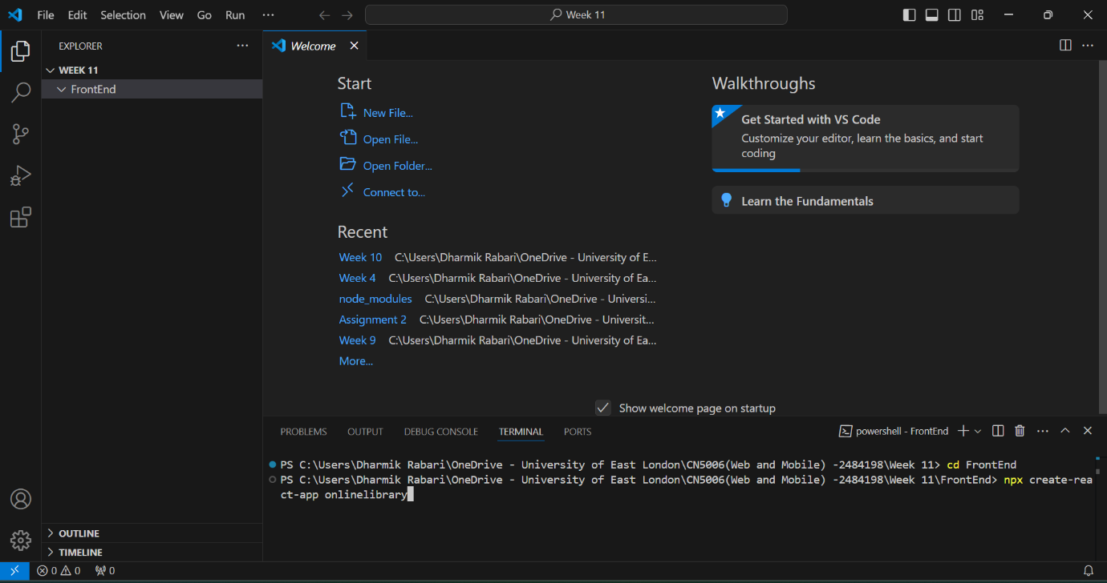

* We will now execute the code with the command npm start:

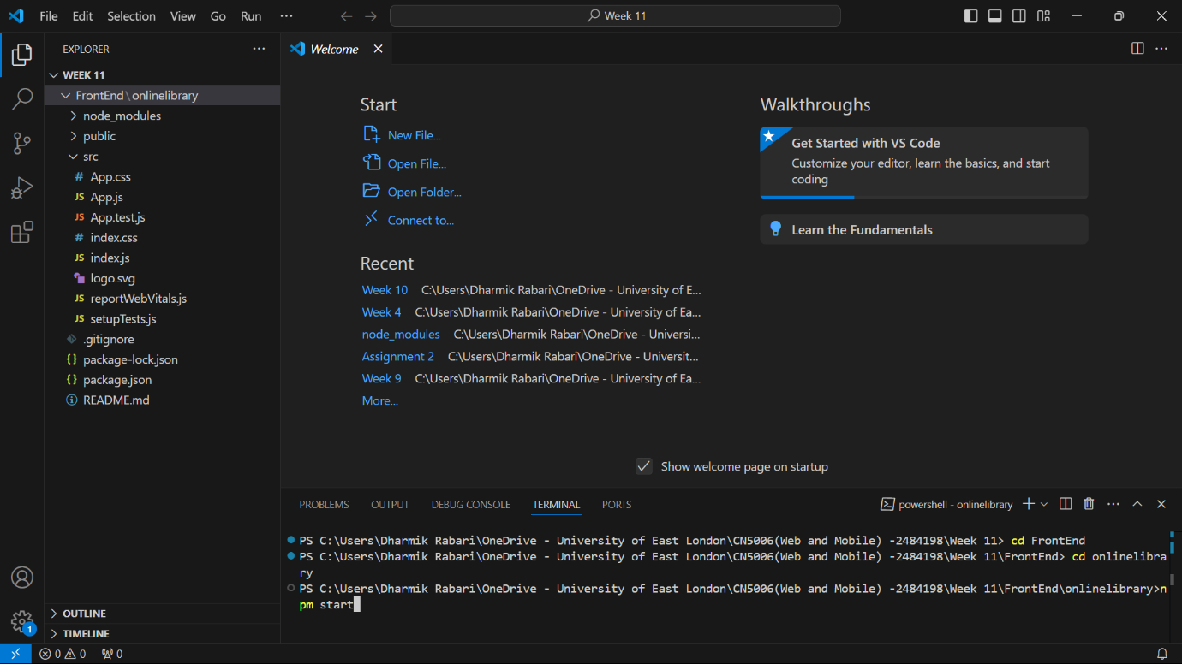

* This problem occurred when I executed the code:

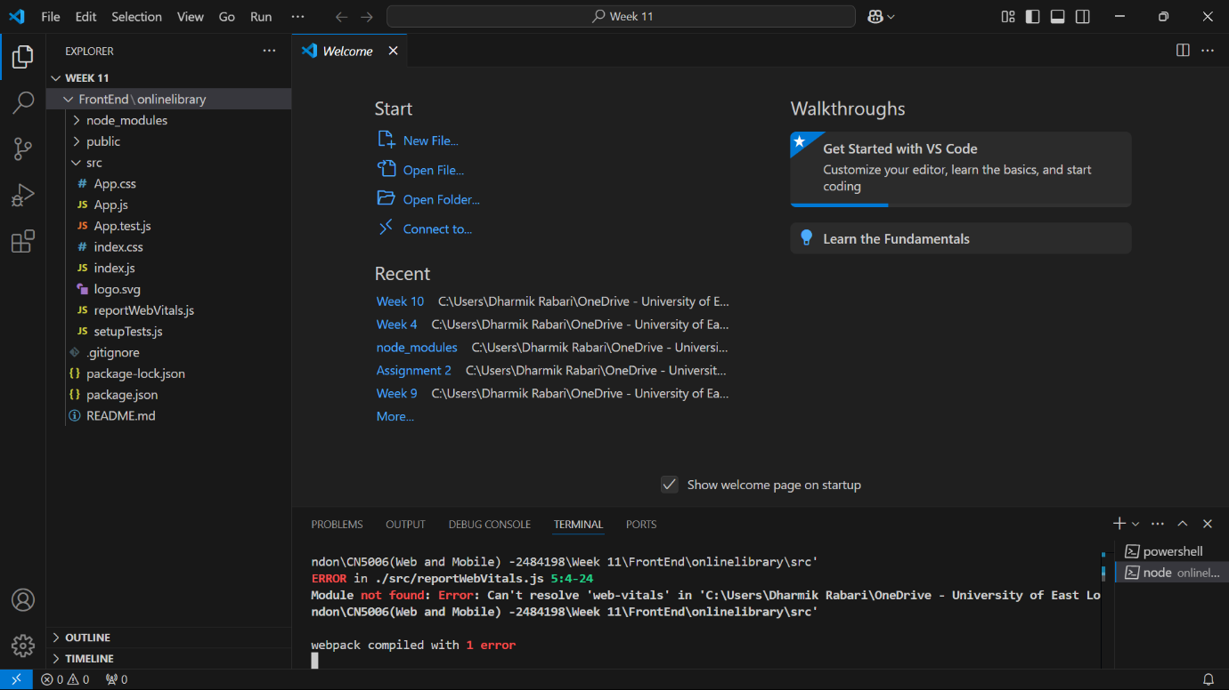

* The code exhibited issues due to an incorrect version of React, React-DOM, and web-vitals; thus, I modified the package.json file.

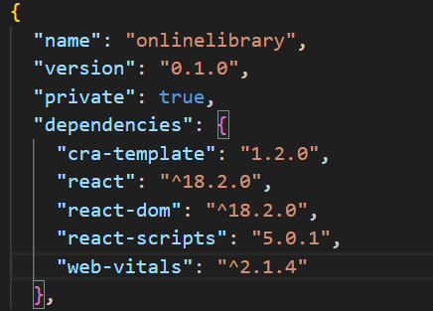

* I subsequently restored the file after its deletion and executed it once more:

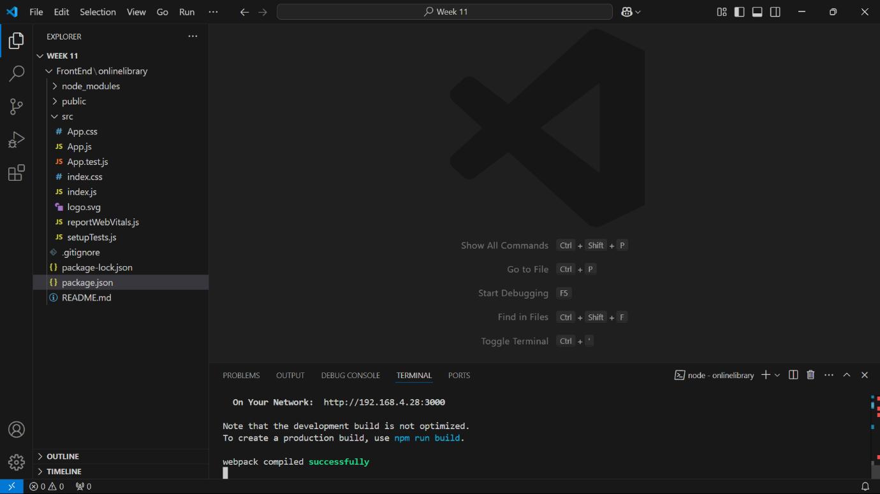

* This constituted the result:

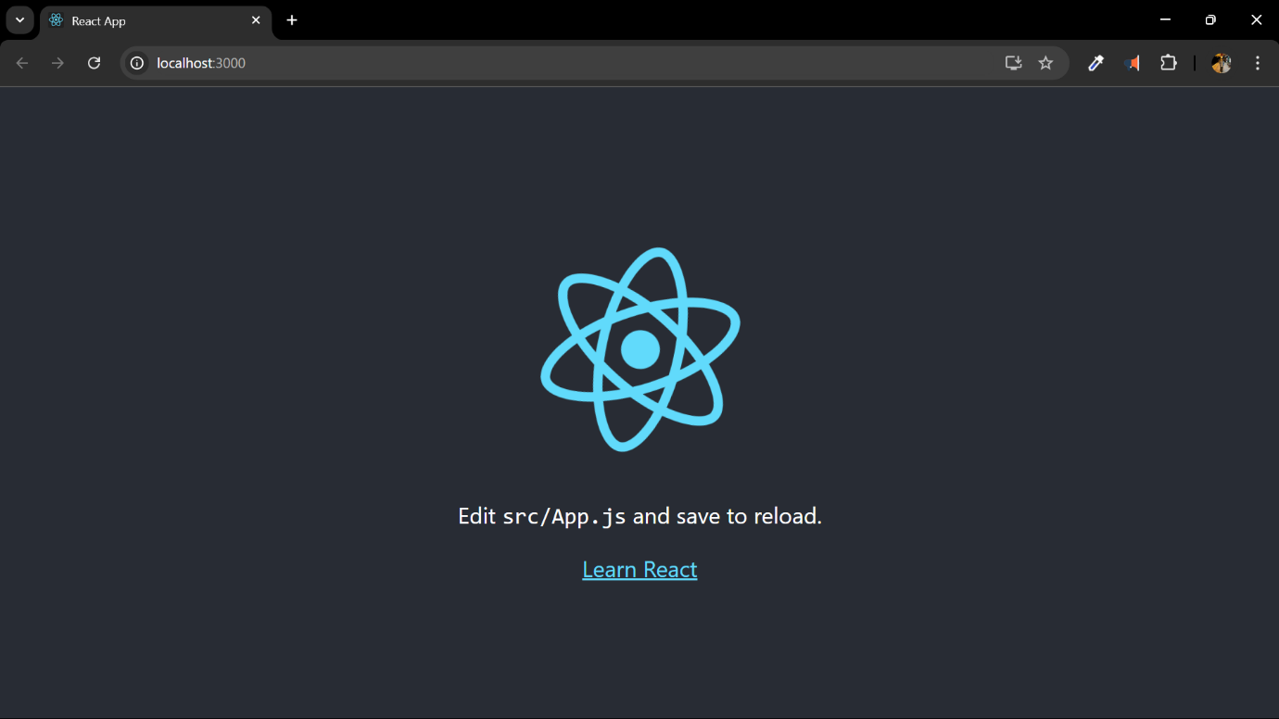

* We will now install React Router dom.

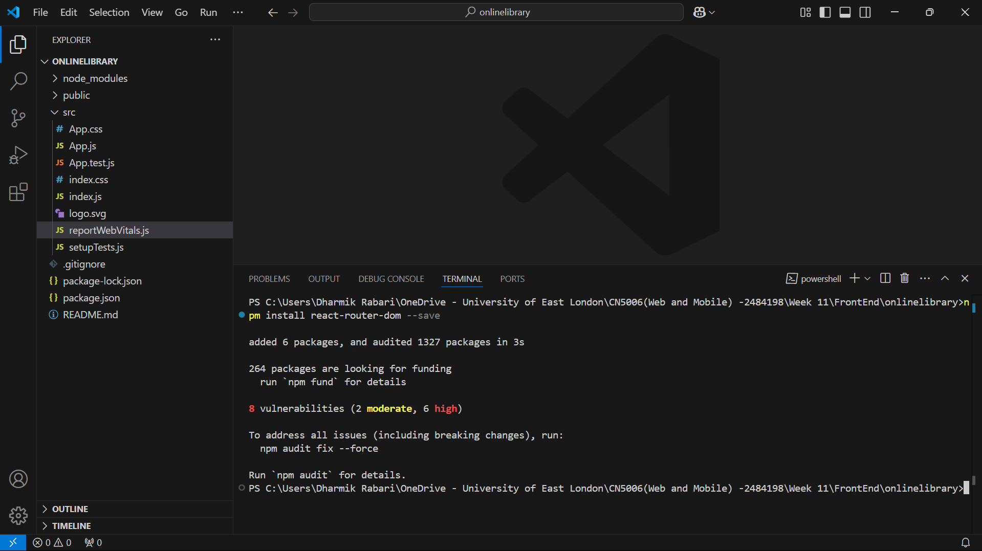

* We will also verify the installed version using:

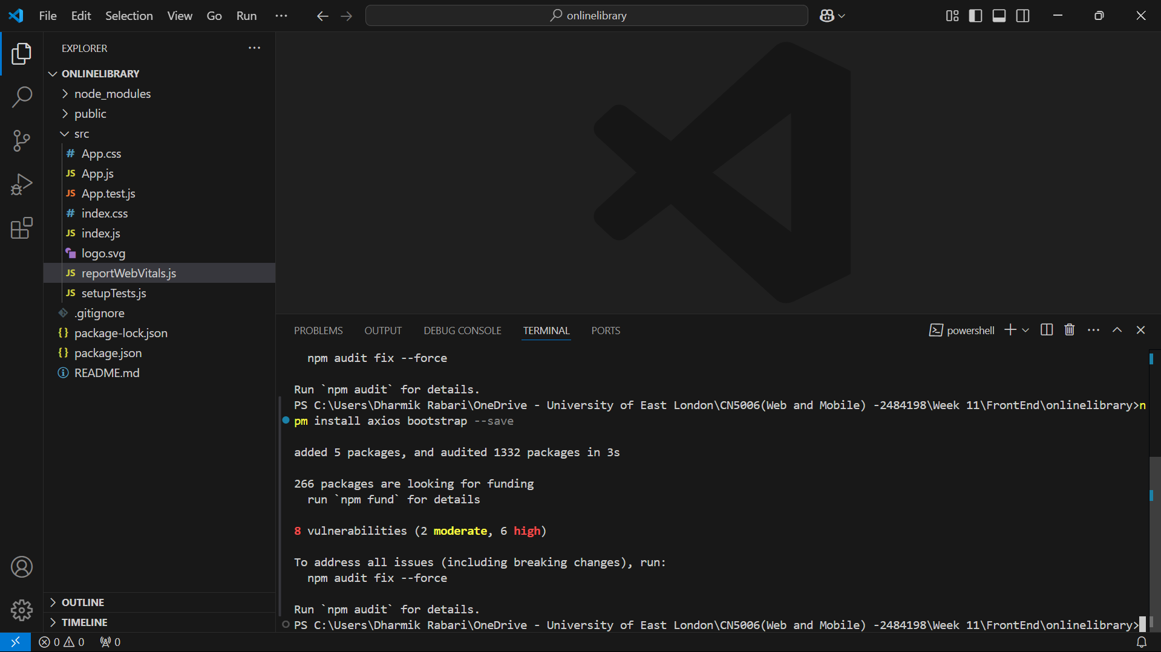

* We will now create a component directory to which we will add the moodle files.

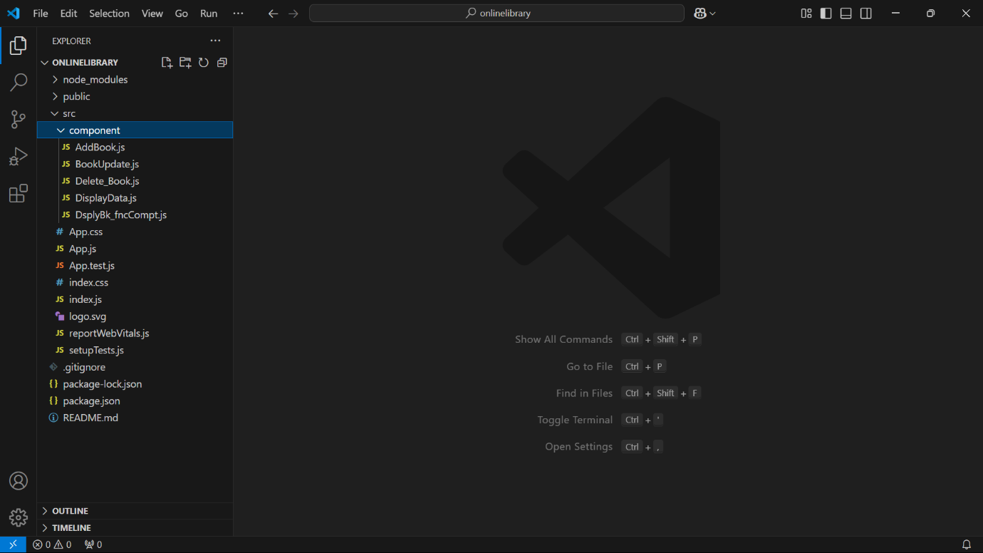

* We will now revise the app.js file as outlined in the laboratory tutorial:

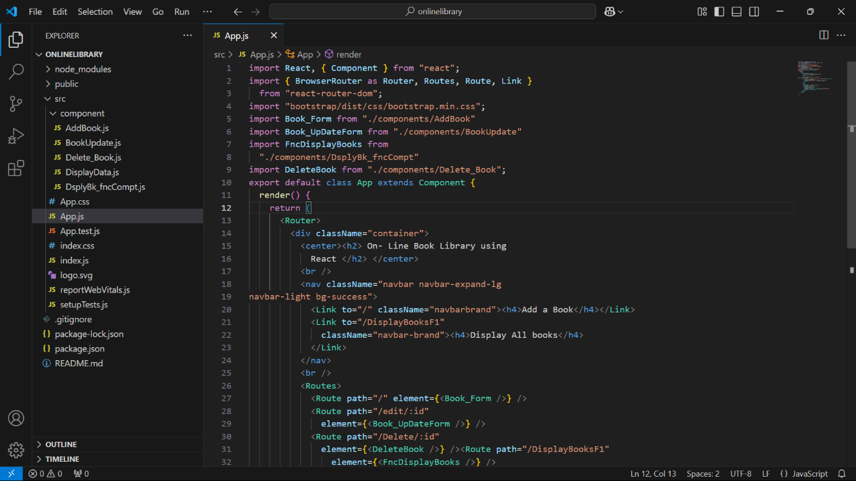

* We will now execute the program using the npm start command:

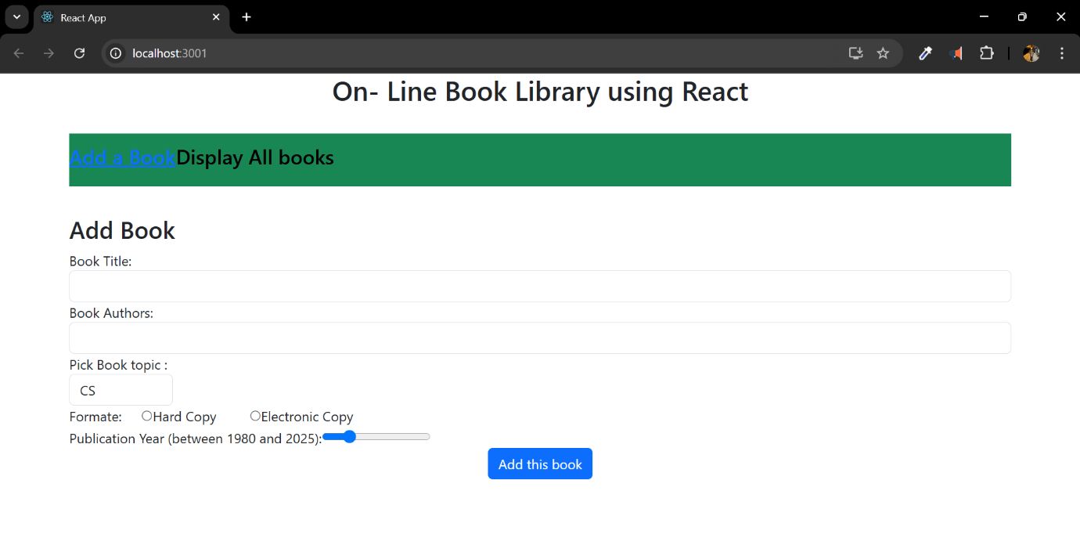

* We will now incorporate the code for adding a book.

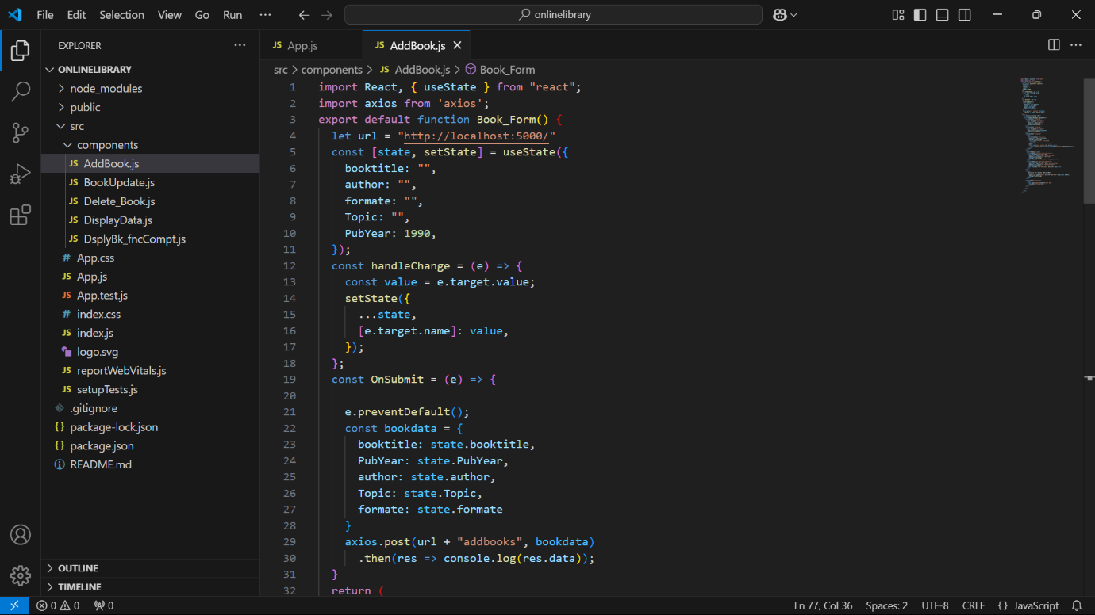

During this week's lab, we gained knowledge of the frontend in its entirety as well as the process of connecting the frontend to the backend. During sometimes, it was a little bit challenging since I was having trouble in many different areas, such as connecting mongoDB, connecting it with the server, and building connections between all of the components. Nevertheless, I was able to find a solution to the problem with the assistance of our mentor and tutor, and I also learned how to connect and operate them. When it comes to the assignments we have to do for the class, we are still considering the components, but we will start working on them very soon.

https://github.com/u2524845/CN5006-week11.git